 Appendix H2
Annual Synod safeguarding report

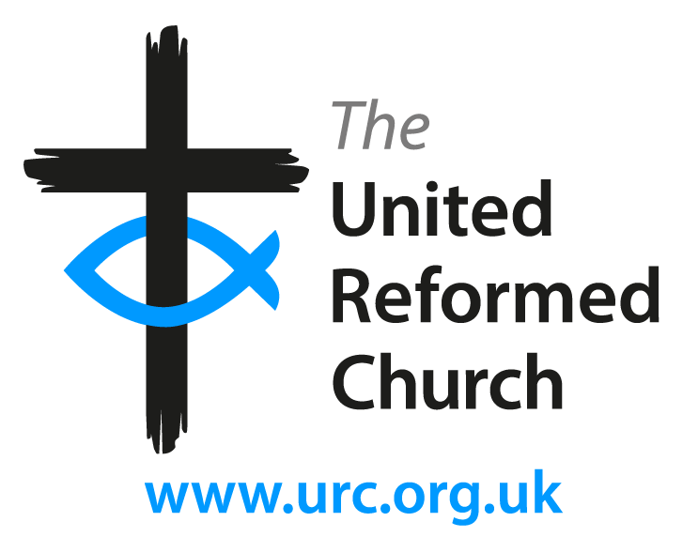

YEAR

SYNOD

AUTHOR

URC’s policy (Good Practice 5) indicates that an annual safeguarding report should be provided
by the Synod Safeguarding Officer to the Synod trustees summarising any safeguarding concerns which have arisen from within the Synod (minus any identifying details), any actions taken in individual cases, any lessons learned, and any implications for the review of safeguarding policy and procedures. In addition, the annual safeguarding report should give a summary of the annual safeguarding return information provided by local churches, and details of the safeguarding training and support provided by the Synod. A copy of this Annual Synod Safeguarding Report should be given to the URC Safeguarding Adviser. This will allow the Church as a whole to review its commitment to safeguarding children and adults at risk, and provide suitable support and guidance to Synods and local churches. Please complete this report to the best of your knowledge and indicate if you were not able to provide specific data in some sections of the report. The final report needs to be sent to safeguarding@urc.org.uk for the attention of URC’s safeguarding adviser by date.

1. Introduction

Please compile all data of the Appendix H2 based on the information provided in the annual safeguarding returns (Appendix H1) received by local churches this year. Please use the comments area to summarise any occurring themes in the implementation of URC’s safeguarding policy and practice during last year. These themes can include concerns, progressions, problems, successes or areas for further development. Please mention whether any safeguarding guidance or procedure has been reviewed or updated this year integrating URC’s policy, new legislation and/or local government guidance.

Number of registered churches at the synod:
Number of churches completed and returned Appendix H2:
Number of Safeguarding Coordinators:
Number of Deputy Safeguarding Coordinators:
Number of churches with no Safeguarding Coordinators:
Number of churches in Local Ecumenical Partnerships (LEP):
Number of churches in Local Ecumenical Partnerships (LEP) using URC’s
safeguarding policy:

Number of churches in Local Ecumenical Partnerships (LEP) using different
safeguarding policy to URC:

Comment:

2. Safeguarding concerns

Please provide details of safeguarding concerns handled at the Synod level in the last 12 months (with no identifying details of individuals), main actions taken in each case, and the number of referrals made to external agencies for further support, if any. In this section,
you need to detail the forms of abuse or neglect and any other serious safeguarding situations addressed within your Synod. Please also include a short and general commentary on possible trends in current safeguarding practices and arrangements with focus on the capacity of ministers and paid and voluntary workers to recognise abuse, harm and neglect and respond timely and proportionally to allegations/concerns/incidents/events that put at risk the protection and safety of children and adults.

Number of concerns relating to safeguarding and protection of children and young
people from any form of abuse:

Number of concerns relating to safeguarding and protection of adults from any form
of abuse:

Number of general enquires (governance, administration, generic advice, etc.):
Number of referrals to a Designated Officer (formerly known LADO):
Number of referrals to children’s services:
Number of referrals to adult social care services:
Number of referrals to Police:
Number of referrals to other local authorities or agencies (please specify):
Number of referrals to Charity Commission or OSCR:
Comment:

3. Pastoral care and support

Please describe and comment on current provision and services ensuring pastoral care and support is available to all those affected by any form of abuse, harm or neglect in your synod, congregations and LEPs. There might be work offered in a local church or support for survivors of historical abuse. How many cases that have come to your attention require pastoral care in the last year? What was the professional help or support provided? What external help have you recommended and utilised? How pastoral care is organised in your synod (specific people, committees, service, external agency, etc)?

Comment:

4. Managing risk and those who may pose a risk

Please report any safeguarding issues arose in the last year in managing risk and supporting ministerial, paid or voluntary workers who may have posed a risk to local churches and synods (with no identifying details of individuals), actions taken and what learning drawn upon them. Please also add how many offenders or alleged offenders are known to your synod. Please provide the number of safeguarding contacts/covenants of care currently in place to manage those who might pose a risk to others, including children and adults. It is also important to outline any sort of safeguards and support provided to the churches or the synod to assess risks and those who may pose a risk to children or vulnerable adults.

Number of known offenders currently attend URC churches:
Number of safeguarding allegations made against a church goer: /volunteer: minister: / paid staff:
Number of Risk Assessments undertaken/involved the synod safeguarding officer:
Number of Covenants of Care/Safeguarding Contracts in place over the last year:
How many written contracts have been reviewed over the last year:
How many written contracts have been terminated over the last year:
Comment:

5. Safeguarding training

Please provide details about safeguarding training delivered by the Synod in the last 12 months (number of participants, policy areas, resources, feedback and recommendations). The training offer might include URC’s safeguarding training, other denomination’s and external training provider or other development opportunities provided to local churches.
In case a specific training plan has already been established at the synod for the new year, please indicate areas of delivery and whether access to any support or further resources is required. In this section also, you can point at any safeguarding support or training the
synod would like to see included in the overall safeguarding training programme of the URC.

Number of Safeguarding Coordinators attended safeguarding training:
Number of Deputy Safeguarding Coordinators attended safeguarding training:
Number of Ministers attended URC safeguarding training:
Number of Paid Workers attended URC safeguarding training:
Number of Volunteers attended URC safeguarding training:
Number of Trustees/Elders attended URC safeguarding training:
Number of people attended other non-URC safeguarding training:
Number of people are due for safeguarding training in the next year:
Comment:

6. Safer recruitment

Please add details whether you had any involvement in supporting recruitment and
induction of paid workers or volunteers, including guidance, job descriptions, DBS, eligible roles for checks, blemished disclosures, etc.

Number of blemishes disclosures supported by the synod safeguarding officer:
Number of churches that sought advice on safer recruitment:
Comment:

7. Ecumenical or other partnerships

Please indicate the level of collaboration work with other denominations or agencies/services and the specific areas of cross-denominational safeguarding practice (training, pastoral care, risk management, offenders’ assessments, etc.). Please also
comment on future planning to build and sustain constructive partnerships and safe interfaith environments in your synod.

Comment:

8. lessons and recommendations

Please use the last comment box for any other lessons learned and ideas that are not
covered in the sections above.

Comment:

Thank you very much for completing the annual safeguarding report for your synod.

