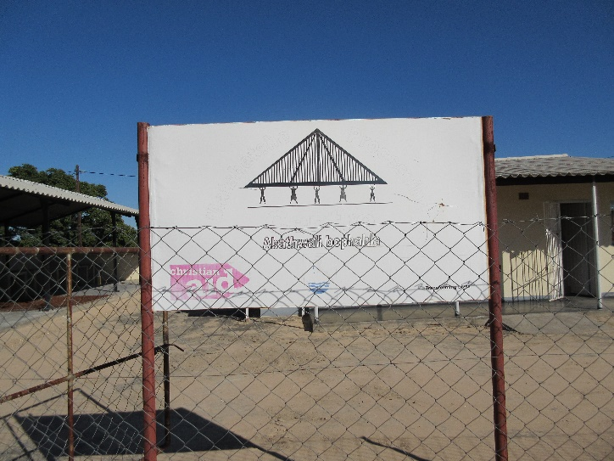
In ten years’ time...

The Matshetshe Food Processing Centre in Nkwidzi Village, Matabeleland South is a small building with three rooms. It is a community-driven project which gives added value to the crops grown in the area. Before the centre was opened in 2011, with funding from Christian Aid and DfiD, the community faced challenges in marketing and selling their produce. It was difficult to generate profits from the sale of produce because farmers spent any profit they might make transporting their produce to Gwanda, 40-60 kilometres away. The produce did not travel well and so they did not get a good price.
Today, produce is sold from the centre and it is great to hear that they have developed a good name for quality in the neighbourhood. Other items produced include peanut butter, maize and sorghum flour, popcorn, oil, plain buns, fruit juices, vegetable drying, meat slicing and amacimbi, a local delicacy a bit like a caterpillar.
Farmers, for a small fee, bring their vegetable crops to be dried by the solar powered dryer and then packaged. This means the vegetables will provide nutritional food throughout the year for the family with any excess being sold. The drying process takes three to five days but is more reliable than the electric dryer because of Zimbabwe’s intermittent electricity supply. The other processing machines can be hand cranked if the power is lost.
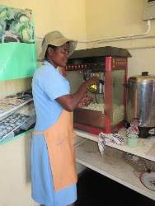
Mcolisi Ncube is one of three women who work there, organising the orders and processing the goods that come in, including making buns and popcorn to sell. She receives a small allowance for this work. The processed items are packed and branded for resale to outlying markets in Insiza, Bulawayo and Gwanda. They also exhibit the fare at local exhibitions and the Zimbabwe International Trade Fair.

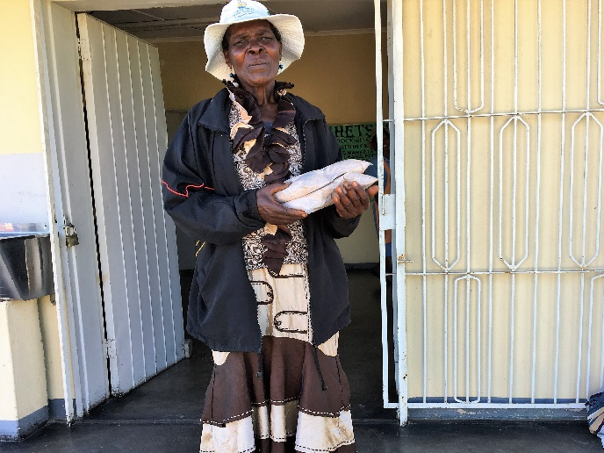
Today, over 4000 households benefit from the project. Pauline Ndlovu, centre member, has been trained in conservation farming methods with Dabane Trust. This increased her yield threefold so now, she brings her excess harvest to the centre. It is processed and sold to provide extra income.
‘Now we have our own processing centre, people look up to us in the community. People come regularly to buy. At first, we did not think of it as a business, now we do. We are grateful to Dabane Trust as we plan ahead. We are always open to new ideas.’
Pauline’s plans are also the community’s.
‘In ten years’ time, we would like to have a shop in a local town and send produce there to be sold.’
What an inspiring, successful and forward-looking group, thanks to donations from Commitment for Life churches over many years.

Image 1: Matshetshe Food Processing Centre
Image 2: Mcolisi Ncube making popcorn to sell at the centre
Image 3: Pauline Ndlovu not only brings goods to process but buys from the shop too.

LMM 2017

