Advent to Epiphany liturgies Week 5
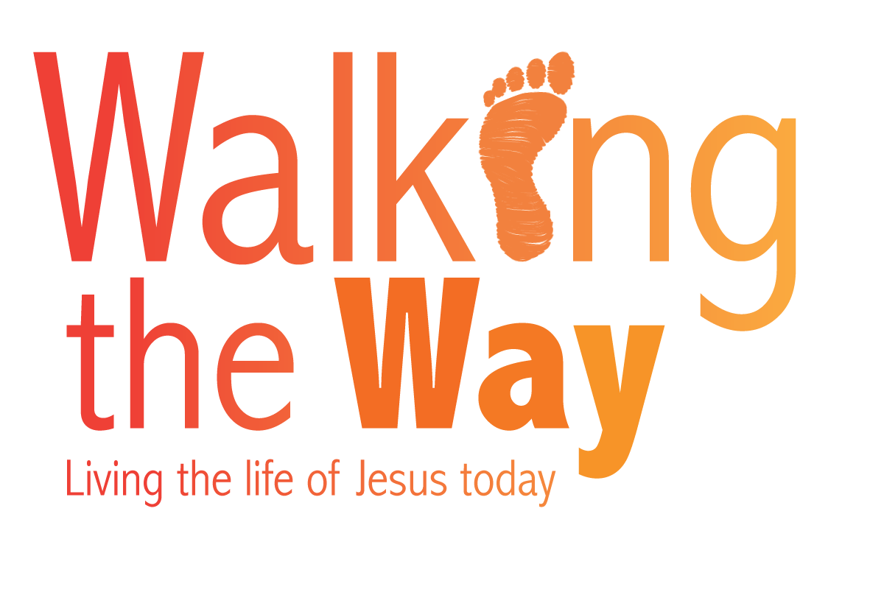
Christmas Day, Monday 25 December
On the theme of the incarnation

A white candle is to be lit with the others before worship

Mary was engaged to Joseph and travelled with him to Bethlehem. She was soon going to have a baby, and while they were there she gave birth to her first-born son. (Luke 2.5-7)

While we were asleep, in the quiet, dark night, a baby was born. Jesus has been our companion on the way, because he was born for us and his resurrection keeps him with us wherever we go.

Let us give thanks for safe arrivals:

Where babies have been safely born
Where travellers have found journey’s end
Where greetings and gifts have crossed the world
Let us pray a welcome blessing in the name of Jesus
Amen.

© The United Reformed Church
This liturgy may be used freely in worship, including in small groups and whole congregations. If used in printed form, acknowledgement of the source must be given. The reproduction of the material for commercial gain and/or for use outside a local church is prohibited without written permission. For such permissions please email communications.pa@urc.org.uk

