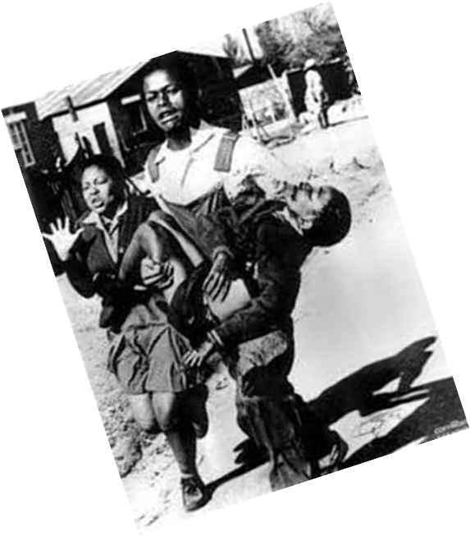
The Kairos Document
Revised Second Edition (1986)

CHALLENGE TO THE CHURCH

A Theological Comment on the Political Crisis in South Africa

Skotaville Publishers, Braamfontein (1986)

PREFACE TO THE REVISED SECOND EDITION
It is exactly one year since the publication of the first edition of the Kairos Document. At that time. we said that “South Africa has been plunged into a crisis that is shaking the foundations and there is every indication that the crisis has only just begun and that it will deepen and become even more threatening in the months to come”. Today, one year later, the situation in South Africa is indeed far worse than before and the crisis far more serious.

A year ago we had a partial state of emergency, now we have a total, national state of emergency. Then one could, to a certain extent, report about what was happening in South Africa, now there is almost a total blackout of news. Then there were threats of sanctions, now it is a matter of what type of sanctions to apply against South Africa. There is more repression now than ever before with thousands of people in detention, many missing and some restricted or deported. Whilst the Botha regime is going all out to demonstrate its power and its determination to maintain apartheid at all costs, the people have become more determined than ever to resist this regime even at the cost of their lives. This is indeed frightening. It is a real Kairos!

The message of the Kairos Document has lost none of its relevance. If anything, it is more relevant today than it was a year ago. The Kairos theologians have therefore decided to publish a second edition of the document.

After extensive discussions amongst the Kairos theologians and with regional groups around the country, and, after considering all the contributions from various groups, churches and other persons here and abroad, and further, because of a desire to keep the document as simple as possible for easy reading by ordinary people, the editing of the document has been kept to a minimum. Amendments, elaborations and additions have been made only where it was absolutely necessary for greater clarity. We have tried to maintain the quality of the first edition, its mood, sharpness, vigour and simplicity because this is what the signatories and others demanded. It had to be left as a prophetic word, a proclamation.

For this reason, no debates on the various themes raised by the first edition have been entered into, To meet this need the Kairos theologians are working on a book which will deal with the debates more scientifically. The publication of this book is scheduled for the middle of next year.

The only chapter of the original Kairos Document which has been almost completely rewritten is that on Prophetic Theology. It was generally felt that this chapter was not well developed in the first edition. Otherwise we have added explanatory notes to help clarify some of the points which were not clear. Also, because of the thousands of people who wanted to have their names put to the document, it has not been possible to include a list of signatories in this edition. It would have made the edition too voluminous. we are nevertheless keeping a record of the list.

Responses to the first editon were overwhelming. The document has generated more discussions and debates than any previous theological document in South Africa. There has been overwhelming excitement about it in the black townships. It reinforced the people’s faith and hope for a new and just society in South Africa. It came as an empowering instrument of faith committing them more than ever before to the struggle for justice and peace in South Africa. It was welcomed as a statement of what it means to be truly Christian in a violent apartheid society. For many, the Gospel became ‘Good News’ for the first time in their lives.

The document also had a mission dimension. Many of those who had abandoned the Church as an irrelevant institution that supports, justifies and legitimizes this cruel apartheid system began to feel that if the Church becomes the Church as expounded in the Kairos Document then they would go back to Church again. Even those who would consider themselves to be ‘non-Christians’ in the conventional sense began to say that if this is Christianity they could become Christians.

There have also been responses from some of the Churches in South Africa, from various Christian groups around the country and from individual theologians and various other persons. And we have received volumes of responses from our sister churches around the world. All were very helpful in advancing the development of an authentic and relevant theology that addresses itself to the issues of the day. Like any other challenging material, the document has also been viciously attacked, mostly by conservative church groups like the ‘Gospel Defence League’ and ‘Christian Mission International’. They actually called for the banning of the document. This came as no surprise to us as they are known for their support of the apartheid regime in South Africa and their attack on anyone who challenges the regime.

It might be interesting to study the relationship between the various individuals and groups who viciously attacked the document and those who welcomed it. For example, how does the theological stance relate to the class position or the social, economic, racial and political interests of these groups or individuals? What is clear is that most of those who attacked the document failed to appreciate the concerns of those who participated in producing the document. They looked at the document from their own situation or context which is completely different from that of the participants whose experience and ministry come from the townships. Most of the critics simply took the document out of its context and analysed it in the realm of abstraction.

To appreciate the Kairos Document one needs to understand and internalize the concerns of those who produced it. Those Christians who live in the townships and who are experiencing the civil war that is tearing their lives apart understand immediately what the Kairos theologians are attempting to say; whilst those who do not have this experience find it difficult to understand the document.

Perhaps the most exciting and most important contribution of the Kairos Document has been its method or way of doing theology. Many Christians here and abroad are using the model or method of the Kairos Document to reflect on their own situation. They have begun to criticise the traditional, historical alignment of the Church with Western ideology, institutions and governments whilst those in the East are grappling with how to live ones faith in socialist societies.

Against this background we publish today this second edition of the Kairos Document. It was developed in the same way as the first edition except that thousands of people have been involved in the process, not only in terms of reflection and study but mostly in terms of involvement and action in the liberation struggle in South Africa. We hope that it will serve as a never-ending stimulus to keep the cycle of action-reflection-action moving forward.

September 1986

PREFACE
The KAIROS document is a Christian, Biblical and theological comment on the political crisis in South Africa today. It is an attempt by concerned Christians in South Africa to reflect on the situation of death in our country. It is a critique of the current theological models that determine the type of activities the Church engages in to try to resolve the problems of the country. It is an attempt to develop, out of this perplexing situation, an alternative biblical and theological model that will in turn lead to forms of activity that will make a real difference to the future of our country.

Of particular interest is the way the theological material was produced. In June 1985 as the crisis was intensifying in the country, as more and more people were killed, maimed and imprisoned, as one black township after another revolted against the apartheid regime, as the people refused to be oppressed or to co-operate with oppressors, facing death by the day, and as the apartheid army moved into the townships to rule by the barrel of the gun, a number of theologians who were concerned about the situation expressed the need to reflect on this situation to determine what response by the Church and by all Christians in South Africa would be most appropriate.

A first discussion group met at the beginning of July in the heart of Soweto. Participants spoke freely about the situation and the various responses of the Church, Church leaders and, Christians. A critique of these responses was made and the theology from which these responses flowed was also subjected to a critical analysis. Individual members of the group were assigned to put together material on specific themes which were raised during the discussion and to present the material to the next session of the group.

At the second meeting the material itself was subjected to a critique and various people were commissioned to do more investigations on specific problematic areas. The latest findings with the rest of the material were collated and presented to the third meeting where more than thirty people, consisting of theologians, ordinary Christians (lay theologians) and some Church leaders.

After a very extensive discussion some adjustments and additions were made especially in regard to the section entitled ‘Challenge to Action.’ The group then appointed a committee to subject the document to further critique by various other Christian groupings throughout the country. Everybody was told that “this was a people’s document which you can also own even by demolishing it if your position can stand the test of biblical faith and Christian experience in South Africa.” They were told that this was an open-ended document which will never be said to be final.

The ‘working Committee,’ as it was called, was inundated with comments, suggestions and enthusiastic appreciation from various groups and individuals in the country. By the 13th of September 1985 when the document was submitted for publication there were still comments and recommendations flowing in. The first publication therefore must be taken as a beginning, a basis for further discussion by all Christians in the country. Further editions will be published later.

25 September 1985
Johannesburg
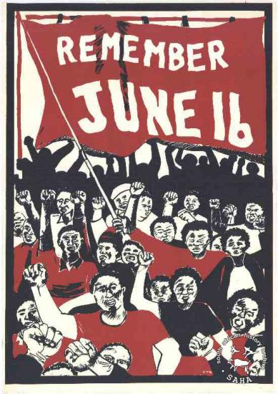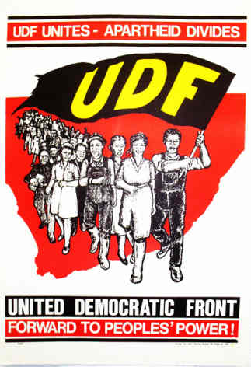

CHAPTER ONE The Moment of Truth
The time has come. The moment of truth has arrived. South Africa has been plunged into a crisis that is shaking the foundations and there is every indication that the crisis has only just begun and that it will deepen and become even more threatening in the months to come. It is the KAIROS
or moment of truth not only for apartheid but also for the Church and all other faiths and religions.

We as a group of theologians have been trying to understand the theological significance of this moment in our history. It is serious, very serious. For very many Christians in South Africa this is the KAIROS, the moment of grace and opportunity, the favourable time in which God issues a challenge to decisive action. It is a dangerous time because, if this opportunity is missed, and allowed to pass by, the loss for the Church, for the Gospel and for all the people of South Africa will be immeasurable. Jesus wept over Jerusalem. He wept over the tragedy of the destruction of the city and the massacre of the people that was imminent, “and all because you did not recognize your opportunity (KAIROS) when God offered it” (Lk 19: 44).

A crisis is a judgment that brings out the best in some people and the worst in others. A crisis is a moment of truth that shows us up for what we really are. There will be no place to hide and no way of pretending to be what we are not in fact. At this moment in South Africa the Church is about to be shown up for what it really is and no cover-up will be possible.

What the present crisis shows up, although many of us have known it all along, is that the Church is divided. More and more people are now saying that there are in fact two Churches in South Africa–a White Church and a Black Church. Even within the same denomination there are in fact two Churches. In the life and death conflict between different social forces that has come to a head in South Africa today, there are Christians (or at least people who profess to be Christians) on both sides of the conflict–and some who are trying to sit on the fence!

Does this prove that Christian faith has no real meaning or relevance for our times? Does it show that the Bible can be used for any purpose at all? Such problems would be critical enough for the Church in any circumstances but when we also come to see that the conflict in South Africa is between the oppressor and the oppressed, the crisis for the Church as an institution becomes much more acute. Both oppressor and oppressed claim loyalty to the same Church. They are both baptized in the same baptism and participate together in the breaking of the same bread, the same body and blood of Christ. There we sit in the same Church while outside Christian policemen and soldiers are beating up and killing Christian children or torturing Christian prisoners to death while yet other Christians stand by and weakly plead for peace.

The Church is divided against itself and its Day of Judgment has come.

The moment of truth has compelled us to analyze more carefully the different theologies in our Churches and to speak out more clearly and boldly about the real significance of these theologies. We have been able to isolate three theologies and we have chosen to call them ‘State Theology,’ ‘Church Theology’ and ‘Prophetic Theology’. In our thoroughgoing criticism of the first and second theologies we do not wish to mince our words. The situation is too critical for that.

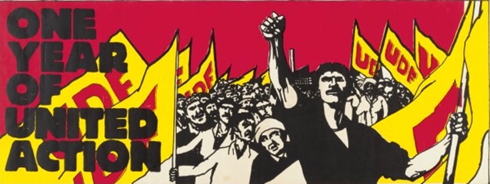
CHAPTER TWO Critique of State Theology
The South African apartheid State has a theology of its own and we have chosen to call it ‘State Theology.’ ‘State Theology’ is simply the theological justification of the status quo with its racism, capitalism and totalitarianism. It blesses injustice, canonizes the will of the powerful and reduces the poor to passivity, obedience and apathy.

How does ‘State Theology’ do this? It does it by misusing theological concepts and biblical texts for its own political purposes. In this document we would like to draw your attention to four key examples of how this is done in South Africa. The first would be the use of Romans 13:1-7 to give an absolute and ‘divine’ authority to the State. The second would be the use of the idea of ‘Law and Order’ to determine and control what the people may be permitted to regard as just and unjust. The third would be the use of the word ‘communist’ to brand anyone who rejects ‘State Theology.’ And finally there is the use that is made of the name of God.

2.1 Romans 13:1-7
The text reads as follows (in the Jerusalem Bible):
1. You must all obey the governing authorities. Since all government comes from God, the civil authorities were appointed by God. 2. And so anyone who resists authority is rebelling against God’s decision, and such an act is bound to be punished. 3. Good behaviour is not afraid of magistrates; only criminals have anything to fear. If you want to live without being afraid of authority, you must live honestly and authority may even honour you. 4. The State is there to serve God for your benefit. If you break the law, however, you may well have fear: the bearing of the sword has its significance. The authorities are there to serve God: they carry out God’s revenge by punishing wrongdoers. 5. You must obey, therefore, not only because you are afraid of being punished, but also for conscience’ sake. 6. This is also the reason why you must pay taxes, since all government officials are God’s officers. They serve God by collecting taxes. 7. Pay every government official what he has a right to ask – whether it be direct tax or indirect, fear or honour.

The misuse of this famous text is not confined to the present government in South Africa. Throughout the history of Christianity totalitarian regimes have tried to legitimize an attitude of blind obedience and absolute servility towards the state by quoting this text. “As soon as Christians, out of loyalty to the gospel of Jesus, offer resistance to a State’s totalitarian claim, the representatives of the State or their collaborationist theological advisers are accustomed to appeal to this saying of Paul, as if Christians are here commended to endorse and thus to abet all the crimes of a totalitarian State.”

But what then is the meaning of Rom 13:1-7 and why is the use made of it by ‘State Theology’ unjustifiable from a biblical point of view?

‘State Theology’ assumes that in this text Paul is presenting us with the absolute and definitive Christian doctrine about the State, in other words an absolute and universal principle that is equally valid for all times and in all circumstances. The falseness of this assumption has been pointed out by numerous biblical scholars.

What has been overlooked here is one of the most fundamental of all principles of biblical interpretation: every text must be interpreted in its context. To abstract a text from its context and to interpret it in the abstract is to distort the meaning of God’s Word. Moreover the context here is not only the chapters and verses that precede and succeed this particular text nor is it even limited to the total context of the Bible. The context includes also the circumstances in which Paul’s statement was made. Paul was writing to a particular Christian community in Rome, a community that had its own particular problems in relation to the State at that time and in those circumstances. That is part of the context of our text.

Many authors have drawn attention to the fact that in the rest of the Bible God does not demand obedience to oppressive rulers. Examples can be given ranging from Pharaoh to Pilate and through into Apostolic times. The Jews and later the Christians did not believe that their imperial overlords, the Egyptians, the Babylonians, the Greeks or the Romans, had some kind of divine right to rule them and oppress them. These empires were the beasts described in the Book of Daniel and the Book of Revelations. God allowed them to rule for a while but he did not approve of what they did. It was not God’s will. His will was the freedom and liberation of Israel. Rom 13:1-7 cannot be contradicting all of this.

But most revealing of all is the circumstances of the Roman Christians to whom Paul was writing. They were not revolutionaries. They were not trying to overthrow the State. They were not calling for a change of government. They were, what has been called, ‘antinomians’ or ‘enthusiasts’ and their belief was that Christians, and only Christians, were exonerated from obeying any State at all, any government or political authority at all, because Jesus alone was their Lord and King. This is of course heretical and Paul is compelled to point out to these Christians that before the second coming of Christ there will always be some kind of State, some kind of secular government and that Christians are not exonerated from subjection to some kind of political authority.

Paul is simply not addressing the issue of a just or unjust State or the need to change one government for another. He is simply establishing the fact that there will be some kind of secular authority and that Christians as such are not exonerated from subjection to secular laws and authorities. “The State is there to serve God for your benefit”, says Paul That is the kind of State he is speaking of. That is the kind of state that must be obeyed. In this text Paul does not tell us what we should do when a State does not serve God and does not work for the benefit of all but has become unjust and oppressive. That is another question.

If we wish to search the Bible for guidance in a situation where the State that is supposed to be “the servant of God” (Romans 13:16) betrays that calling and begins to serve Satan instead, then we can study chapter 13 of the Book of Revelations. Here the Roman State becomes the servant of the dragon (the devil) and takes on the appearance of a horrible beast. Its days are numbered because God will not permit his unfaithful servant to reign forever.

Consequently those who try to find answers to the very different questions and problems of our time in the text of Rom 13:1-7 are doing a great disservice to Paul. The use that ‘State Theology’ makes of this text tells us more about the political options of ‘those who construct this theology than it does about the meaning of God’s Word in this text. As one biblical scholar puts it: “The primary concern is to justify the interests of the State and the text is pressed into its service without respect for the context and the intention of Paul.”

2.2 Law and Order
The State makes use of the concept of law and order to maintain the status quo which it depicts as ‘normal.’ But this law is the unjust and discriminatory laws of apartheid and this order is the organized and institutionalized disorder of oppression. Anyone who wishes to change this law and this order is made to feel that they are lawless and disorderly. In other words they are made to feel guilty of sin.

It is indeed the duty of the State to maintain law and order, but it has not divine mandate to maintain any kind of law and order. Something does not become moral and just simply because the State has declared it to be a law and the organization of a society is not a just and right order simply because it has been instituted by the State. We cannot accept any kind of law and any kind of order. The concern of Christians is that we should have in our country a just law and a right order.

In the present crisis and especially during the State of Emergency, ‘State Theology’ has tried to re-establish the status quo of orderly discrimination, exploitation and oppression by appealing to the consciences of its citizens in the name of law and order. It tries to make those who reject this law and this order feel that they are ungodly. The State here is not only usurping the right of the Church to make judgments about what would be right and just in our circumstances; it is going even further than that and demanding of us, in the name of law and order, an obedience that must be reserved for God alone. The South African State recognizes no authority beyond itself and therefore it will not allow anyone to question what it has chosen to define as ‘law and order.’ However, there are millions of Christians in South Africa today who are saying with Peter: “We must obey God rather than man (human beings)” (Acts 5:29).

‘State Theology’ further believes that the government has the God-given right to use violence to enforce its system of ‘law and order’. It bases this on Romans 13.4: ‘The authorities are there to serve God: they carry out God’s revenge by punishing wrongdoers’. In this way state security becomes a more important concern than justice, and those who in the name of God work to change the unjust structures of society are branded as ungodly agitators and rebels. The State often admonishes church leaders to ‘preach the pure gospel’ and not to ‘meddle in politics’, while at the same time it indulges in its own political theology which claims God’s approval for its use of violence in maintaining an unjust system of ‘law and order’.

The State appeals to the consciences of Christians in the name of ‘law and order’ to accept this violence as a God-given duty, in order to re-establish the status quo of oppression. In this way people are sacrificed for the sake of laws, rather than laws for the sake of the people, as in the life of Jesus: ‘The sabbath was made for man (the human person); not man (the human person) for the sabbath’ (Mark 2.27). The State’s efforts to preserve law and order, which should imply the protection of human life, means the very opposite for the majority of the people, namely the suppression and destruction of life.

2.3 The Threat of Communism
We all know how the South African State makes use of the label ‘communist.’ Anything that threatens the status quo is labeled ‘communist.’ Anyone who opposes the State and especially anyone who rejects its theology is simply dismissed as a ‘communist.’ No account is taken of what communism really means. No thought is given to Why some people have indeed opted for communism or for some form of socialism. Even people who have not rejected capitalism are called ‘communists’ when they reject ‘State Theology.’ The State uses the label ‘communist’ in an uncritical and unexamined way as its symbol of evil.

‘State Theology’ like every other theology needs to have its own concrete symbol of evil. It must be able to symbolize what it regards as godless behavior and what ideas must be regarded as atheistic. It must have its own version of hell. And so it has invented, or rather taken over, the myth of communism. All evil is communistic and all communist or socialist ideas are atheistic and godless. Threats about hell-fire and eternal damnation are replaced by threats and warnings about the horrors of a tyrannical, totalitarian, atheistic and terrorist communist regime–a kind of hell-on-earth. This is a very convenient way of frightening some people into accepting any kind of domination and exploitation by a capitalist minority.

The South African State has its own heretical theology and according to that theology millions of Christians in South Africa (not to mention the rest of the world) are to be regarded as ‘atheists.’ It is significant that in earlier times when Christians rejected the gods of the Roman Empire they were branded as ‘atheists’–by the State.

2.4 The God of the State
The State in its oppression of the people makes use again and again of the name of God. Military chaplains use it to encourage the South African Defence Force, police chaplains use it to strengthen policemen and cabinet ministers use it in their propaganda speeches. But perhaps the most revealing of all is the blasphemous use of God’s holy name in the preamble to the new apartheid constitution.

In humble submission to Almighty God, who controls the destinies of nations and the history
of peoples; who gathered our forebears together from many lands and gave them this their
own; who has guided them from generation to generation; who has wondrously delivered
them from the dangers that beset them.

This god is an idol. It is as mischievous, sinister and evil as any of the idols that the prophets of Israel had to contend with. Here we have a god who is historically on the side of the white settlers, who dispossesses black people of their land and who gives the major part of the land to his “chosen people.”

It is the god of superior weapons who conquered those who were armed with nothing but spears. It is the god of the casspirs and hippos, the god of teargas, rubber bullets, sjamboks, prison cells and death sentences. Here is a god who exalts the proud and humbles the poor–the very opposite of the God of the Bible who “scatters the proud of heart, pulls down the mighty from their thrones and exalts the humble” (Lk 1:51-52). From a theological point of view the opposite of the God of the Bible is the devil, Satan. The god of the South African State is not merely an idol or false god, it is the devil disguised as Almighty God–the antichrist.

The oppressive South African regime will always be particularly abhorrent to Christians precisely because it makes use of Christianity to justify its evil ways. As Christians we simply cannot tolerate this blasphemous use of God’s name and God’s Word. ‘State Theology’ is not only heretical, it is blasphemous. Christians who are trying to remain faithful to the God of the Bible are even more horrified when they see that there are Churches, like the White Dutch Reformed Churches and other groups of Christians, who actually subscribe to this heretical theology. ‘State Theology’ needs its own prophets and it manages to find them from the ranks of those who profess to be ministers of God’s Word in some of our Churches. What is particularly tragic for a Christian is to see the number of people who are fooled and confused by these false prophets and their heretical theology.

South African ‘State Theology’ can be compared with the ‘Court Theology’ of Israel’s Kings, and our false prophets can be compared with the ‘Court Prophets’ of Israel, of whom it was said:

They have misled my people by saying: Peace! when there is no peace. Instead of my
people rebuilding the wall, these men come and slap on the plaster. I mean to shatter the wall you slapped with plaster, to throw it down and lay its foundations bare. It will fall and you will perish under it; and so you will learn that I am Yahweh’ (Ezekiel 13:10,14).

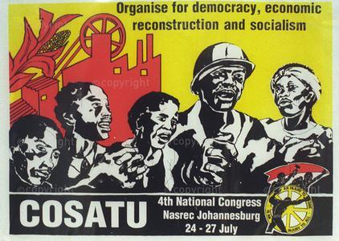
CHAPTER THREE Critique of ‘Church Theology’
We have analysed the statements that are made from time-to-time by the so-called ‘English-speaking’ Churches. We have looked at what Church leaders tend to say in their speeches and press statements about the apartheid regime and the present crisis. What we found running through all these pronouncements is a series of inter-related theological assumptions. These we have chosen to call ‘Church Theology.’ We are well aware of the fact that this theology does not express the faith of the majority of Christians in South Africa today who form the greater part of most of our Churches. Nevertheless the opinions expressed by Church leaders are regarded in the media and generally in our society as the official opinions of the Churches. We have therefore chosen to call these opinions ‘Church Theology.’ The crisis in which we find ourselves today compels us to question this theology, to question its assumptions, its implications and its practicality.

In a limited, guarded and cautious way this theology is critical of apartheid. Its criticism, however, is superficial and counter-productive because instead of engaging in an in-depth analysis of the signs of our times, it relies upon a few stock ideas derived from Christian tradition and then uncritically and repeatedly applies them to our situation. The stock ideas used by almost all these Church leaders that we would like to examine here are: reconciliation (or peace), justice and non-violence.

3.1 Reconciliation
There can be no doubt that our Christian faith commits us to work for true reconciliation and genuine peace. But as so many people, including Christians, have pointed out there can be no true reconciliation and no genuine peace without justice. Any form of peace or reconciliation that allows the sin of injustice and oppression to continue is a false peace and counterfeit reconciliation. This kind of “reconciliation” has nothing whatsoever to do with the Christian faith.

“Church Theology” is not always clear on this matter and many Christians have been lead to believe that what we need in South Africa is not justice but reconciliation and peace. The argument goes something like this: “We must be fair. We must listen to both sides of the story. If the two sides can only meet to talk and negotiate they will sort out their differences and misunderstandings, and the conflict will be resolved.” On the face of it this may sound very Christian. But is it?

The fallacy here is that ‘Reconciliation’ has been made into an absolute principle that must be applied in all cases of conflict or dissension. But not all cases of conflict are the same. We can imagine a private quarrel between two people or two groups whose differences are based upon misunderstandings. In such cases it would be appropriate to talk and negotiate to sort out the misunderstandings and to reconcile the two sides. But there are other conflicts in which one side is right and the other wrong. There are conflicts where one side is a fully armed and violent oppressor while the other side is defenseless and oppressed. There are conflicts that can only be described as the struggle between justice and injustice, good and evil, God and the devil. To speak of reconciling these two is not only a mistaken application of the Christian idea of reconciliation, it is a total betrayal of all that Christian faith has ever meant. Nowhere in the Bible or in Christian tradition has it ever been suggested that we ought to try to reconcile good and evil, God and the devil. We are supposed to do away with evil, injustice, oppression and sin–not come to terms with it. We are supposed to oppose, confront and reject the devil and not try to sup with the devil.

In our situation in South Africa today it would be totally unChristian to plead for reconciliation and peace before the present injustices have been removed. Any such plea plays into the hands of the oppressor by trying to persuade those of us who are oppressed to accept our oppression and to become reconciled to the intolerable crimes that are committed against us. That is not Christian reconciliation, it is sin. It is asking us to become accomplices in our own oppression, to become servants of the devil. No reconciliation is possible in South Africa without justice, without the total dismantling of apartheid.

What this means in practice is that no reconciliation, no forgiveness and no negotiations are possible without repentance. The Biblical teaching on reconciliation and forgiveness makes it quite clear that nobody can be forgiven and reconciled with God unless he or she repents of their sins. Nor are we expected to forgive the unrepentant sinner. When he or she repents we must be willing to forgive seventy times seven times but before that, we are expected to preach repentance to those who sin against us or against anyone. Reconciliation, forgiveness and negotiations will become our Christian duty in South Africa only when the apartheid regime shows signs of genuine repentance. The recent State of Emergency, the continued military repression of the people in the townships and the jailing of all its opponents is clear proof of the total lack of repentance on the part of the present regime.

There is nothing that we want more than true reconciliation and genuine peace–the peace that God wants and not the peace the world wants (Jn 14:27). The peace that God wants is based upon truth, repentance, justice and love. The peace that the world offers us is a unity that compromises the truth, covers over injustice and oppression and is totally motivated by selfishness. At this stage, like Jesus, we must expose this false peace, confront our oppressors and sow dissension. As Christians we must say with Jesus: “Do you suppose that I am here to bring peace on earth. No, I tell you, but rather dissension” (Lk 12:51). There can be no real peace without justice and repentance.

It would be quite wrong to try to preserve ‘peace’ and ‘unity’ at all costs, even at the cost of truth and justice and, worse still, at the cost of thousands of young lives. As disciples of Jesus we should rather promote truth and justice and life at all costs, even at the cost of creating conflict, disunity and dissension along the way. To be truly biblical our Church leaders must adopt a theology that millions of Christians have already adopted-a biblical theology of direct confrontation with the forces of evil, rather than a theology of reconciliation with sin and the devil.

3.2 Justice
It would be quite wrong to give the impression that ‘Church Theology’ in South Africa is not particularly concerned about the need for justice. There have been some very strong and very sincere demands for justice. But the question we need to ask here, the very serious theological question is: What kind of justice? An examination of Church statements and pronouncements gives the distinct impression that the justice that is envisaged is the justice of reform, that is to say, a justice that is determined by the oppressor, by the white minority and that is offered to the people as a kind of concession. It does not appear to be the more radical justice that comes from below and is determined by the people of South Africa.

One of our main reasons for drawing this conclusion is the simple fact that almost all Church statements and appeals are made to the State or to the white community. The assumption seems to be that changes must come from whites or at least from people who are at the top of the pile. The general idea appears to be that one must simply appeal to the conscience and the goodwill of those who are responsible for injustice in our land and that once they have repented of their sins and after some consultation with others they will introduce the necessary reforms to the system. Why else would Church leaders be having talks with PW Botha , if this is not the vision of a just and peaceful solution to our problems?

At the heart of this approach is the reliance upon ‘individual conversions’ in response to ‘moralizing demands’ to change the structures of a society. It has not worked and it never will work. The present crisis with all its cruelty, brutality and callousness is ample proof of the ineffectiveness of years and years of Christian ‘moralizing’ about the need for love. The problem that we are dealing with here in South Africa is not merely a problem of personal guilt, it is a problem of structural injustice. People are suffering, people are being maimed and killed and tortured every day. We cannot just sit back and wait for the oppressor to see the light so that the oppressed can put out their hands and beg for the crumbs of some small reforms. That in itself would be degrading and oppressive.

There have been reforms and, no doubt, there will be further reforms in the near future. And it may well be that the Church’s appeal to the consciences of whites has contributed marginally to the introduction of some of these reforms. But can such reforms ever be regarded as real change, as the introduction of a true and lasting justice. Reforms that come from the top are never satisfactory. They seldom do more than make the oppression more effective and more acceptable. If the oppressor does ever introduce reforms that might lead to real change this will come about because of strong pressure from those who are oppressed. True justice, God’s justice, demands a radical change of structures. This can only come from below, from the oppressed themselves. God will bring about change through the oppressed as he did through the oppressed Hebrew slaves in Egypt. God does not bring his justice through reforms introduced by the Pharaoh’s of this world.

Why then does ‘Church Theology’ appeal to the top rather than to the people who are suffering? Why does this theology not demand that the oppressed stand up for their rights and wage a struggle against their oppressors? Why does it not tell them that it is their duty to work for justice and to change the unjust structures? Perhaps the answer to these questions is that appeals from the ‘top’ in the Church tend very easily to be appeals to the ‘top’ in society. An appeal to the conscience of those who perpetuate the system of injustice must be made. But real change and true justice can only come from below, from the people–most of whom are Christians.

3.3 Non-Violence
The stance of ‘Church Theology’ on non-violence, expressed as a blanket condemnation of all that is called violence, has not only been unable to curb the violence of our situation, it has actually, although unwittingly, been a major contributing factor in the recent escalation of State violence. Here again non-violence has been made into an absolute principle that applies to anything anyone calls violence without regard for who is using it, which side they are on or what purpose they may have in mind. In our situation, this is simply counter-productive.

The problem for the Church here is the way the word violence is being used in the propaganda of the State. The State and the media have chosen to call violence what some people do in the townships as they struggle for their liberation i.e. throwing stones, burning cars and buildings and sometimes killing collaborators. But this excludes the structural, institutional and unrepentant violence of the State and especially the oppressive and naked violence of the police and the army. These things are not counted as violence. And even when they are acknowledged to be ‘excessive,’ they are called ‘misconduct’ or even ‘atrocities’ but never violence. Thus the phrase ‘violence in the townships’ comes to mean what the young people are doing and not what the police are doing or what apartheid in general is doing to people. If one calls for nonviolence in such circumstances one appears to be criticizing the resistance of the people while justifying or at least overlooking the violence of the police and the State. That is how it is understood not only by the State and its supporters but also by the people who are struggling for their freedom. Violence, especially in our circumstances, is a loaded word.

It is true that Church statements and pronouncements do also condemn the violence of the police. They do say that they condemn all violence. But is it legitimate, especially in our circumstances, to use the same word violence in a blanket condemnation to cover the ruthless and repressive activities of the State and the desperate attempts of the people to defend themselves? Do such abstractions and generalizations not confuse the issue? How can acts of oppression, injustice and domination be equated with acts of resistance and self-defense? Would it be legitimate to describe both the physical force used by a rapist and the physical force used by a woman trying to resist the rapist as violence?

Moreover there is nothing in the Bible or in our Christian tradition that would permit us to make such generalizations. Throughout the Bible the word violence is used to describe everything that is done by a wicked oppressor (e.g. Ps 72:12-14; Is 59:1-8; Jer 22:13-17; Amos 3:9-10; 6: 3; Mic 2:2; 3:1-3; 6:12). It is never used to describe the activities of Israel’s armies in attempting to liberate themselves or to resist aggression. When Jesus says that we should turn the other cheek he is telling us that we must not take revenge; he is not saying that we should never defend ourselves or others. There is a long and consistent Christian tradition about the use of physical force to defend oneself against aggressors and tyrants. In other words there are circumstances when physical force may be used. They are very restrictive circumstances, only as the very last resort and only as the lesser of two evils, or, as Bonhoeffer put it, “the lesser of two guilts.” But it is simply not true to say that every possible use of physical force is violence and that no matter what the circumstances may be it is never permissible.

This is not to say that any use of force at any time by people who are oppressed is permissible simply because they are struggling for their liberation. There have been cases of killing and maiming that no Christian would want to approve of. But then our disapproval is based upon a concern for genuine liberation and a conviction that such acts are unnecessary, counter-productive and unjustifiable and not because they fall under a blanket condemnation of any use of physical force in any circumstances.

And finally what makes the professed non-violence of ‘Church Theology’ extremely suspect in the eyes of very many people, including ourselves, is the tacit support that many-Church leaders give to the growing militarisation of the South African State. How can one condemn all violence and then appoint chaplains to a very violent an oppressive army? How can one condemn all violence and then allow young white males to accept their conscription into the armed forces? Is it because the activities of the armed forces and the police are counted as defensive? That raises very serious questions about whose side such Church leaders might be on. Why are the activities of young blacks in the townships not regarded as defensive?

The problem of the Church here is that it starts from the premise that the apartheid regime in South Africa is a legitimate authority. It ignores the fact that it is a white minority regime which has imposed itself upon the majority of the people, that is blacks, in this country and that it maintains itself by brutality and violent force and the fact that a majority of South Africans regard this regime as illegitimate.

In practice what one calls ‘violence’ and what one calls ‘self-defense’ seems to depend upon which side one is on. To call all physical force ‘violence’ is to try to be neutral and to refuse to make a judgment about who is right and who is wrong. The attempt to remain neutral in this kind of conflict is futile. Neutrality enables the status quo of oppression (and therefore violence) to continue. It is a way of giving tacit support to the oppressor, a support for brutal violence.

3.4 The Fundamental Problem
It is not enough to criticize ‘Church Theology’ we must also try to account for it. What is behind the mistakes and misunderstandings and inadequacies of this theology?

In the first place we can point to a lack of social analysis. We have seen how ‘Church Theology’ tends to make use of absolute principles like reconciliation, negotiation non-violence and peaceful solutions and applies them indiscriminately and uncritically to all situations. Very little attempt is made to analyze what is actually happening it our society and why it is happening. It is not possible to make valid moral judgment: about a society without first understanding that society. The analysis of apartheid that underpins ‘Church Theology’ is simply inadequate. The present crisis has now made it very clear that the efforts of Church leaders to promote effective and practical ways of changing our society have failed. This failure is due in no small measure to the fact that ‘Church Theology’ has not developed a social analysis that would enable it to understand the mechanics of injustice and oppression.

Closely linked to this, is the lack in ‘Church Theology’ of an adequate understanding of politics and political strategy. Changing the structures of a society is fundamentally a matter of politics. It requires a political strategy based upon a clear social or political analysis. The Church has to address itself to these strategies and to the analysis upon which they are based. It is into this political situation that the Church has to bring the gospel. Not as an alternative solution to our problems as if the gospel provided us with a non-political solution to political problems. There is no specifically Christian solution. There will be a Christian way of approaching the political solutions, a Christian spirit and motivation and attitude. But there is no way of bypassing politics and political strategies.

But we have still not pinpointed the fundamental problem. Why has ‘Church Theology’ not developed a social analysis? Why does it have an inadequate understanding of the need for political strategies? And why does it make a virtue of neutrality and sitting on the sidelines?

The answer must be sought in the type of faith and spirituality that has dominated Church life for centuries. As we all know, spirituality has tended to be an other-worldly affair that has very little, if anything at all, to do with the affairs of this world. Social and political matters were seen as worldly affairs that have nothing to do with the spiritual concerns of the Church. Moreover, spirituality has also been understood to be purely private and individualistic. Public affairs and social problems were thought to be beyond the sphere of spirituality. And finally the spirituality we inherit tends to rely upon God to intervene in his own good time to put right what is wrong in the world. That leaves very little for human beings to do except to pray for God’s intervention.

It is precisely this kind of spirituality that, when faced with the present crisis in South Africa, leaves so many Christians and Church leaders in a state of near paralysis.

It hardly needs saying that this kind of faith and this type of spirituality has no biblical foundation. The Bible does not separate the human person from the world in which he or she lives; it does not separate the individual from the social or one’s private life from one’s public life. God redeems the whole person as part of his whole creation (Rom 8:18-24). A truly biblical spirituality would penetrate into every ‘aspect of human existence and would exclude nothing from God’s redemptive will. Biblical faith is prophetically relevant to everything that happens in the world.
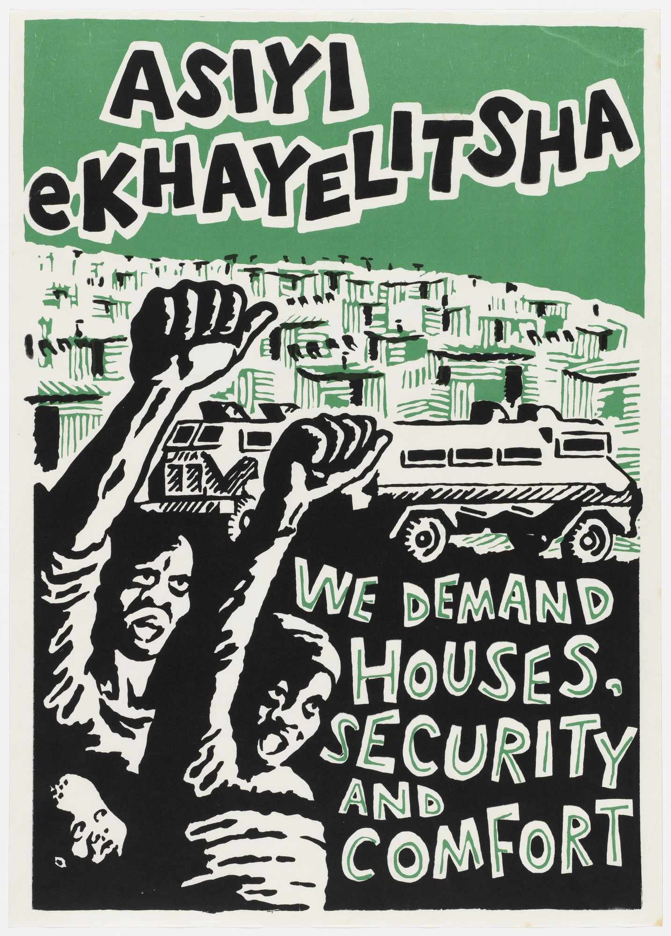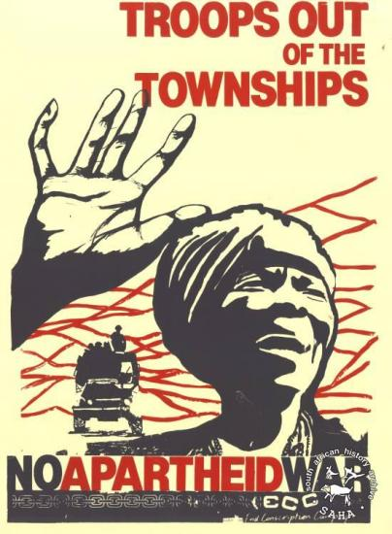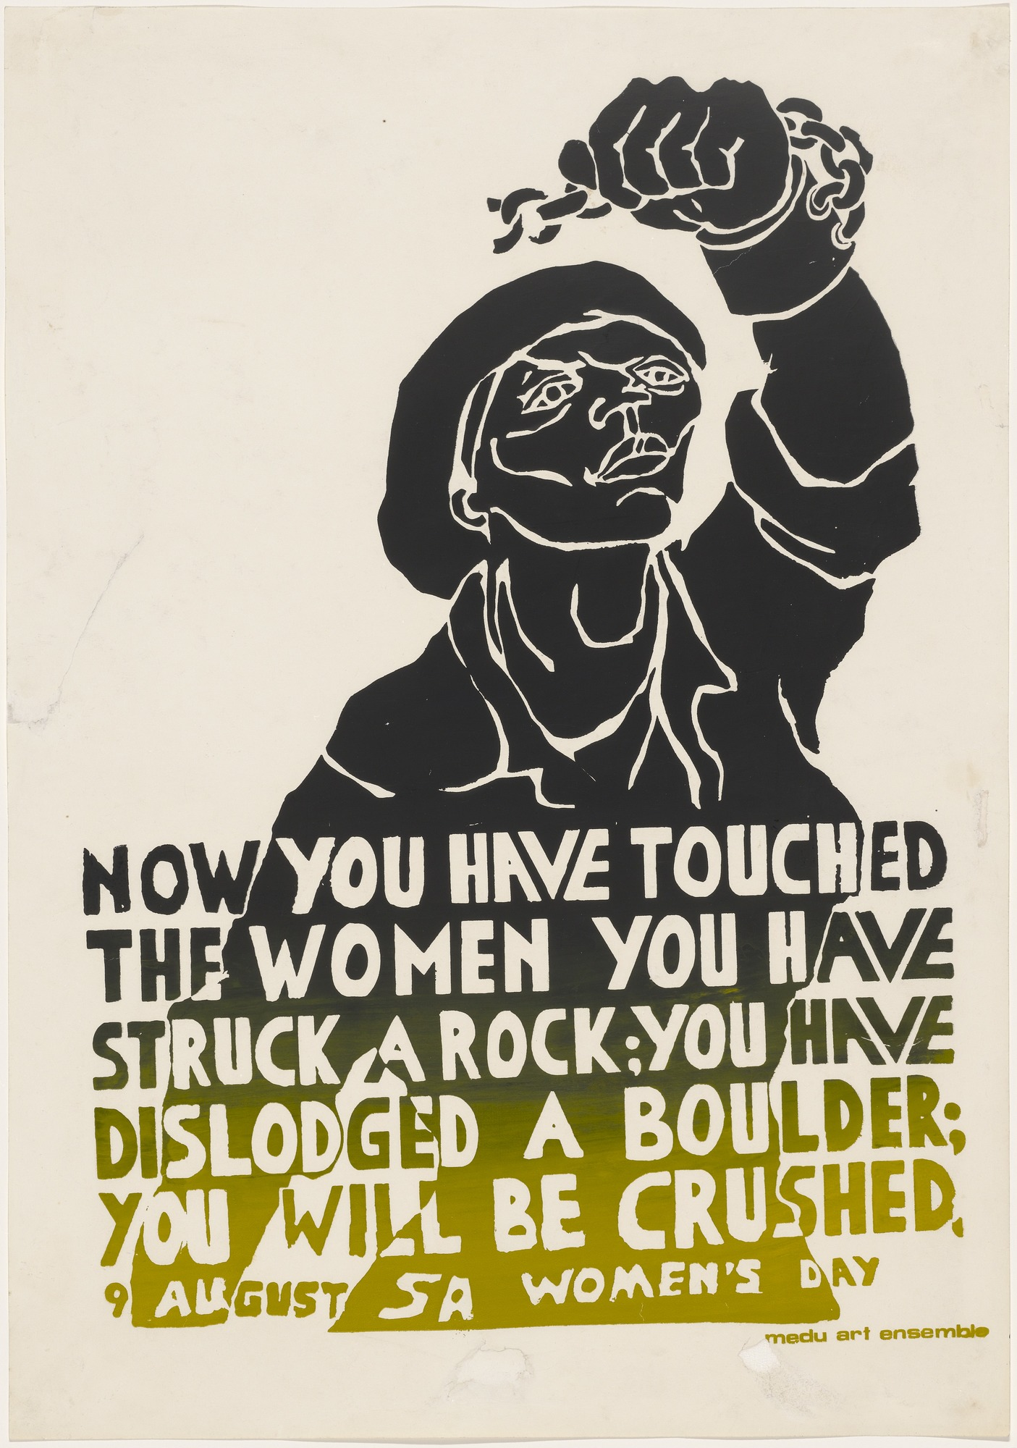
CHAPTER FOUR Towards a Prophetic Theology

Our present KAIROS calls for a response from Christians that is biblical, spiritual, pastoral and, above all, prophetic. What is it then that would make our response truly prophetic? What would be the characteristics of a prophetic theology?

4.1 Prophetic Theology
To be truly prophetic, our response would have to be, in the first place, solidly grounded in the Bible. Our KAIROS impels us to return to the Bible and to search the Word of God for a message that is relevant to what we are experiencing in South Africa today. This will be no mere academic exercise. Prophetic theology differs from academic theology because, whereas academic theology deals with all biblical themes in a systematic manner and formulates general Christian principles and doctrines, prophetic theology concentrates on those aspects of the Word of God that have an immediate bearing upon the critical situation in which we find ourselves. The theology of the prophets does not pretend to be comprehensive and complete, it speaks to the particular circumstances of a particular time and place – the KAIROS.

Consequently, a prophetic response and prophetic theology would include a reading of the signs of the times. This is what the great Biblical prophets did in their times and this is what Jesus tells us to do. When the Pharisees and Sadducees asked for a sign from heaven, he tells them to “read the signs of the times” (Mt 16.3) or to “interpret this KAIROS” (Lk 12.56). A prophetic theology must try to do this. It must know what is happening, analyse what is happening (social analysis) and then interpret what is happening in the light of the gospel. This means that the starting point for prophetic theology will be our experience of the present KAIROS, our experience of oppression and tyranny, our experience of conflict, crisis and struggle, our experience of trying to be Christians in this situation. It is with this in mind that we must begin to search the scriptures.

Another thing that makes prophetic theology different is that it is always a call to action. The prophets do not have a purely theoretical or academic interest in God and in the signs of the times. They call for repentance, conversion and change. They are critical, severely critical, of the status quo; they issue warnings about God’s punishment and in the name of God, they promise great blessings for those who do change. Jesus did the same. “Repent”, he says “the KAIROS hso come and the Kingdom of God is close at hand”.

Thus prophecy is always confrontational. It confronts the evils of the times and speaks out against them in no uncertain terms. Prophetic theology is not afraid to take a stand, clearly and unambiguously. Prophetic statements are stark and simple without being hedged in with qualifications or possible exceptions. They deal with good and evil, justice and injustice, God and the devil. It is not surprising then that any theology that is truly prophetic will be controversial and in some circles it will be very unpopular. The prophets were persecuted and Jesus was crucified.

Nevertheless, prophetic theology will place a great deal of emphasis upon hope. Despite all the criticisms, condemnations and warnings of doom, prophecy always has a message of hope for the future. After death comes resurrection. That is the prophetic good news.

A genuinely prophetic theology will also be deeply spiritual. All its words and actions will have to be infused with a spirit of fearlessness and courage, a spirit of love and understanding, a spirit of joy and hope, a spirit of strength and determination. A prophetic theology would have to have in it the mind of Christ, his willingness to suffer and to die, his humility and his power, his willingness to forgive and his anger about sin, his spirit of prayer and of action.

Last but not least prophetic theology should be thoroughly practical and pastoral. It will denounce sin and announce salvation. But to be prophetic our theology must name the sins and the evils that surround us and the salvation that we are hoping for. Prophecy must name the sins of apartheid, injustice, oppression and tyranny in South Africa today as ‘an offence against God’ and the measures that must be taken to overcome these sins and the suffering that they cause. On the other hand prophecy will announce the hopeful good news of future liberation, justice and peace, as God’s will and promise, naming the ways of bringing this about and encouraging people to take action.

4.2 Suffering and Oppression in the Bible
Black Theology, African Theology and the theology of the African Independent Churches have already laid great emphasis upon the biblical teaching about suffering especially the suffering of Jesus Christ. When we read the Bible from the point of view of our daily experience of suffering and oppression, then what stand out for us is the many, many vivid and concrete descriptions of suffering and oppression throughout the Bible culminating in the cross of Jesus Christ.

For most of their history from Exodus to Revelations, the people of the Bible suffered under one kind of oppression or another: “The sons of Israel are oppressed” (Jer 50.33); “You will be exploited and crushed continually” (Dt 28.33). They were oppressed by the tyrannical, imperial nations around them. First it was the Egyptians: “The Egyptians ill-treated us, they gave us no peace and inflicted harsh slavery upon us” (Dt 26.6). Then the various Canaanite kings oppressed them, for example Jabin the Canaanite king of Hasor “cruelly oppressed the Israelites for twenty years” (Jud 4:3). And so it carried on with the Philistines, the Assyrians, the Babylonians, the Greeks and the Romans, each in turn exercising an oppressive domination over this small nation.

But this was not all. The people of Israel were also for many centuries oppressed internally, within their own country, by the rich and the powerful and especially by the kings or rulers of Israel who were for the most part typical oriental tyrants. “Here we are now, enslaved; here in the land you gave our Fathers, we are slaves. Its rich fruits swell the profit of the kings who dispose as they please of our bodies and our cattle” (Neh 9.36-37). For the people of South Africa this situation is all too familiar.

The experience of oppression is vividly described in the Bible. First of all it is described as the painful experience of being crushed to the ground: “Yahweh, they crush your people” (Ps 94.5); “We are bowed in the dust, our bodies crushed to the ground” (Ps 44.25). It is the experience of being weighed down by heavy loads (Ex 1.11; Mt 11.28). But it is more than just an experience of being degraded and humiliated. They lived with the terrifying reality of killings and murders. “We are being massacred daily” (Ps 44.22). “Yahweh, they oppress your hereditary people, murdering and massacring widows, orphans and migrants” (Ps 94.5-6). What grief and torment this causes. “My bones are in torment, my soul is in utter torment. I am worn out with groaning , every night I drench my pillow and soak my bed with tears, my eye is wasted with grief; I have grown old with enemies all round me” (Ps 6.3, 6-10).

Their oppressors were their enemies. The people of Israel were in no doubt about that. There seemed to be no limit to the wickedness and sinfulness of these enemies: greed, arrogance, violence and barbaric cruelty. “My enemies cluster round me, breathing hostility, entrenched in their fat, their mouths utter arrogant claims; now they are closing in. They look like lions eager to tear to pieces” (Ps 17.9-12). “They (the rulers of Israel) have devoured the flesh of my people and torn off their skin and crushed their bones and shredded them like meat” (Micah 3.3).

Only people who had actually experienced oppression could have written such vivid and graphic descriptions of what it means to be oppressed. In South Africa today, in this our KAIROS, more than ever before the people of the townships can identify fully with these descriptions of suffering, oppression and tyranny.

Nor should we think that this concern about oppression is confined to the Old Testament. In the time of Jesus the Jews were oppressed by the Romans, the great imperial superpower of those days. But what was far more immediate and far more pressing what the internal oppression of the poor and the ordinary people by the Herods, the rich, the chief priests and the elders, the Sadducees and the Pharisees. These were the groups who were experienced more immediately as oppressors. In one way or another they were puppets of the Romans and to a greater or lesser extent they collaborated in the oppression of the poor. Jesus called Herod “that fox” (Lk 13.32). He pronounces “woes” upon the rich (Lk 6.24-26), he calls the Pharisees hypocrites, whited sepulchres and a brood of vipers who lay heavy burdens on the shoulders of the people and never lift a finger to relieve them (Mt 23 passim). It was the chief priests and the elders who handed Jesus over to the Romans.

Throughout his life Jesus associated himself with the poor and the oppressed and as the suffering (or oppressed) servant of Yahweh he suffered and died for us. “Ours were the sufferings he bore, ours the sorrows he carried” (Is 53.4). He continues to do so, even today.

4.3 Social Analysis
It is in the light of the Biblical teaching about suffering, oppression and tyranny that our prophetic theology must begin to analyse our KAIROS and read the signs of our times. Although it will not be possible to attempt a detailed social analysis or a complete reading of the signs of our times in this document, we must start with at least the broad outlines of an analysis of the conflict in which we find ourselves.

It would be quite wrong to see the present conflict as simply a racial war. The racial component is there but are not dealing with two equal races or nations each with their own selfish group interests. The situation we are dealing with here is one of tyranny and oppression. we can therefore use the social categories that the Bible makes use of, namely, the oppressor and the oppressed.

What we are dealing with here, in the Bible or in South Africa today, is a social structure. The oppressors are the people who knowingly or unknowingly represent a sinful cause and unjust interests. The oppressed are people who knowingly or unknowingly represent the opposite cause and interests, the cause of justice and freedom. Structurally in our society these two causes are in conflict. The individuals involved may or may not realise this but the structural oppression that in South Africa is called apartheid will sooner or later bring the people involved into conflict.

On the one hand we have the interests of those who benefit from status quo and who are determined to maintain it at any cost, even at the cost of millions of lives. It is in their interests to introduce a number of reforms in order to ensure that the system is not radically changed and that they can continue to benefit from it as they have done in the past. They benefit from the system because it favours them and enables them to accumulate a great deal of wealth and to maintain an exceptionally high standard of living. and the want to make sure that it stays that way even if some adjustments are needed.

On the other hand we have those who do not benefit in any way from the system the way it is now. They are treated as mere labour units, paid starvation wages, separated from their families by migratory labour, moved about like cattle and dumped in homelands to starve – and all for the benefit of a privileged minority. They have no say in the system and are supposed to be grateful for the concessions that are offered to them like crumbs. It is not in their interests to allow this system to continue even in some ‘reformed’ or ‘revised’ form. They are no longer prepared to be crushed, oppressed and exploited. They are determined to change the system radically so that it no longer benefits only the privileged few. And the are willing to do this even at the cost of their own lives. What they want is justice for all irrespective of race, colour, sex or status.

Each of the two sides can be further subdivided according to the different opinions people or groups have about the means and strategies to be used to maintain the system or the means and strategies to be used to change it. An almost infinite variety of opinion is possible here and much debate and discussion is needed, as long as one does not lose sight of the fundamental structural division between efforts to continue oppression even in a mitigated or changed form and efforts to do away with oppression in principle and in every form. There are two conflicting projects here and no compromise is possible. Either we have full and equal justice for all or we don’t.

Prophetic theology therefore faces us with the fundamental choice that admits of no compromises. Jesus did the same. He faced the people with the fundamental choice between God and money. “You cannot serve two masters” (Mt 6.24). Once we have made our choice, once we have taken sides then we can begin to discuss the morality and effectiveness of means and strategies. It is therefore not primarily a matter of trying to reconcile individual people but a matter of trying to change unjust structures so that people will not be pitted against one another as oppressor and oppressed.

This is our KAIROS. The structural inequality (political, social and economic) expressed in discriminatory laws, institutions and practices has led the people of South Africa into a virtual civil war and rebellion against tyranny.

4.4 Tyranny
According to our Christian tradition, based upon what we have already seen in the Bible, once it is established beyond doubt that a particular ruler is a tyrant of that a particular regime is tyrannical, it forfeits the moral right to govern and the people acquire the right to resist and to find the means to protect their own interests against injustice and oppression. In other words a tyrannical regime has no moral legitimacy. It may be the de facto government and it may even be recognized by other governments and therefore be the de iure or legal government. But if it is a tyrannical regime, it is, from a moral and theological point of view, illegitimate.

There are indeed some differences of opinion in the Christian tradition about the means that might be used to replace a tyrant but there has not been any doubt about our Christian duty to refuse to co-operate with tyranny and to do whatever we can to remove it.

Of course everything hinges on the definition of a tyrant. At what point does a government become a tyrannical regime?

The traditional Latin definition of a tyrant is hostis boni communis – an enemy of the common good. The purpose of all government is the promotion of what is called the common good of the people governed. To promote the common good is to govern in the interests of, and for the benefit of, all the people. Many governments fail to do this at times. There might be this or that injustice done to some of the people. And such lapses would indeed have to be criticized. But occasional acts of injustice would not make a government into an enemy of the people, a tyrant.

To be an enemy of the people a government would have to be hostile to the common good in principle. Such a government would be acting against the interests of the people as a whole and permanently. This would be clearest in cases where the very policy of a government is hostile towards the common good and where the government has a mandate to rule in the interests of some of the people rather than in the interests of all the people. Such a government would be in principle irreformable. Any reform that it might try to introduce would not be calculated to serve the common good but to serve the interests of the minority from whom it received its mandate.

A tyrannical regime cannot continue to rule for very long without becoming more and more violent. As the majority of the people begin to demand their rights and to put pressure on the tyrant, so will the tyrant resort more and more to desperate, cruel, gross and ruthless forms of tyranny and repression. The reign of a tyrant always ends up as a reign of terror. It is inevitable because from the start the tyrant is an enemy of the common good.

That leaves us with the question of whether the present government of South Africa is tyrannical or not? There can be no doubt what the majority of the people of South Africa think. For them the apartheid regime is indeed the enemy of the people and that is precisely what they call it: the enemy. In the present crisis, more than before, the regime has lost any legitimacy that it might have had in the eyes of the people. Are the people right or wrong?

Apartheid is a system whereby a minority regime elected by one small section of the population is given an explicit mandate to govern in the interests of, and for the benefit of, the white community. Such a mandate or policy is by definition hostile to the common good of all the people. In fact because it tries to rule in the exclusive interests of whites and not in the interests of all, it ends up ruling in a way that is not even in the interests of those whites. It becomes an enemy of all the people, a tyrant. A totalitarian regime. A reign of terror.

This also means that the apartheid minority regime is irreformable. We cannot expect the apartheid regime to experience a conversion or change of heart and totally abandon the policy of apartheid. It has no mandate from its electorate to do so. Any reforms or adjustments it might make would have to be done in the interests of who elected it. Individual members of the government could experience a real conversion and repent but, if they did, they would simply have to follow this through by leaving a regime that was elected and put into power precisely because of its policy of apartheid.

And that is why we have reached the present impasse. As the oppressed majority becomes more insistent and puts more and more pressure on the tyrant by means of boycotts, strikes, uprisings, burnings and even armed struggle, the more tyrannical will regime become. On the one hand it will use repressive measures: detentions, trials, killings, torture, bannings, propaganda, states of emergency and other desperate and tyrannical methods. And on the other hand it will introduce reforms that will always be unacceptable to the majority because all its reforms must ensure that the minority remains on top.

A regime that is in principle the enemy of the people cannot suddenly begin to rule in the interests of all the people. It can only be replaced by another government–one that has been elected by the majority of the people with an explicit mandate to govern in the interests of all the people.

A regime that has made itself the enemy of the people has thereby also made itself the enemy of God. People are made in the image and likeness of God and whatever to the least of them we do to God (Mt 25:49, 45).

To say that the State or the regime is the enemy of God is not to say that all those who support the system are aware of this. On the whole they simply do not know what they are doing. Many people have been blinded by the regime’s propaganda. They are frequently quite ignorant of the consequences of their stance. However, such blindness does not make the State any less tyrannical or any less of an enemy of the people and an enemy of God.

On the other hand the fact that the State is tyrannical and an enemy of God is no excuse for hatred. As Christians we are called upon to love our enemies (Mt 5:44). It is not said that we should not or will not have enemies or that we should not identify tyrannical regimes as indeed our enemies. But once we have identified our enemies, we must endeavor to love them. That is not always easy. But then we must also remember that the most loving thing we can do for both the oppressed and for our enemies who are oppressors is to eliminate the oppression, remove the tyrants from power and establish a just government for the common good of all the people .

4.5 Liberation and Hope in the Bible
The Bible, of course, does not only describe oppression, tyranny and suffering. The message of the Bible is that oppression is sinful and wicked, an offence against God. The oppressors are godless sinners and the oppressed are suffering because of the sins of their oppressors. But there is hope because Yahweh, the God of the Bible, will liberate the oppressed from their suffering and misery. “He will redeem their lives from exploitation and outrage” (Ps 74.14). “I have seen the miserable state of my people in Egypt. I have heard their appeal to be free of their slave-drivers. I mean to deliver them out of the hands of the Egyptians” (Ex 3.7).

Throughout the Bible God appears as the liberator of the oppressed: “For the plundered poor, for the needy who groan, now I will act, says Yahweh” (Ps 12.5). God is not neutral. He does not attempt to reconcile Moses and Pharaoh, to reconcile the Hebrew slaves with their Egyptian oppressors or to reconcile the Jewish people with any of their later oppressors. “You have upheld the justice of my cause… judging in favour of the orphans and exploited so that earthborn man (human beings) may strike fear no more. My enemies are in retreat, stumbling, perishing as you confront them. Trouble is coming to the rebellious, the defiled, the tyrannical city” (Ps 9.4; 10.18; 9.3; Zeph 3.1). Oppression is a crime and it cannot be compromised with, it must be done away with. “They (the rulers of Israel) will cry out to God. but he will not answer them. He will hide his face at that time because of all the crimes they have committed” (Micah 3.4). “God, who does what is right, is always on the side of the oppressed” (Ps 103.6).

There can be no doubt that Jesus, the Son of God, also takes up the cause of the poor and the oppressed and identifies himself with their interests. When he stood up in the synagogue at Nazareth to announce his mission, he made use of the words of Isaiah.

The Spirit of the Lord has been given to me,
For he has anointed me,
He has sent me to bring the good news to the poor,
to proclaim liberty to captives
and to the blind new sight,
to set the downtrodden free
to proclaim the Lord’s year of favour (Lk 4.18-19)

Not that Jesus is unconcerned about the rich and the oppressors. These he calls to repentance. At the very heart of the gospel of Jesus Christ and at the very centre of all true prophecy is a message of hope. Jesus has taught us to speak of this hope as the coming of God’s kingdom. We believe that God is at work in our world turning hopeless and evil situations to good so that God’s Kingdom may come and God’s Will may be done on earth as it is in heaven. We believe that goodness and justice a love will triumph in the end and that tyranny and oppression cannot last forever. One day “all tears will be wiped away” (Rev 7.17; 12.4) and “the lamb will lie down with the lion” (Is 11.6). True peace and true reconciliation are not only desirable, they are assured and guaranteed. This is our faith and our hope. we believe in and hope for the resurrection.

4.6 A Message of Hope
Nothing could be more relevant and more necessary at this moment of crisis in South Africa than the Christian message of hope. As the crisis deepens day-by-day, what both the oppressor and the oppressed can legitimately demand of the Churches is a message of hope. Most of the oppressed people in South Africa today and especially the youth do have hope. They are acting courageously and fearlessly because they have a sure hope that liberation will come. Often enough their bodies are broken but nothing can now break their spirit. But hope needs to be confirmed. Hope needs to be maintained and strengthened. Hope needs to be spread. The people need to hear it said again and again that God is with them and that “the hope of the poor is never brought to nothing” (Ps 9.18).

On the other hand the oppressor and those who believe the propaganda of the oppressor are desperately fearful. They must be made aware of the diabolical evils of the present system and they must be called to repentance. “By what right do you crush my people and grind the face of the poor” (Is 3.15). But they must also be given something to hope for. At present they have false hopes. They hope to maintain the status quo and their special privileges with perhaps some adjustments and they fear any real alternative. But there is much more than that to hope for and nothing to fear. Can the Christian message of hope not help them in this matter?

A prophetic theology for our times will focus our attention on the future. What kind of future do the oppressed people of South Africa want? What kind of future does God want? And how, with God’s help are we going to secure that future for ourselves? We must begin to plan the future now but above all we must heed God’s call to action to secure God future for ourselves in South Africa.

There is hope. There is hope for all of us. But the road to that hope is going to be ver hard and very painful. The conflict and the struggle will have to intensify in the months and years ahead because there is no other way to remove the injustice and oppression. But God is with us. We can only learn to become the instruments of his peace even unto death. We must participate in the cross of Christ if we are to have the hope of participating in his resurrection.

Why is it that this powerful message of hope has not been highlighted in ‘Church Theology’, in the statements and pronouncements of church leaders? Is it because they have been addressing themselves to the oppressor rather than the oppressed? Is it because they do not want to encourage the oppressed to be too hopeful for too much?

Now is the time to act – to act hopefully, to act with full confidence and trust in God.

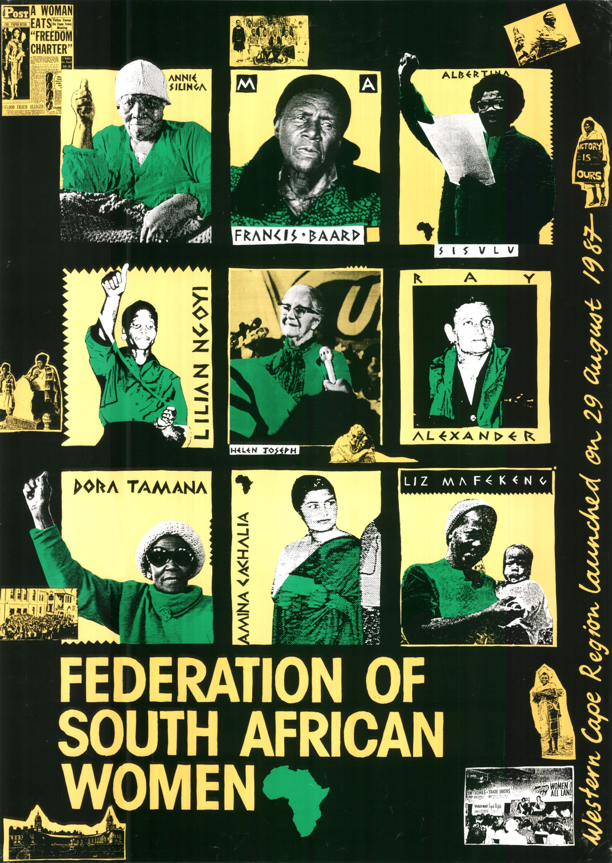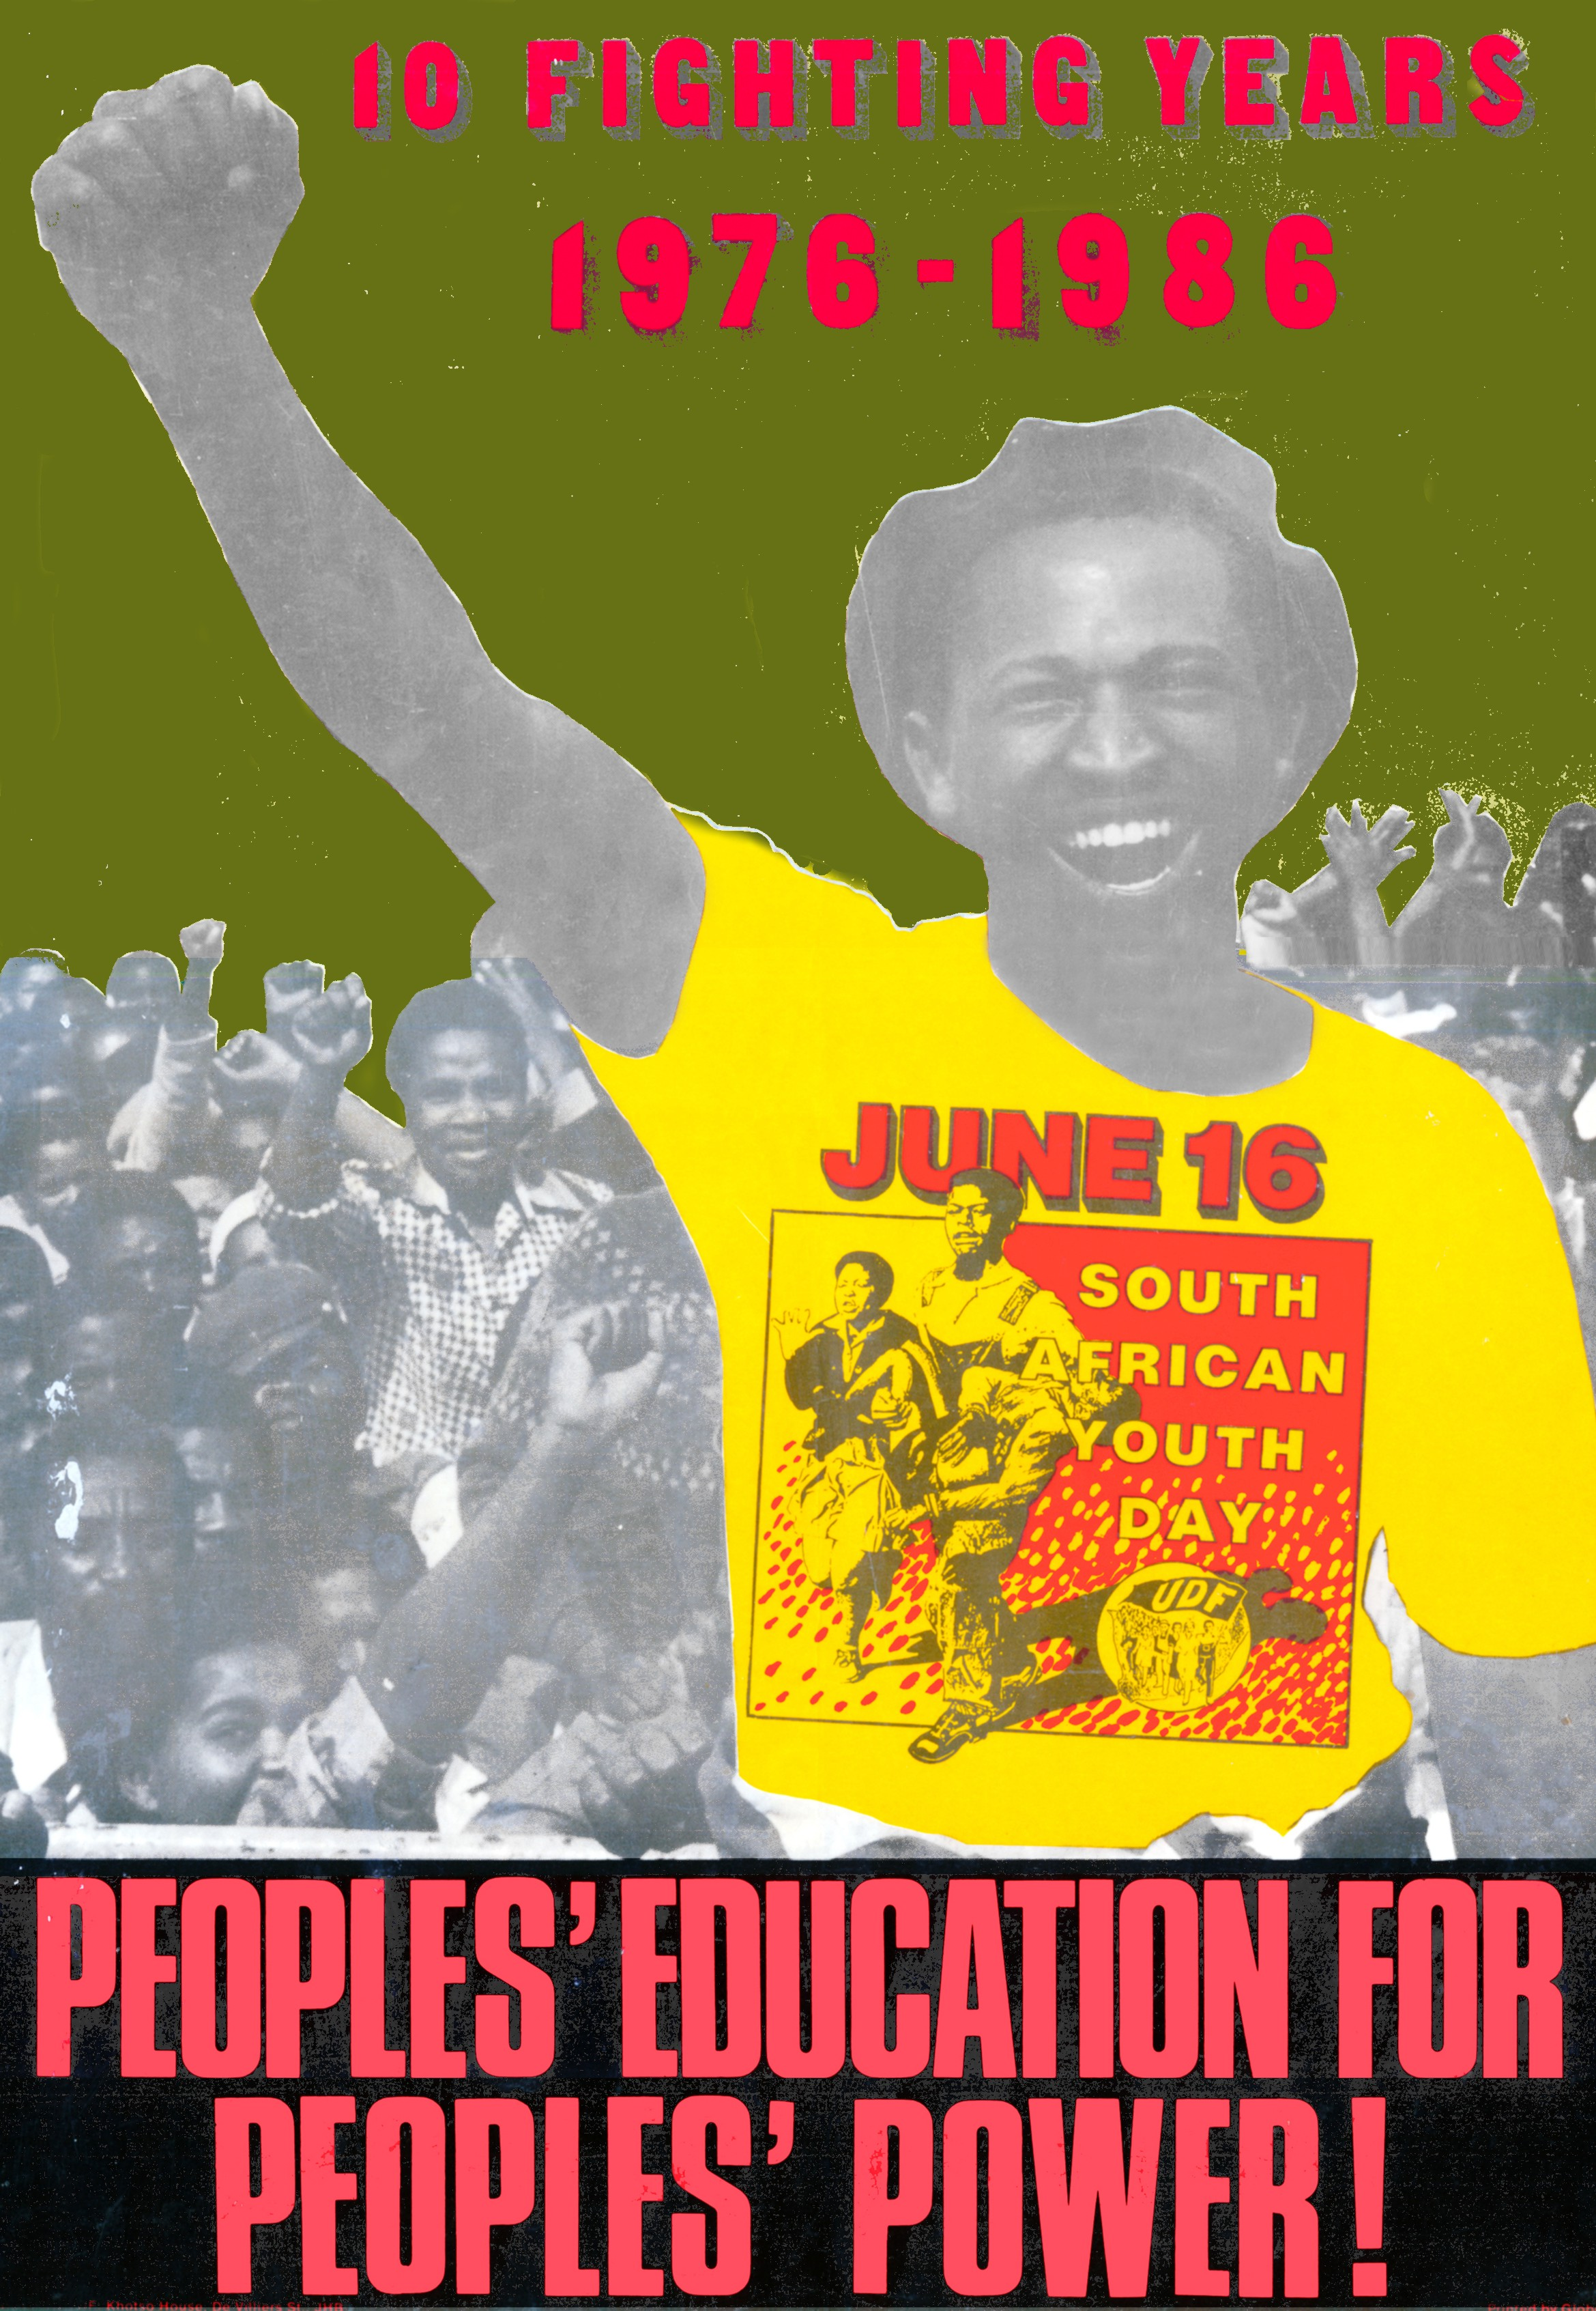
CHAPTER FIVE Challenge to Action

5.1 God Sides with the Oppressed
To say that the Church must now take sides unequivocally and consistently with the poor and the oppressed is to overlook the fact that the majority of Christians in South Africa have already done so. By far the greater part of the Church in South Africa is poor and oppressed. Of course it cannot be taken for granted that everyone who is oppressed has taken up their own cause and is struggling for their own liberation. Nor can it be assumed that all oppressed Christians are fully aware of the fact that their cause is God’s cause. Nevertheless it remains true that the Church is already on the side of the oppressed because that is where the majority of its members are to be found. This fact needs to be appropriated and confirmed by the Church as a whole.

At the beginning of this document it was pointed out that the present crisis has highlighted the divisions in the Church. We are a divided Church precisely because not all the members of our Churches have taken sides against oppression. In other words not all Christians have united themselves with God “who is always on the side of the oppressed” (Ps 103:6). As far as the present crisis is concerned, there is only one way forward to Church unity and that is for those Christians who find themselves on the side of the oppressor or sitting on the fence, to cross over to the other side to be united in faith and action with those who are oppressed. Unity and reconciliation within the Church itself is only possible around God and Jesus Christ who are to be found on the side of the poor and the oppressed.

If this is what the Church must become, if this is what the Church as a whole must have as its project, how then are we to translate it into concrete and effective action?

5.2 Participation in the Struggle
Christians, if they are not doing so already, must quite simply participate in the struggle for liberation and for a just society. The campaigns of the people, from consumer boycotts to stayaways, need to be supported and encouraged by the Church. Criticism will sometimes be necessary but encouragement and support will also be necessary. In other words the present crisis challenges the whole Church to move beyond a mere ‘ambulance ministry’ to a ministry of involvement and participation.

5.3 Transforming Church Activities
The Church has its own specific activities: Sunday services, communion services, baptisms, Sunday school, funerals and so forth. It also has its specific way of expressing its faith and its commitment i.e. in the form of confessions of faith. All of these activities must be re-shaped to be more fully consistent with a prophetic faith related to the KAIROS that God is offering us today. The evil forces we speak of in baptism must be named. We know what these evil forces are in South Africa today. The unity and sharing we profess in our communion services or Masses must be named. It is the solidarity of the people inviting all to join in the struggle for God’s peace in South Africa. The repentance we preach must be named. It is repentance for our share of the guilt for the suffering and oppression in our country.

Much of what we do in our Church services has lost its relevance to the poor and the oppressed. Our services and sacraments have been appropriated to serve the need of the individual for comfort and security. Now these same Church activities must be reappropriated to serve the real religious needs of all the people and to further the liberating mission of God and the Church in the world.

5.4 Special Campaigns
Over and above its regular activities the Church would need to have special programmes, projects and campaigns because of the special needs of the struggle for liberation in South Africa today. But there is a very important caution here. The Church must avoid becoming a ‘Third Force,’ a force between the oppressor and the oppressed. The Church’s programmes and campaigns must not duplicate what the people’s organizations are already doing and, even more seriously, the Church must not confuse the issue by having programmes that run counter to the struggles of those political organizations that truly represent the grievances and demands of the people Consultation, co-ordination and co-operation will be needed. We all have the same goals even when we differ about the final significance of what we are struggling for.

5.5 Civil Disobedience
Once it is established that the present regime has no moral legitimacy and is in fact a tyrannical regime, certain things follow for the Church and its activities. In the first place the Church cannot collaborate with tyranny. It cannot or should not do any thing that appears to give legitimacy to a morally illegitimate regime. Secondly, that Church should not only pray for a change of government, it should also mobilize it members in every parish to begin to think and work and plan for a change of government in South Africa. We must begin to look ahead and begin working now with firm hope and faith for a better future. And finally the moral illegitimacy of the apartheid regime means that the Church will have to be involved at times in civil disobedience. A Church that takes its responsibilities seriously in these circumstances will sometimes have to confront and to disobey the State in order to obey God.

5.6 Moral Guidance
The people look to the Church, especially in the midst of our present crisis, for moral guidance. In order to provide this the Church must first make its stand absolutely clear and never tire of explaining and dialoguing about it. It must then help people to understand their rights and their duties. There must be no misunderstanding about the moral duty of all who are oppressed to resist oppression and to struggle for liberation and justice. The Church will also find that at times it does need to curb excesses and to appeal to the consciences of those who act thoughtlessly and wildly.

But the Church of Jesus Christ is not called to be a bastion of caution and moderation. The Church should challenge, inspire and motivate people. It has a message of the cross that inspires us to make sacrifices for justice and liberation. It has a message of hope that challenges us to wake up and to act with hope and confidence. The Church must preach this message not only in words and sermons and statements but also through its actions, programmes, campaigns and divine services.

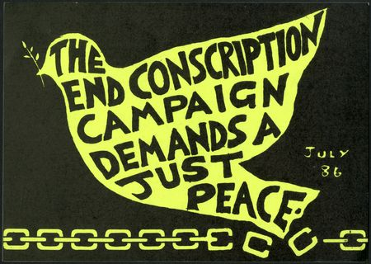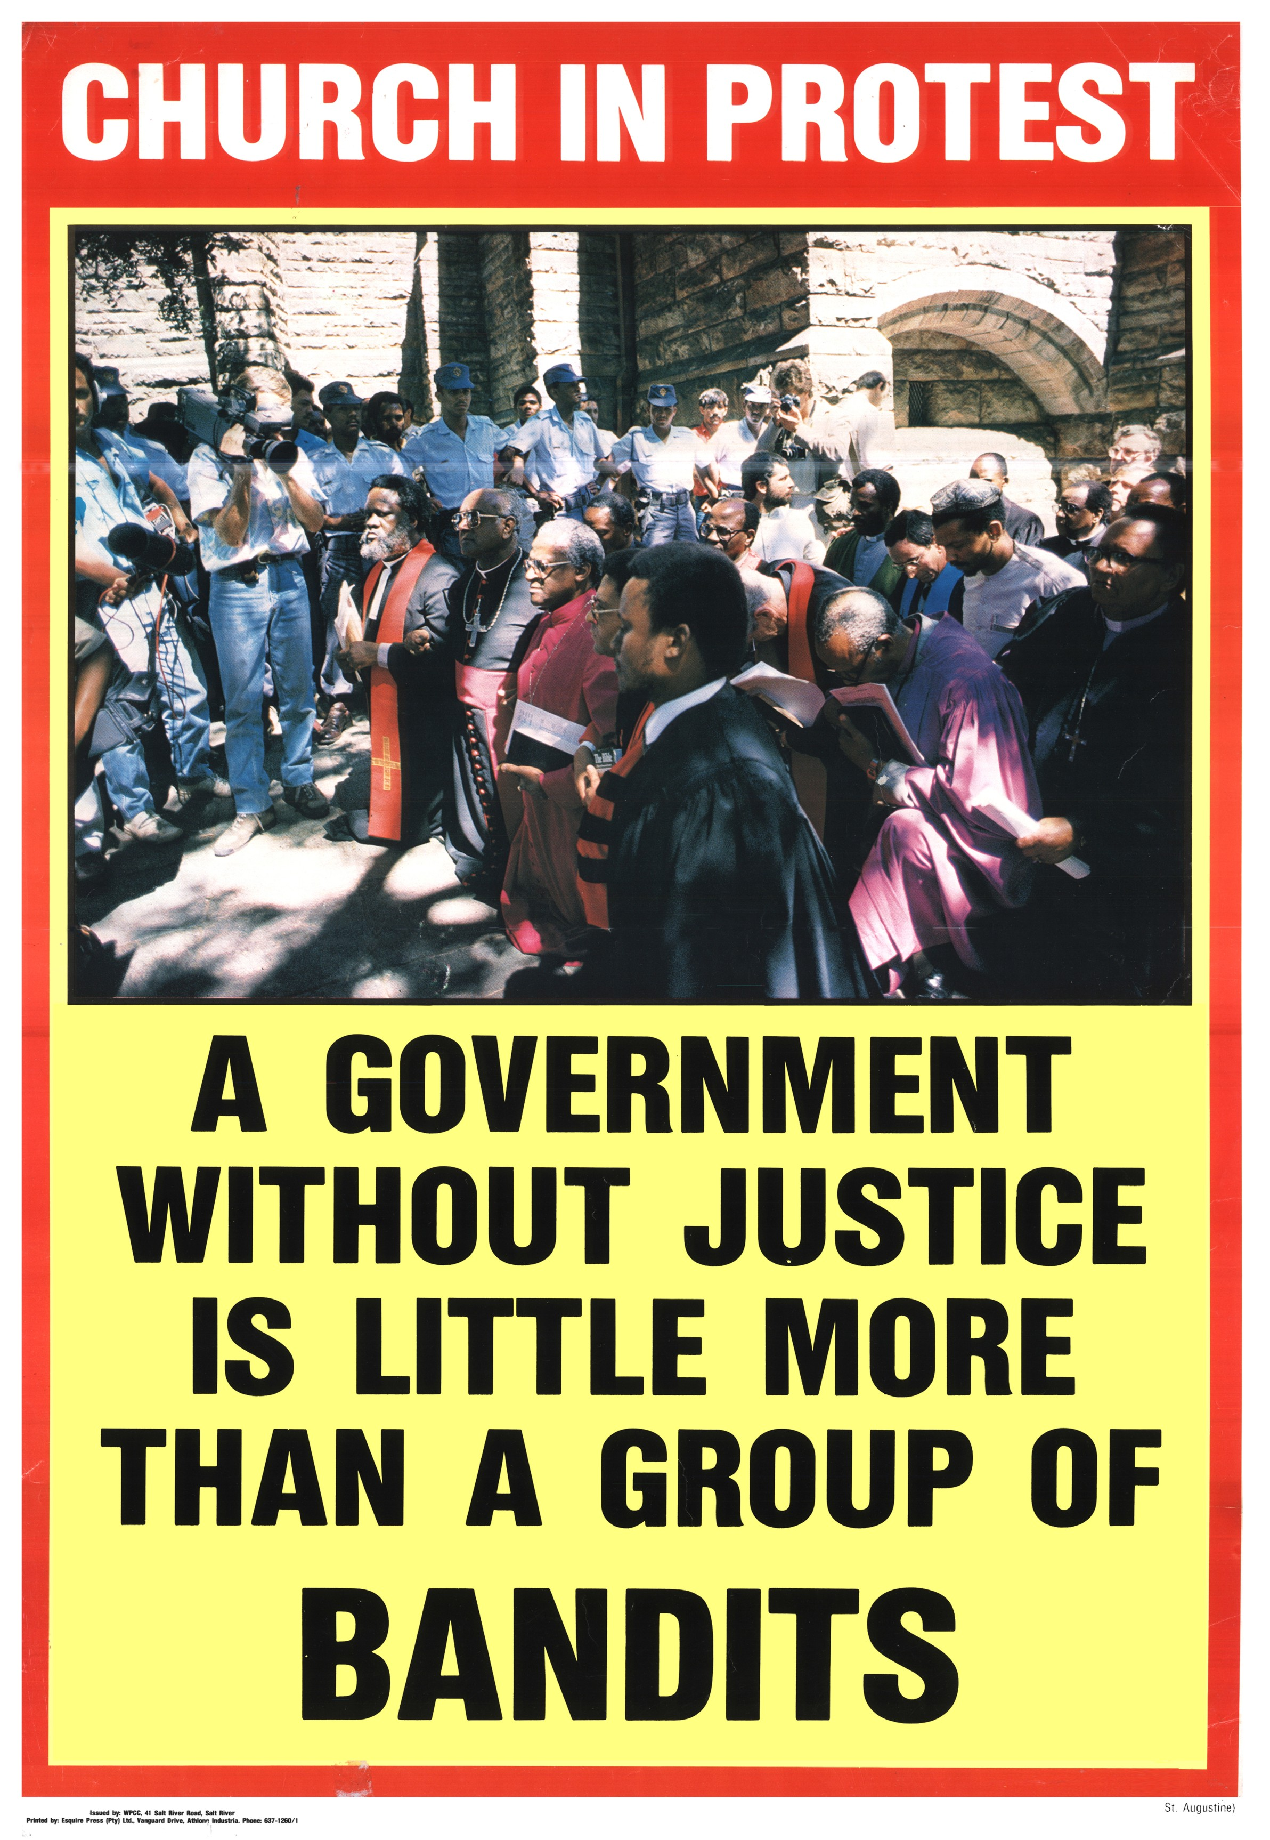
CHAPTER SIX Conclusion
As we said in the beginning, there is nothing final about this document. Our hope is that it will stimulate discussion, debate, reflection and prayer, but, above all, that it will lead to action. We invite all committed Christians to take this matter further, to do more research, to develop the themes we have presented here or to criticize them and to return to the Bible, as we have tried to do, with the question raised by the crisis of our times.

Although the document suggests various modes of involvement it does not prescribe the particular actions anyone should take. We call upon all those who are committed to this prophetic form of theology to use the document for discussion in groups, small and big, to determine an appropriate form of action, depending on their particular situation, and to take up the action with other related groups and organizations.

The challenge to renewal and action that we have set out here is addressed to the Church. But that does not mean that it is intended only for Church leaders. The challenge of the faith and of our present KAIROS is addressed to all who bear the name Christian. None of us can simply sit back and wait to be told what to do by our Church leaders or anyone else. We must all accept responsibility for acting and living out our Christian faith in these circumstances. We pray that God will help all of us to translate the challenge of our times into action.

We as theologians (both lay and professional), have been greatly challenged by our own reflections, our exchange of ideas and our discoveries as we met together in smaller and larger groups to prepare this document or to suggest amendments to it. We are convinced that this challenge comes from God and that it is addressed to all of us. We see the present crisis or KAIROS as indeed a divine visitation.

And finally we also like to call upon our Christian brothers and sisters throughout the world to give us the necessary support in this regard so that the daily loss of so many young lives may be brought to a speedy end.

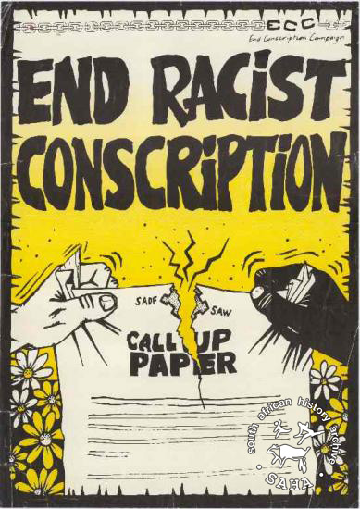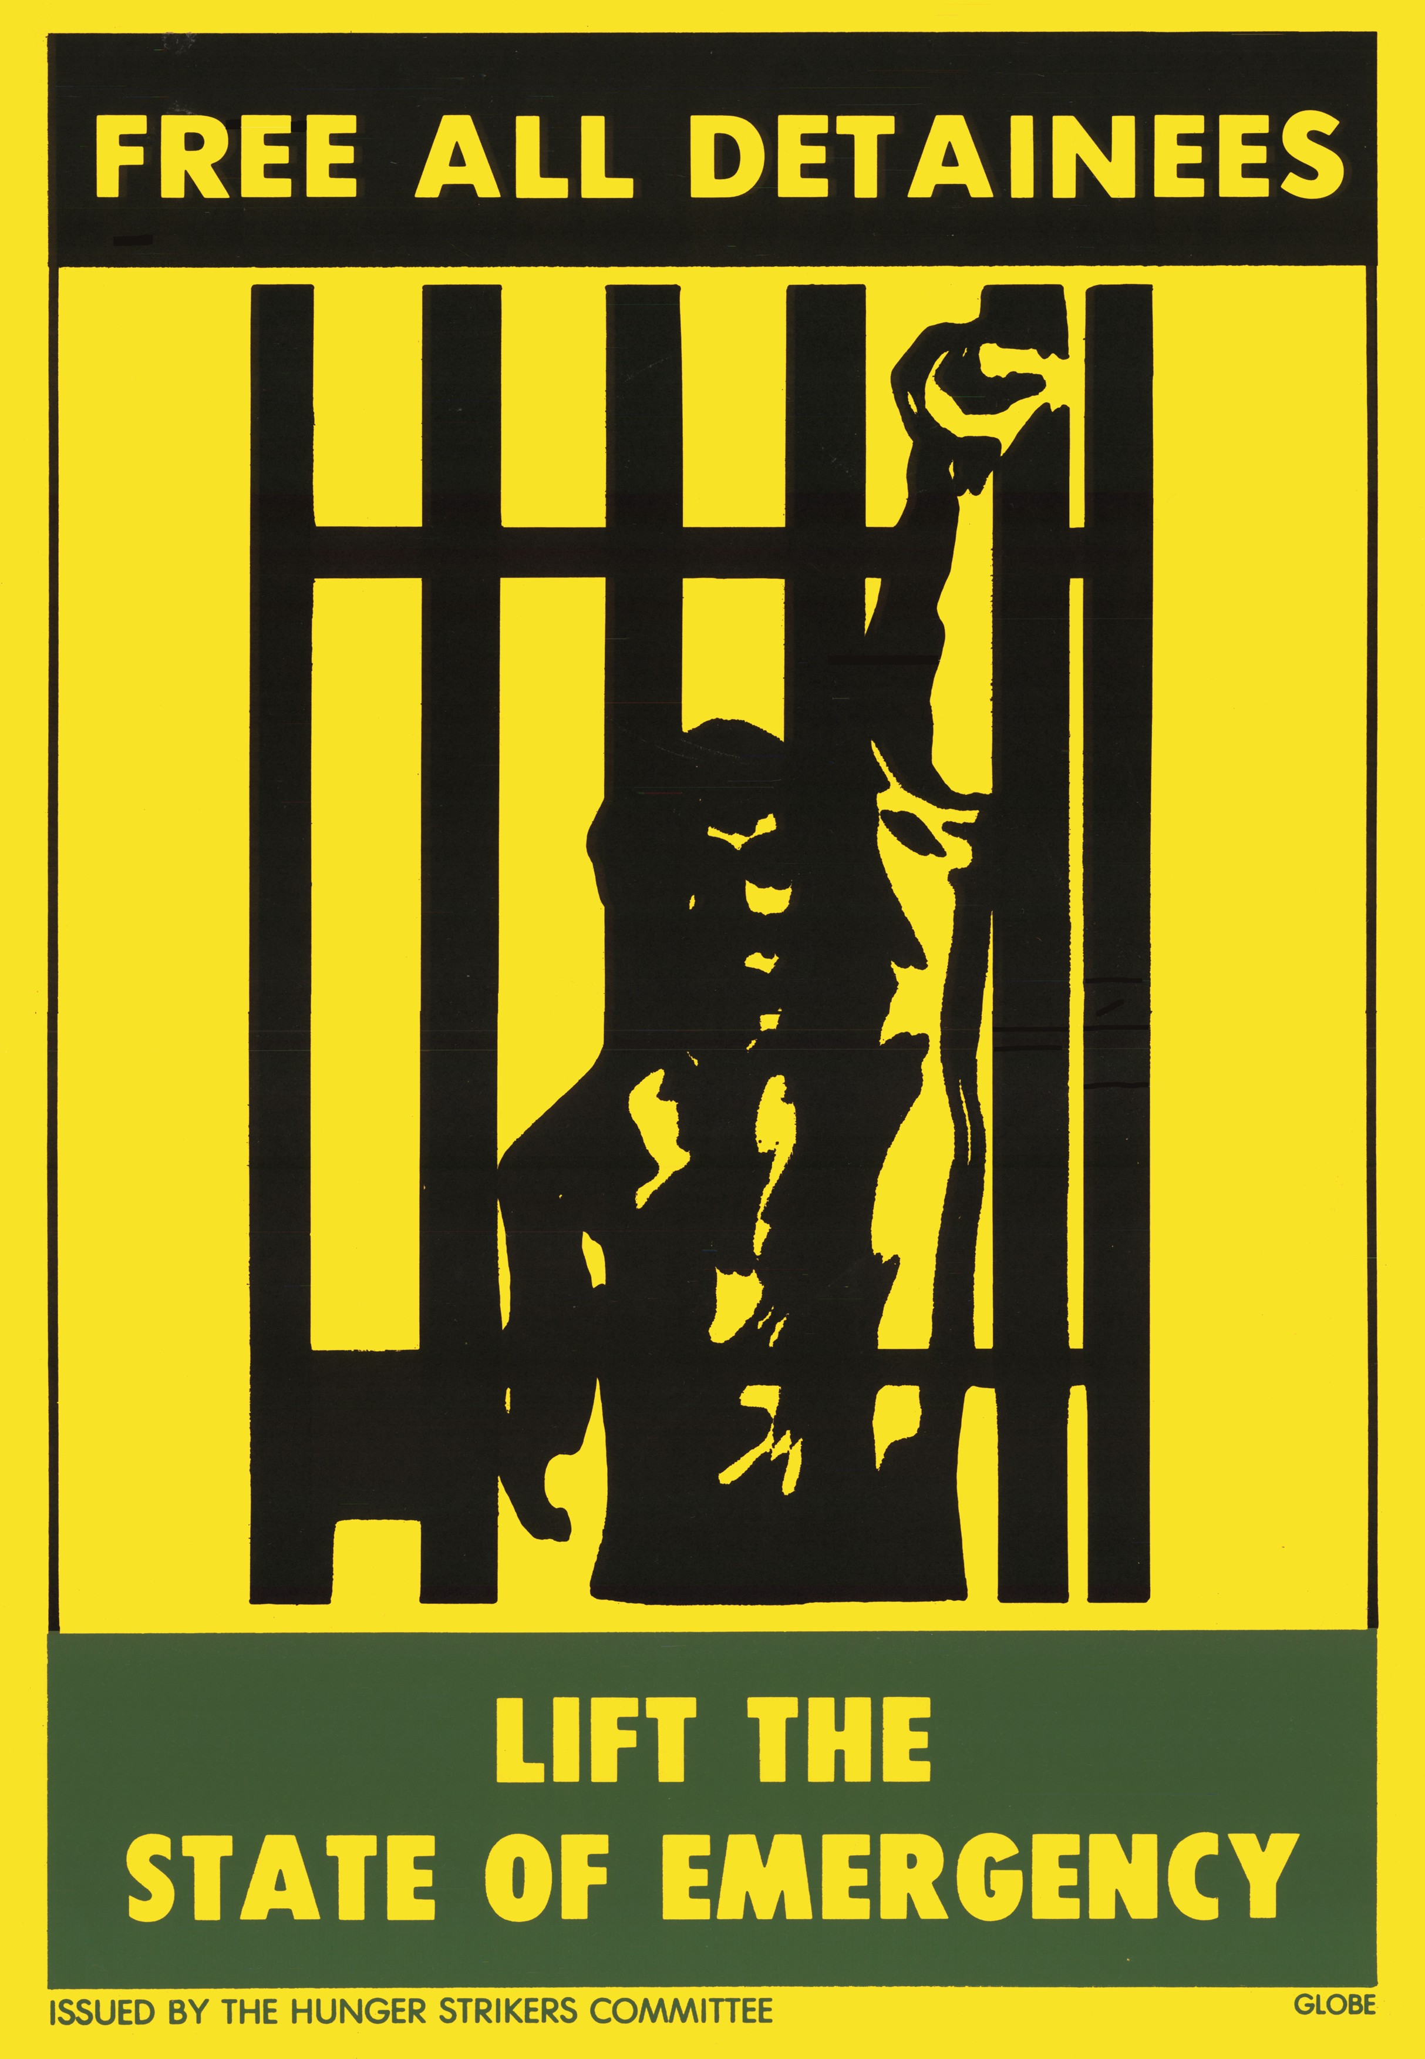

Explanatory Notes CHAPTER ONE Kairos is the Greek word that is used in the Bible to designate a special moment of time when God visits his people to offer them a unique opportunity for repentance and conversion, for change and decisive action. It is a time of judgement. It is a moment of truth, a crisis. (see, for example, Mk 1.15; 13.33; Lk 8.13; 19.44; Rom 13.11-13; 1Cor 7.29; 2 Cor 6.2; Tit 1.3; Rev 1.3; 22.10).
What is said here of Christianity and the Church could be applied, mutatis mutanda, to other faiths and religions in South Africa; but this particular document is addressed to “all who bear the name Christian” (see Conclusion).
See Chapter Four below.
If the Apostle Paul judged that the truth of the gospel was at stake when Greek and Jewish Christians no longer ate together (Gal 2.11-14), how much more acute is the crisis of the gospel of Jesus Christ when some Christians take part in the systematic oppression of other Christians!
Mt 12.25; 1 Cor 1.13.
These are obviously not the only theologies that are current in South Africa but they represent the three Christian theological stances in relation to the present situation in South Africa. CHAPTER TWO
What we are referring to here is something more than the ‘Apartheid Theology’ of the White Dutch Reformed Churches that once tried to justify apartheid by appealing to certain texts in the Bible. Our analysis of present-day theological stances has led us to the conclusion that there is a ‘State Theology’ that does not only justify racism but justifies all the activities of the State in its attempts to hold on to power and that is subscribed to as a theology well beyond the White Dutch Reformed Churches.
This and all other quotations in this document are taken from the Jerusalem Bible. The reader is invited to compare this translation with others that he or she might prefer.
Oscar Cullman, The State in the New Testament, SCM, 1957 p.56.
For example, E. Kasemann, Commentary on Romans, SCM, p 354-7; O. Cullmann, The State in the New Testament, SCM, p 55-7 CHAPTER THREE
We realise only too well that we are making broad and sweeping generalisations here. There are some church statements that would be exceptions to the general tendency. However, what concerns us here is that there are a set of opinions that in the mind of the people are associated with the liberal ‘English-speaking’ Churches.
It should be noted here that there is a difference between the willingness to forgive, on the one hand, and the reality of forgiveness or the experience of being forgiven with all its healing consequences, on the other hand. God’s forgiveness is unconditional and permanent in the sense that he is always willing to forgive. Jesus expresses this on the cross by saying, “Father, forgive them for they know not what they do” (Lk 23.24). However, we as sinners will not experience God’s forgiveness in our lives, we will not actually be freed or liberated from our sins until we confess and renounce our sins (1 Jn 1.9-9) and until we demonstrate the fruits of repentance. Human beings must also be willing to forgive one another at all times even seventy times seven times. But forgiveness will not become a reality with all its healing effects until the offender repents. Thus in South Africa forgiveness will not become an experienced reality until the apartheid regime shows signs of genuine repentance. Our willingness to forgive must not be taken to mean a willingness to allow sin to continue, a willingness to allow our oppressors to continue oppressing us. To ask us to forgive our unrepentant oppressors in the sense that we simply ignore or overlook the fact that they are continuing to humiliate, crush, repress, imprison, maim and kill us is to add insult to injury. What is required at this stage above all else is repentance and conversion.
Despite what is clearly stated here in the text, several commentators have interpreted the concept of “justice from below” as an exclusion of God and an exclusion of the who are now at the top. This misrepresentation is very revealing. In the first place it assumes that God belongs on top together with the kings, rulers, governments and others who have power, whether they are oppressors or not, and that God cannot work from below, through the efforts of the people who are oppressed. It assumes that God is on the side of the oppressor (on top) and not on the side of the oppressed (below). This is precisely what the Kairos Document is contesting. In the second place, there is the conclusion that “justice from below” excludes the White community and anyone else who is presently on top. This is based upon the very revealing assumption that conversion and repentance are impossible and that those who are presently on top will never climb down in order to negotiate as equals with those who are presently at the bottom. Unless they do this, they will indeed be unable to be part of the construction of a just and peaceful South Africa. Those who refuse to repent and change cannot become instruments of God’s justice and God’s peace.
What we have said here about violence and non-violence does not pretend to be a solution to the complex moral problems that we are all faced with as our country is plunged more and deeply into civil war. Our only aim in this section has been to critique an oversimplified and misleading theology of non-violence. CHAPTER FOUR
Many readers of the first edition suggested that the meaning of prophetic theology should be spelt out more clearly. The characteristics of prophetic theology that have been included in this second edition are a summary of discussions among Kairos theologians both before and immediately after the publication of the first edition. It should also be noted that there is a subtle difference between prophetic theology and people’s theology. The Kairos Document itself, signed by theologians, ministers and other church workers, and addressed to all who bear the name Christian is a prophetic statement. But the process that led to the production of the document, the process of theological reflection and action in groups, the involvement of many different people in doing theology was an exercise in people’s theology. The document is therefore pointing out two things: that our present Kairos challenges Church leaders and other Christians to speak out prophetically and that our present Kairos is challenging all of us to do theology together reflecting upon our experiences in working for justice and peace in South Africa and thereby developing together a better theological understanding of our Kairos. The method that was used to produce the Kairos Document shows that theology is not the preserve of professional theologians, ministers and priests. Ordinary Christians can participate in theological reflection and should be encouraged to do so. When this people’s theology is proclaimed to others to challenge and inspire them, it takes on the character of a prophetic theology.
This section has been re-written mainly because of the request that more quotations form the Bible be included in the text. CHAPTER FIVE
However, the church must participate in the struggle as a Church and not as a political organisation. Individual Christians as citizens of this country can and must join the political organisations that are struggling for justice and liberation, but the Church as Church must not become a political organisation or subject itself to the dictates of any political party. The Church has its own motivation, its own inspiration for participating in the struggle for justice and peace. The Church has its own beliefs and its own values that impel it to become involved, alongside of other organisations, in God’s cause of liberation for the oppressed. The Church will have its own way of operating and it may sometimes have its own special programmes and campaigns but it does not have, and cannot have, its own political blueprint for the future, its own political policy, because the Church is not a political party. It has another role to play in the world. The individual Christian, therefore, is both a member of the Church and a member of society, and, on both accounts, Christians should be involved in doing what is right and just. The same is no doubt true of people who adhere to other religious faiths.
There has been a lot of debate about whether the Church should be a “Third Force” or not. It is closely related to the question of whether the Church should take sides or not, which we explained in the previous note. The whole question and the full debate will be dealt with in a forthcoming book entitled “The Kairos Debate”.

