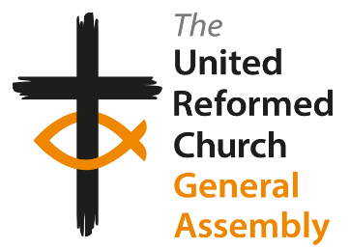
Election of the Moderator of the General Assembly 2022-2023*

The Revd Fiona Bennett
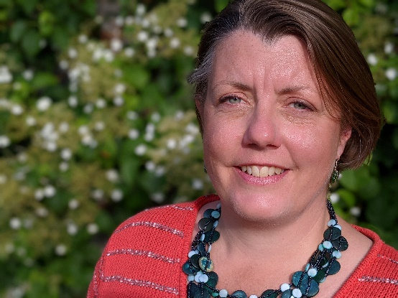
“If you are simply interested in saving your life, you have probably already
lost it.”
The Revd Richard Frazer, Greyfriars
Kirk, Edinburgh

I grew up in Aberdeen and studied at New College, Edinburgh University followed by a post-graduate in Community Education from Northern College Dundee. During this period, I studied and volunteered in Austria, Jerusalem and Seattle USA.

I was ordained as a Minister of Word and Sacrament of the Scottish Congregational Church (SCC) in 1996, the same year as I married. My husband, Pete, was working in Community Education in the central belt of Scotland.

At that time there were no available charges in the SCC in the central belt, which became a great opportunity for me to serve as a recognized and regarded minister in the Lanarkshire Circuit of the Methodist Church with responsibility for two local churches in Wishaw.

When the stationing drew to a close after five years, I moved into a new post in a local Church of Scotland congregation in Edinburgh as an associate minister and director of a project exploring spirituality and creativity, which became called “Creative Space”- a fascinating and life-giving ministry.

Seven years on in 2009, I felt it was time for change. I was called to serve as a minister in Augustine United URC, Edinburgh, where we have an exciting and growing ministry and community that celebrates and strives to be transformed through God’s inclusive love, and works closely with our ecumenical partners Greyfriars Kirk and St Columba’s-by-the-Castle, Scottish Episcopal Church.

Through each of these ministries I have served the denominations (The Methodist Church in Scotland, The Church of Scotland and The United Reformed Church) on committees at both synod and national levels and as well as on ecumenical and Interfaith bodies, several of which I have convened. I have served as a line-manager for posts locally and ecumenically.

I am trained and qualified as a mediator with Scottish Mediation, serving with both Place for Hope and the Listening and Reconciliation Service of the five Northerly Synods. I am one of the alternate chairs for the National Synod of Scotland, contributed as a writer for Stepwise Worship Stream, and am currently a member of Mission Council.

We live in Edinburgh and have three children who are all at college or university. I have coped with lock down by reading copious quantities of historical murder mysteries and fantasy novels, singing, and walking and cycling around the beautiful city of Edinburgh with Pete and other friends.

Some of my core values, grown from my experience, faith and theology as a disciple of Jesus, are:
- The transformative power of inclusion towards abundant life for all.
- An undying trust in the Spirit’s creativity to craft God’s life-giving Realm.
- A conviction to choose love over fear.

Bill Robson, Synod Clerk for the National Synod of Scotland

(*Subject to Resolution)

