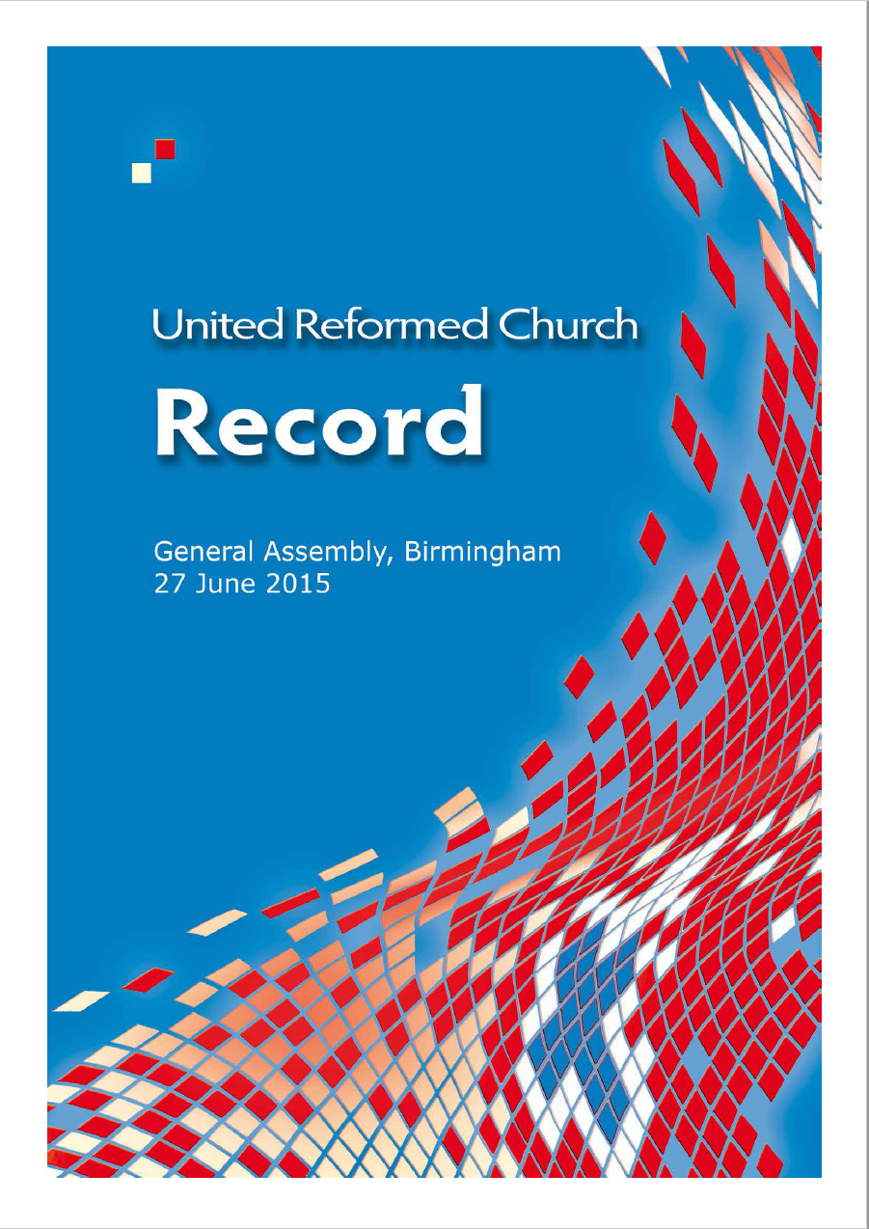

© The United Reformed Church, 2015 URC127
Published by
The United Reformed Church
86 Tavistock Place, London WC1H 9RT

All rights reserved. This material may be used freely within the churches.
No part of this publication may be reproduced outside the Church in any form or by any means – graphic, electronic, or mechanical, including photocopying, recording, taping or information storage and retrieval systems –
without the prior written permission of the publishers.

The publishers make no representation, express or implied, with regard to the accuracy of the information contained in this book and cannot accept any legal responsibility
for any errors or omissions that may take place.

Photography
© United Reformed Church/Chris Andrews

Designed by Sara Foyle, graphics office, on behalf of the Assembly arrangements committee, The United Reformed Church, Church House, 86 Tavistock Place, London WC1H 9RT

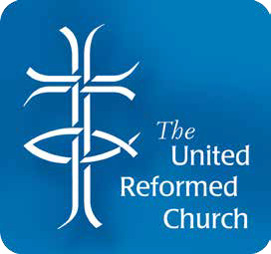

If you require this text in another format please contact the graphics office at Church House on 020 7916 9875 or graphics@urc.org.uk, giving three weeks notice.

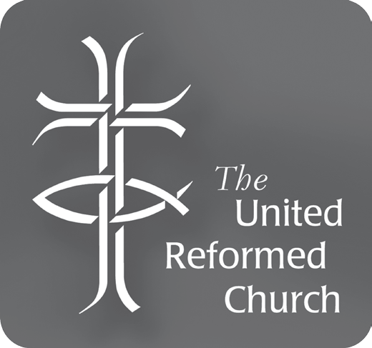
Record of Assembly

Minutes of an extaordinary meeting of the United Reformed Church
General Assembly
At Birmingham, and within The Church at Carrs Lane

Saturday, 27 June 2015 11:00 am

The Assembly, having been summoned to meet by resolution of Mission Council on Saturday 9 May 2015, was constituted with worship, led by the Moderators, the Revd David Grosch-Miller and Mr John Ellis, and Mr Ellis’s chaplain, the Revd Nigel Uden.

Following worship, Mr Ellis took the chair. The Moderator welcomed members of Assembly.

The convener of the Assembly arrangements committee, the Revd James Breslin, presented Resolutions 1, 2, and 3. He then moved:
Resolution 1
General Assembly concurs in the decision to hold this special meeting.

This was passed overwhelmingly, with two votes against. The Revd David Grosch-Miller moved:

Resolution 2
General Assembly notes that the holders of several offices and roles, which are members of General Assembly ex officiis, have changed since General Assembly met in July 2014. General Assembly confirms the consequent changes to the Roll: General Secretary – the Revd John Proctor
Deputy General Secretary (Administration & Resources) – Mrs Jane Baird Deputy General Secretary (Discipleship) – the Revd Richard Church Deputy General Secretary (Mission) – Ms Francis Brienen
Clerk – the Revd Michael Hopkins
Moderator of the North Western Synod – vacant Moderator of the Mersey Synod – the Revd Jacky Embrey
Convener of the Assembly Arrangements Committee – the Revd James Breslin
United Reformed Church • Record of General Assembly 2015 • 1

Convener of the Equalities Committee – the Revd Helen Mee Convener of the Ministries Committee – the Revd Gethin Rhys Convener of the Nominations Committee – Mrs Irene Wren
Saturday, 27 June 2015
Convener of the United Reformed Church Trust – the Revd Richard Gray

This was passed unanimously.

The convener of the Assembly Arrangements Committee then moved:

Resolution 3
General Assembly appoints Dr James Merrilees as convener of tellers for this meeting.

This was passed unanimously.

The Moderator introduced those sitting at the front, and those in new roles.

The Moderator invited the pastoral listeners to stand and identify themselves: the Revd Steve Faber, the Revd Dick Gray, the Revd Jenny Mills, and the Revd Melanie Smith.

The Moderator called for the report of the human sexuality task group. The Moderator explained the process to be followed for Resolution 4.
The convener of the human sexuality task group, the Revd Elizabeth Caswell, presented the report (Paper 2) and on behalf of Mission Council moved:

Resolution 4
- In keeping with the 2007 commitment on Human Sexuality, General Assembly does not consider it appropriate to express a single view on behalf of the whole United Reformed Church on the matter of Same-Sex Marriage.

- General Assembly declares that the Church Meeting of each Local Church of the United Reformed Church in England and Wales is the relevant governing authority for the purpose of giving consent for the trustees of its building to seek the registration of that building for
religious marriage ceremonies of same-sex couples, in accordance with the provisions of Section 26A(1) of the Marriage Act 1949 as amended by the Marriage (Same Sex Couples) Act 2013.

- In the case of Local Ecumenical Partnerships and Union Churches, where the constitution makes no provision for a Church or Congregational Meeting (including a Special or Extraordinary General Meeting) the relevant governing authority of the United Reformed Church under Section 26A(1) of the Marriage Act 1949 as amended by the Marriage (Same Sex Couples) Act 2013 is the council which represents the widest gathering of members of that Church or Partnership. In case of doubt the council to act in this matter shall be jointly determined, in light of the LEP constitution and any sharing agreement, by the Moderator and Clerk of the synod on which that church is represented.

The General Assembly authorises the General Secretary, the Clerk, or any Deputy General Secretary to sign and furnish a copy of this resolution (or a relevant extract) in the name of the Assembly, whenever such a copy may be required by law.
F.
The General Assembly recalls that the trusts on which Local Church buildings are commonly held empower the Church Meeting to direct in what ways such a building is or is not to be used for public worship and ancillary purposes.
E.
Noting that Mission Council has already recognised, on behalf of General Assembly, ‘that if a future Assembly were to allow for ministers and members of the United Reformed Church to solemnise same-sex marriages under Scots Law, the Synod of Scotland would be the appropriate council of the URC to approach the Registrar General for Scotland’, the General Assembly confirms that it now lies within the competence of the National Synod of Scotland to nominate under Section 9(1A) of the Marriage (Scotland) Act 1977 as amended by the Marriage and Civil Partnership (Scotland) Act 2014 members of the United Reformed Church who
have indicated their willingness in writing to the Synod to be approved celebrants of same-sex marriage in Scotland.
D.

Under the consensus decision-making process, questions were asked during the information session, to which the convener and the Clerk responded.
Saturday, 27 June 2015

Assembly moved to a discussion session. During this session, a variety of suggestions for amendment were considered, but none were adopted, and the resolution was
not amended.

Assembly then moved to the decision session. It was not possible to achieve consensus, and the Moderators invited those holding blue cards to meet them privately over lunch, so that their concerns could be heard in a smaller space.

The Assembly adjourned for lunch, and re-convened at 2.00pm.

It was not possible to pass the resolution recognising disagreement. The Moderator considered all the options available under Standing Order 2.5.9, and explained that many of the options were either impossible or impractical in this instance, with which Assembly agreed. Having given reasons for considering the business “urgent”, the Moderator listened to comments from members of Assembly. The Moderator then ruled that, while still following the consensus process, Assembly would follow standing order 2.5.9.7, and take a majority vote. This was done by a show of cards, and Resolution 4 was passed by a large majority.

The chaplain led Assembly in prayer.

The following Members of Assembly recorded their dissent:

The Revd David Bedford The Revd James Church The Revd Paul Ellis
The Revd Ashley Evans The Revd Steve Faber
The Revd Kenneth Philip Gray The Revd Annette Haigh
Mr Alex Jeffs
The Revd Chris Kemshell The Revd Neil Kirkham The Revd Stuart Nixon Mr John Rider
The Revd Paul Robinson

The Moderator then explained that in order to ensure the decision was as legally watertight as possible, the Assembly needed to repeat the voting process under the Majority Voting Standing Orders (Group B) on wording identical to that just agreed, and count the votes.
Saturday, 27 June 2015

The General Secretary formally proposed, and the Clerk formally seconded:

Resolution 4A
- In keeping with the 2007 commitment on Human Sexuality, General Assembly does not consider it appropriate to express a single view on behalf of the whole United Reformed Church on the matter of Same-Sex Marriage.

- General Assembly declares that the Church Meeting of each Local Church of the United Reformed Church in England and Wales is the relevant governing authority for the purpose of giving consent for the trustees of its building to seek the registration of that building for
religious marriage ceremonies of same-sex couples, in accordance with the provisions of Section 26A(1) of the Marriage Act 1949 as amended by the Marriage (Same Sex Couples) Act 2013.

- In the case of Local Ecumenical Partnerships and Union Churches, where the constitution makes no provision for a Church or Congregational Meeting (including a Special or Extraordinary General Meeting) the relevant governing authority of the United Reformed Church under Section 26A(1) of the Marriage Act 1949 as amended by the Marriage (Same Sex Couples) Act 2013 is the council which represents the widest gathering of members of that Church or Partnership. In case of doubt the council to act in this matter shall be jointly determined, in light of the LEP constitution and any sharing agreement, by the Moderator and Clerk of the synod on which that church is represented.

- Noting that Mission Council has already recognised, on behalf of General Assembly, ‘that if a future Assembly were to allow for ministers and members of the United Reformed Church to solemnise same-
sex marriages under Scots Law, the Synod of Scotland would be the appropriate council of the URC to approach the Registrar General for Scotland’, the General Assembly confirms that it now lies within the competence of the National Synod of Scotland to nominate under Section 9(1A) of the Marriage (Scotland) Act 1977 as amended by the Marriage and Civil Partnership (Scotland) Act 2014 members of the United Reformed Church who have indicated their willingness in writing to the Synod to be approved celebrants of same-sex marriage in Scotland.

- The General Assembly recalls that the trusts on which Local Church buildings are commonly held empower the Church Meeting to direct in what ways such a building is or is not to be used for public worship and ancillary purposes.

- The General Assembly authorises the General Secretary, the Clerk, or any Deputy General Secretary to sign and furnish a copy of this resolution (or a relevant extract) in the name of the Assembly, whenever such a copy may be required by law.

Following discussion, resolution 4A was put to the vote. There voted for the resolution, 205, and there voted against the resolution, 14. This represented a percentage in favour of 93.6%, in excess of the two-thirds required.
Saturday, 27 June 2015

The following Members of Assembly recorded their dissent:

The Revd David Bedford The Revd James Church The Revd Paul Ellis
The Revd Ashley Evans The Revd Steve Faber
The Revd Kenneth Philip Gray The Revd Annette Haigh
Mr Alex Jeffs
The Revd Chris Kemshell The Revd Neil Kirkham The Revd Stuart Nixon Mr John Rider
The Revd Paul Robinson

The Revd David Grosch-Miller took the Chair.

Mr Grosch-Miller reminded Assembly that Resolution 5 would be conducted under the Majority Voting Standing Orders (Group B).

The convener of the human sexuality task group presented, and the General Secretary formally moved:
Resolution 5
General Assembly refers Resolution 4A to the synods, using the procedure in Paragraph 3(1) of the Structure, with responses to the General Secretary by 31 March 2016.

After extensive discussion, the resolution was put to the vote, and there voted for the resolution 184, and there voted against the resolution 30. The resolution was therefore carried.

The Moderator thanked the human sexuality task group for the work undertaken, and Assembly responded with acclamation.

The Clerk moved:
Resolution 6
General Assembly authorises the Officers of Assembly to check the accuracy of the minutes, and to arrange for their publication in a supplementary Record of Assembly, also containing the Roll of Assembly and any other material also accidentally omitted from the Record of the Assembly meeting in July 2014.

This was passed unanimously.

The Moderator offered the thanks of the Assembly to all involved in the organisation, and especially to The Church at Carrs Lane, and presented a gift to the church secretary.
Saturday, 27 June 2015

The General Secretary offered thanks to the Moderators. Worship was led by the Moderators and the chaplain.
The General Assembly, having completed its business, was adjourned to meet at Southport on 8-11 July 2016, or at such time and place as shall be determined.

The Roll of Assembly, at Cardiff, July 2014
Saturday, 27 June 2015
(accidentally omitted from the Record printed after that meeting of Assembly)
Moderators Mr John Ellis
The Revd David Grosch-Miller
Clerk The Revd James Breslin General Secretary The Revd Roberta Rominger Deputy General Secretary Ms Francis Brienen

Moderators of synods
  - The Revd Lis Mullen
  - The Revd Richard Church
- The Revd Kevin Watson
- The Revd Peter Meek
- The Revd Roy Lowes
- The Revd Paul Whittle
- The Revd Ruth Whitehead
- The Revd Clare Downing
- The Revd Dr Andrew Prasad
- The Revd Nicola Furley-Smith
- The Revd Simon Walkling
- The Revd John Humphreys

Conveners of Assembly Committees
Assembly Arrangements Dr David Robinson Children’s and Youth Work The Revd Tim Meachin Communication and Editorial The Revd John Humphreys Education and Learning The Revd John Smith
Equalities The Revd Elizabeth Nash
Faith and Order The Revd Elizabeth Welch
Finance Mr John Ellis
Ministries The Revd Ruth Whitehead
Mission The Revd Tracey Lewis
Nominations The Revd John Durell
Pastoral Reference The Revd Sheila Maxey
URC Trust The Revd Prof David Thompson
Immediate past Moderator The Revd Dr Michael Jagessar
Former Moderators Mrs Wilma Frew
The Revd Prof David Thompson

Resource Centres for Learning
Northern College Staff The Revd Dr Graham Adams
Student Mr Stephen Best

Scottish College Staff The Revd Dr Jack Dyce
Student Mrs Nadene Snyman

Westminster College Staff The Revd Neil Thorogood
Student Ms Elaine Colechin

The Windermere Centre Mr Lawrence Moore

Youth Representatives Mr Matthew Barkley Mr Simon Peters
Mr Andrew Weston
Chaplain (URC) to HM forces The Revd Clare Callanan

Synod representatives
Saturday, 27 June 2015
* denotes substitute

Synod 1 – Northern
The Revd Ray Anglesea, The Revd Helen Drummond, The Revd Ron Forster, The Revd Catey Morrison

Miss Lesley Bustard, *Mr Jack Charlesworth, Mrs Lucy Cooke, Ms Moira Copeland, Mr Henry Gowland, Mrs Ann Honey, *Ms Becky Leggett, Ms Elisabeth Meikle

Synod 2 – North Western
The Revd Nigel Adkinson, The Revd Martyn Coe, The Revd Bob Day, The Revd Kate Gray, The Revd Michele Jarmany, The Revd Brian Jolly,
The Revd Nick Mark, The Revd Carole Marsden, The Revd George Mwaura, The Revd Stuart Nixon, The Revd John Piper, The Revd Martin Whiffen,
The Revd Ruth Watson

Mrs Paulette Bailey, Mrs Angela Bogg, Mr Andy Braunston, *Mrs Margaret Brock, Mrs Sheila Church, Mr Vernon Dunn, Mrs Sheila Green, Miss Judith Haughton,
Mr Peter Melvin, Mr Dan Morrell, Mr Tony Porter, Ms Lauren Stanger, Mr Alex Young

Synod 3 – Mersey
The Revd Ann Bedford, The Revd Allison Claxton, The Revd Gwynfor Evans, The Revd Kate Gartside, The Revd Murray George, The Revd Peter Lyth, The Revd Dawn Mather, The Revd Tim Meadows

Mrs Joan Colwell, Mrs Barbara Ellis, Mrs Rita Griffiths, Mr John Grundy, Mrs Jane Leighton, Mr Muzaffar Nazish, Mr Nathan Stott, Mr Paul Taylor

Synod 4 – Yorkshire
The Revd Dr James Coleman, The Revd David Coote, The Revd Annette Haigh, The Revd Fran Kissack, The Revd Anne Lewitt, The Revd Alison Micklem,
The Revd Nick Percival, The Revd Alison Termie

Ms Jessica Coatesworth, Mrs Jenny Horton, Ms Katie Kissack, Mr Tom Knight, Mr Nsubisi Mwakasungura, Mrs Jenny Poulter, Mr Chris Reed, Mr John Rider

Synod 5 – East Midlands
The Revd David Dean, The Revd David Downing, The Revd Richard Eastman, The Revd Steve Faber, The Revd Malcolm Fife, The Revd Lynn Fowkes,
The Revd Martha McInnes, The Revd Jenny Mills

Ms Lucy Ette, Ms Natalie Gibbs, Mr David Greatorex, Ms Alison Hadley,
Mrs Helen Lidgett, Mr David Passmore, Mr Duncan Smith, Mrs Valerie Smith

Synod 6 – West Midlands
The Revd Maz Allen, The Revd James Church, The Revd Jacky Embrey, The Revd Peter Little, The Revd Colin McIlwaine, The Revd Craig Muir,
The Revd Dr Malachie Munyaneza, The Revd Richard Pope, The Revd Neil Riches, The Revd Wilbert Sayimani, The Revd David Walton

Ms Claudette Binns, Mr John Desmond, Mr Alan Eaton, Mr David Harvey,
Mrs Margaret Marshall, Mrs Glenis Massey, Miss Barbara McDowell, Mr Luke Noble, Mrs Adella Pritchard, Mrs Cynthia Simister, Mrs Chris Watson

Synod 7 – Eastern
Saturday, 27 June 2015
The Revd Dr Catherine Ball, The Revd Ernie Bossé, The Revd Samuel Cyuma, The Revd Paul Ellis, The Revd Christopher Kemshell, The Revd Jon Morgan, The Revd Mary Playford, The Revd Melanie Smith, The Revd Kathryn Taylor, The Revd Cecil White

Mrs Audrey Elliott, Mrs Lisa Gordon, Mr Ian Hardie, Mrs Linda Harrison, Mr Andrew Mackenzie, Mr Clifford Patten, Mrs Margaret Thompson, Mrs Gwynneth Tilley, Mr John Tyler, Ms Sarah Wilson

Synod 8 – South Western
The Revd Dougie Burnett, The Revd Arthur Climpson, The Revd Janet Conway, The Revd Dick Gray, The Revd Robert Jennings, The Revd Kathryn Price,
The Revd Heather Whyte

Mr George Faris, Cllr Philip Fowles, Mrs Peggy Gray, Ms Sabrina Gröschel,
Mrs Gwen Jennings, Mrs Brenda Jesse, Mrs Lorna Lewis, *Mr Rhys McKavanagh,
*Mr Sandy Nunn, Mr Rychard Winslade

Synod 9 – Wessex
The Revd Heather-Ann Adlem, The Revd Nigel Appleton, The Revd Cliff Bembridge, The Revd Kay Blackwell, The Revd Barrie Cheetham, The Revd Graham Dadd,
The Revd Joshua Han, The Revd Martyn Neads, The Revd Timothy Searle, The Revd Ray Stanyon, The Revd Caroline Vodden

Mrs Mary Cooper, Mrs Anna Crawford, Mrs Alison Dalton, Mr Ray Dunnett, Mr Colin MacBean, Dr Faye Mitchell, Ms Pat Oliver, Ms Anna Ouston,
Mrs Thelma Roberts, Mrs Pam Sales, Mrs Val Sykes, Mrs Margaret Telfer, Mr Peter Thomas, Mr David Townsend, Mr Martin Waldron

Synod 10 – Thames North
The Revd Francis Ackroyd, The Revd Ray Adams, The Revd John Danso, The Revd Ashley Evans, The Revd Kate Hackett, The Revd Dr John Parry,
The Revd Bridget Powell, The Revd Geoffrey Roper, The Revd Edward Sanniez

Ms Sally Bateman, Mr Nick Booth, Mrs Mary Carpenter, Mrs Gill Elliott,
Mr Simon Fairnington, Mr Jeremy Flynn, Mr Brian Hosier, Mr Peter Knowles,
Mr Philipp Koeker, Mrs Carole Lindfield, Mr Doug Maxwell, Mr Tony Obi-Ezekpazu, Ms Camilla Quartey

Synod 11 – Southern
The Revd Bruce Allinson, The Revd Bridget Banks, The Revd David Bedford,
The Revd Heather Cadoux, The Revd Derrick Dzandu-Hedidor, The Revd Tod Gobledale, The Revd John Gordon, The Revd Dominic Grant, The Revd Philip Gray,
The Revd Howard John, The Revd John Joseph, The Revd Andrew Mills,
The Revd Kristin Ofstad, The Revd Kim Plumpton, The Revd Raymond Singh, The Revd Dr Alan Spence, The Revd Bob Street, The Revd Karen Street,
The Revd Derek Wales, The Revd Helen Warmington, The Revd David Yule, The Revd Jenny Yule

Mr Ian Fletcher, Mr Alex Jeffs, Mrs Jenny John, Mr Frank Liddell, Ms Grace Marriott,
Mr Guy Morfett, Miss Diana Nye, Mrs Pam Rowden, Miss Katie Steel, Mr Alistair Wilson

Synod 12 – Wales
Saturday, 27 June 2015
The Revd Sue Fender, The Revd Paul Floe, The Revd Stephen Gilbert, The Revd Shelagh Pollard, The Revd Paul Robinson

*Mr Gary Leighton, Dr Fiona Liddell, Dr Jean Silvan Evans, Ms Helen Stenson, Ms Bethan Walkling

Synod 13 – Scotland
The Revd Fiona Bennett, The Revd Connie Bonner, The Revd Stephen Brown, The Revd Mitchell Bunting, The Revd David Coleman, The Revd Alan McGougan, The Revd Helen Mee, The Revd Leslie Morrison, The Revd Penelope Smirthwaite, The Revd Gordon Smith, The Revd William Young

Mr Clive Bonner, Ms Lorna Bowry, Mr John Collings, Mr Ben Forsyth, Dr Ewen Harley, Ms Kiera Lane, Ms Morag McLintock, Mrs Irene Merrilees, Dr Jim Merrilees,
Ms Mandy Scott, Ms Joanna Smith, Mr Patrick Smyth

British and Irish ecumenical representatives
The Rt Revd Dr Michael Barry Presbyterian Church in Ireland The Revd Barbara Bridges Congregational Federation
The Revd Philip Cooper Moravian Church in Great Britain and Ireland The Revd Dr Keith Davies Methodist Church
The Revd Aled Edwards CYTUN (Churches Together in Wales) The Revd Douglas Galbraith Church of Scotland
The Revd Wayne Hawkins CWM (Europe) The Venerable George Howe Church of England The Revd Andy Hughes Baptist Church
The Revd Neil Kirkham Presbyterian Church of Wales
The Revd Carla Maurer Swiss Reformed Church
The Rt Revd Richard Pain Church in Wales
Mrs Carys Whelan Catholic Bishops’ Conference of England and Wales

Overseas representatives
The Revd Michael Blair United Church of Canada The Revd Dr Peggy Kabonde United Church of Zambia The Revd Dr Lee Hong Jung Presbyterian Church of Korea Pfarrer Michael Pernt-Weigel Church of the Palatinate
The Revd Philip Woods CWM

Changes to the Roll of Assembly
The following changes to the Roll of Assembly were agreed on 27 June 2015, by Resolution 2.

General Secretary – The Revd John Proctor
Deputy General Secretary (Administration & Resources) – Mrs Jane Baird Deputy General Secretary (Discipleship) – The Revd Richard Church Deputy General Secretary (Mission) – Ms Francis Brienen
Clerk – The Revd Michael Hopkins

Moderator of the North Western Synod – vacant
Moderator of the Mersey Synod – The Revd Jacky Embrey
Convener of the Assembly Arrangements Committee – The Revd James Breslin
Convener of the Equalities Committee – The Revd Helen Mee Convener of the Ministries Committee – The Revd Gethin Rhys Convener of the Nominations Committee – Mrs Irene Wren
Convener of the United Reformed Church Trust – The Revd Richard Gray

Corrections to Record of Assembly 2014
Saturday, 27 June 2015
Since the publication of the Record of Assembly from Cardiff in July 2014, a number of errors have been noticed, and these are now corrected as follows:

- On page 4, the record of Resolution 3 should also include the name of the Revd David Bedford.

- On page 8, there is a correction to the recorded order of items. The Westminster College Appeal was in fact considered first in Business Session 4.

- Also on page 8, there is a correction to the printed wording of Resolution 28. The version eventually agreed read, ‘General Assembly challenges all local churches to increase their giving to the ministry and mission fund by at least an additional 1% per annum.’

- On page 9, there is a correction to the last half-sentence of the second paragraph.: ‘...and the Moderator instructed that because this resolution had been changed after the deadline for material to be removed from en bloc business, resolution 24 be withdrawn from the list of en bloc resolutions.’

- On page 27, the last sentence of the penultimate paragraph – ‘The children ... shared their tree building activity.’ – should appear instead at the very start of that paragraph.

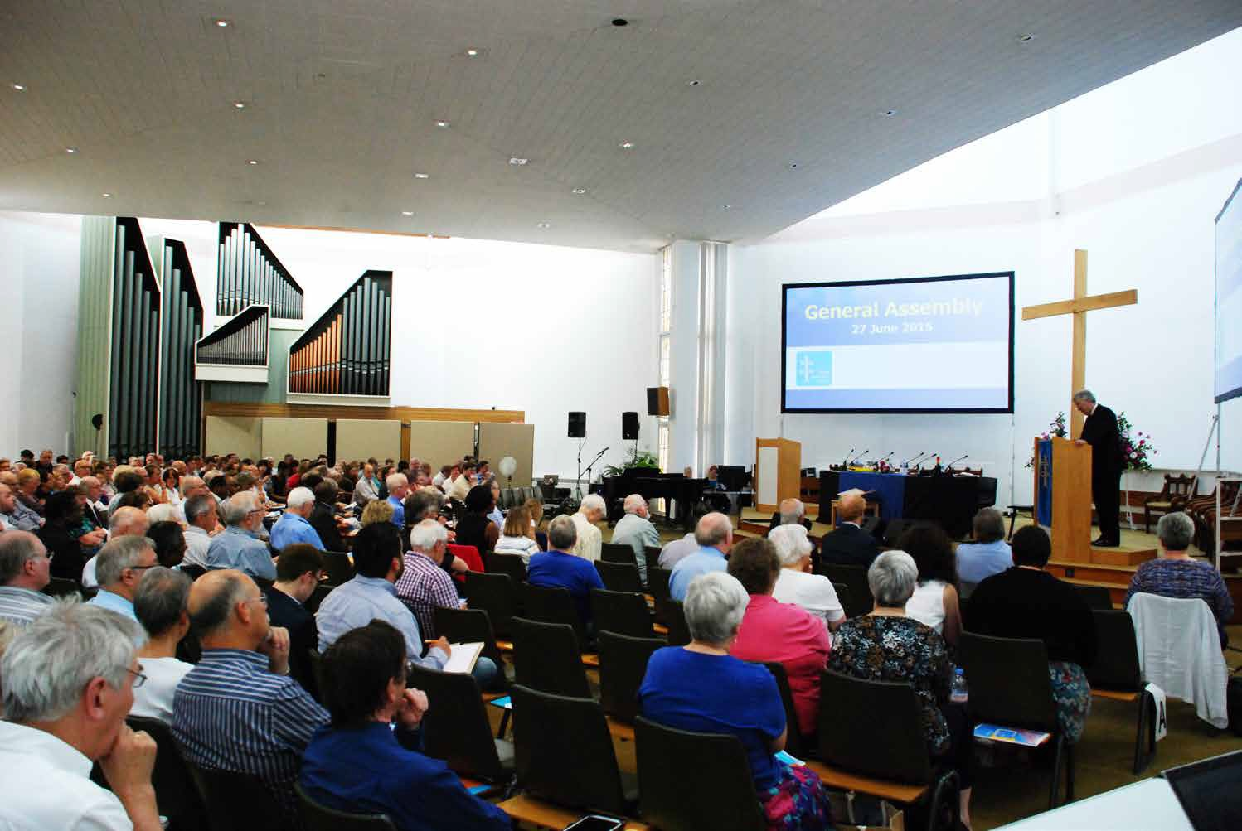

Members of the General Assembly prepare for the day ahead

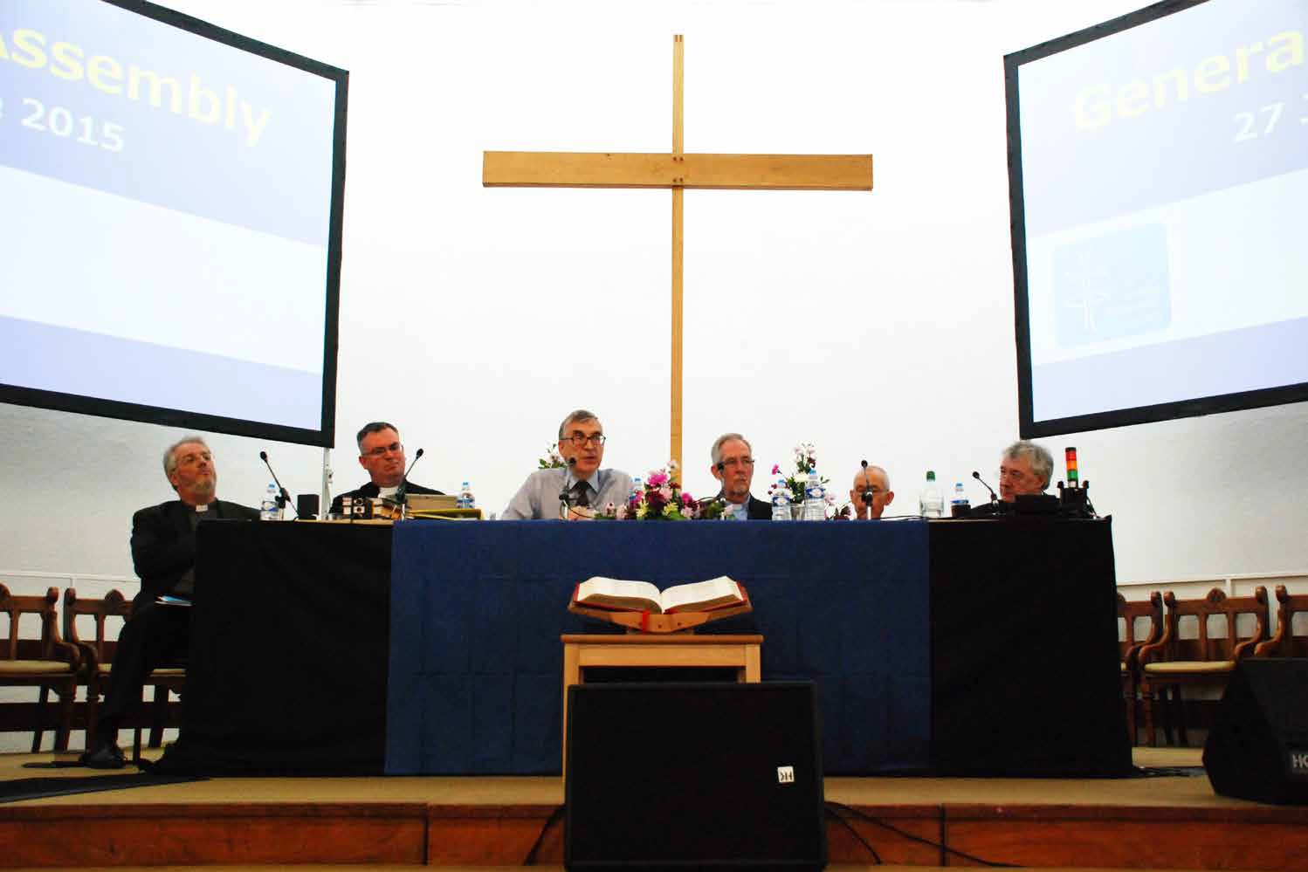
The platform party

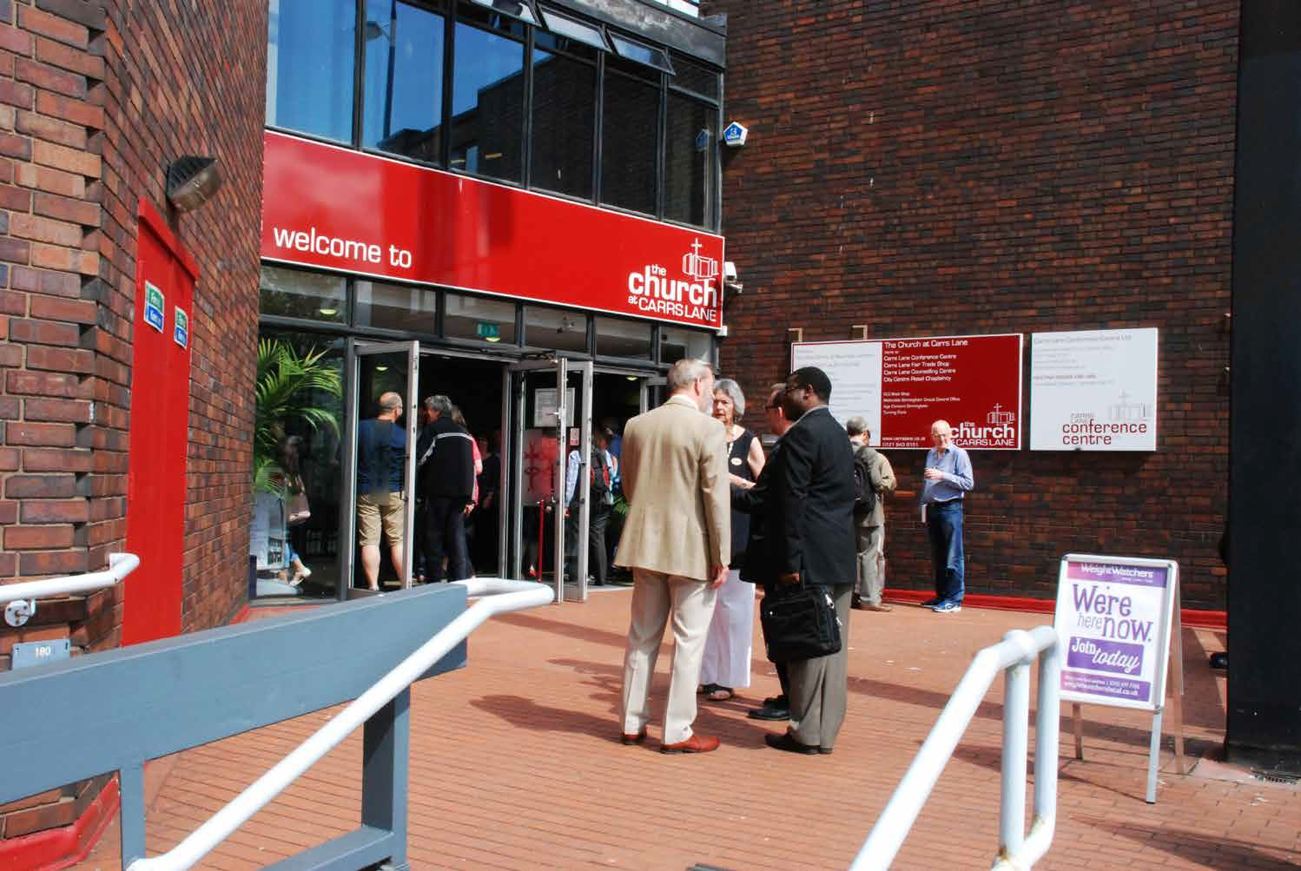
The Church at Carrs Lane, Birmingham

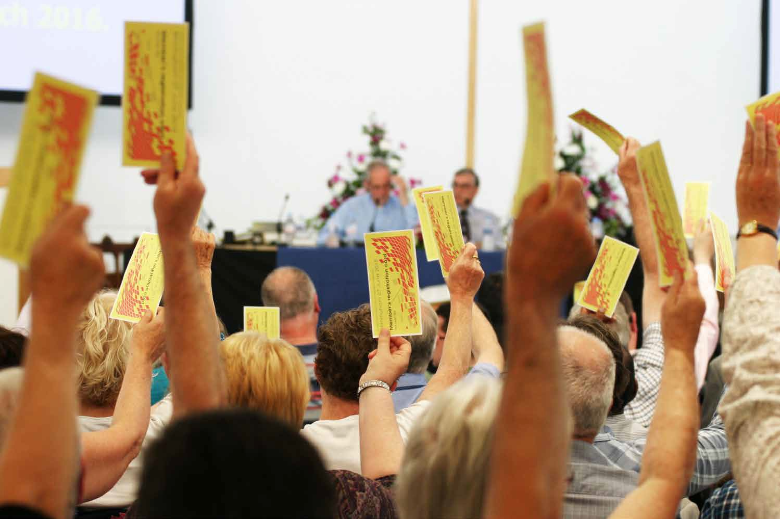
Voting in progress

