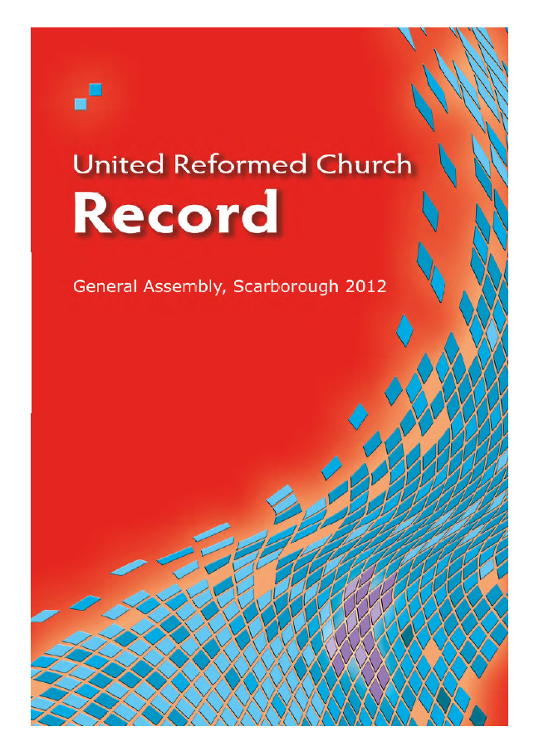

© The United Reformed Church, 2012 URC092
Published by
The United Reformed Church
86 Tavistock Place, London WC1H 9RT

All rights reserved. This material may be used freely within the churches.
No part of this publication may be reproduced outside the Church in any form or by any means – graphic, electronic, or mechanical, including photocopying, recording, taping or information storage and retrieval systems –
without the prior permission in writing of the publishers.

The publishers make no representation, express or implied, with regard to the accuracy of the information contained in this book and cannot accept any legal responsibility
for any errors or omissions that may take place.

© Photography
Mark Howard, Twenty-Five Educational www.base25.com and Chris Andrews, REFORM, Church House www.urc.org.uk

Designed by Sara Foyle, Communications graphic office, on behalf of the Assembly Arrangements Committee, The United Reformed Church, Church House, 86 Tavistock Place, London WC1H 9RT

Environmental credentials

Papers used in the production of this book are Character Express: Wood fibre from sustainable forests, fully recyclable and biodegradable, PEFC, 14001 certified, ECF, iso 9706 long life archival usage

Designed and printed by the graphics office in Communications on behalf of the Assembly Arrangements Committee, The United Reformed Church, Church House, 86 Tavistock Place, London WC1H 9RT

Printed on a RISO HC5500: low energy consumption/low heat output.
Sample batches of RISO products have shown a 100% recycle rate (IT equipment target, WEEE directive).

Produced with reference to See it Right: Making information accessible to people with sight problems (2006), Royal National Institute of the Blind, London. ISBN 1 85878 704 1

If you require this text in another format please inform the graphics office, Church House. Please give two weeks notice.

Matters for consideration and action

United Reformed Church • General Assembly 2012

Resolution number |  | Report page/s | Record page/s | Synods | Local churches
13 | Registration of civil partnerships on religious premises | 67, 245 | 21 | x | x
15 | Changes to the structure | 246 | 37 | x
18 | Giving to the Ministry and Mission Fund | 251 | 31 |  | x
21 | Synod Finacial Safety Net | 254 | 33 | x
22 | Ministers’ Pension Fund: revision of benefits | 256 | 34 | x
25 | Ending of full-time stipendiary service | 259 | 36 | x
28 | Addressing the social impact of poverty and inequality | 204, 261 | 22 | x | x
32 | A Pilots Sunday | 263 | 24 |  | x
34 | The Occupy Movement | 264 | 50 | x | x

United Reformed Church • Record of General Assembly 2012 • 1

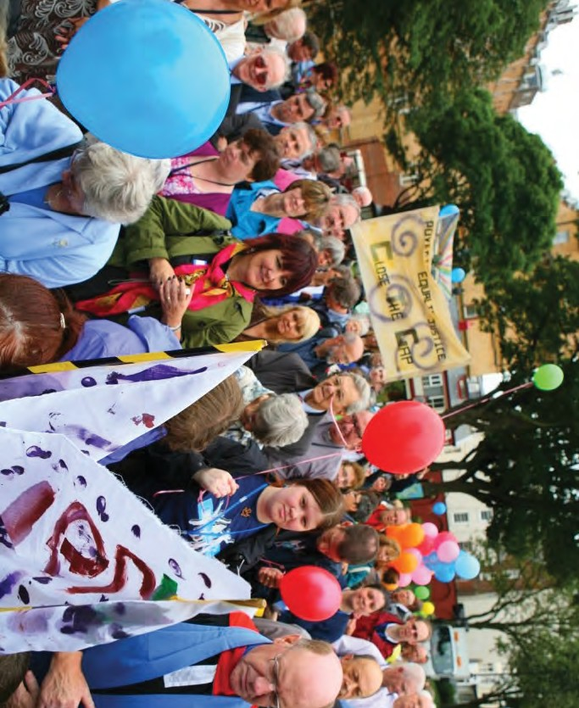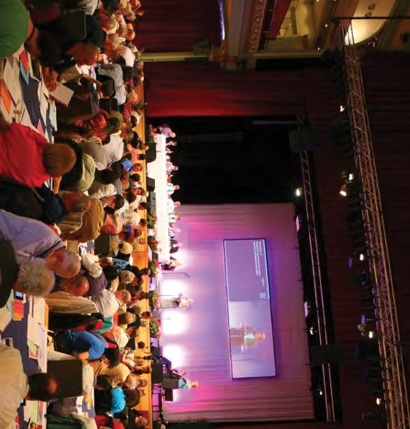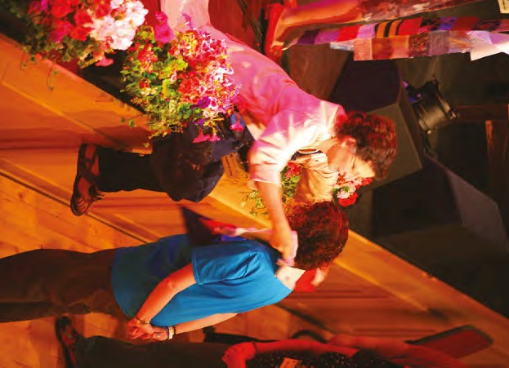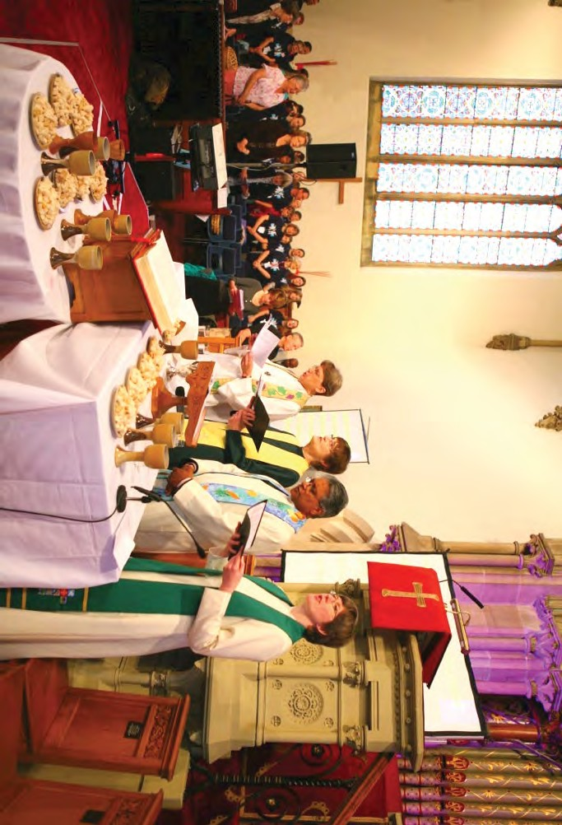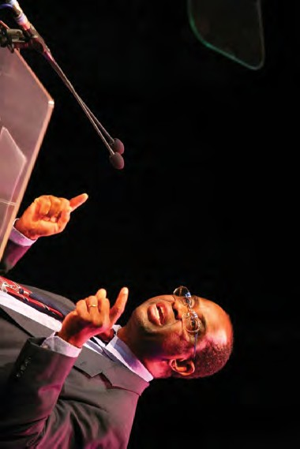
2 • Scarborough

Top to bottom: fabric squares collection; communion at St Andrews; the Assembly hall; guest speaker, Setri Nyomi; and the Walk of Witness

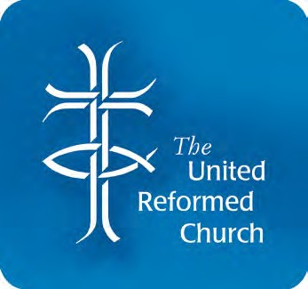
Record of Assembly

Minutes of the GENERAL ASSEMBLY of
THE UNITED REFORMED CHURCH 2012

Friday 6 July 2012 First Session

Constitution of Assembly
At 2.00 pm members of Assembly met in the Grand Hall at the Spa Complex in Scarborough. The Moderator, the Revd Dr Kirsty Thorpe, constituted the Assembly with prayer, the place and the time having been duly appointed.

Statement by the Clerk
The Clerk reported that the lay Moderator-Elect, Mr Lawrence Moore, had resigned and in consequence the serving lay Moderator, Mrs Valerie Morrison, would continue in office until Mission Council in May 2013. An election of a ministerial Moderator to serve 2014-16 and a lay Moderator to serve 2013-16 would be held at this Assembly.

Induction of Moderator
The Revd Dr Michael Jagessar, Moderator-Elect, was inducted with prayer into the office of Moderator of the General Assembly of the United Reformed Church. He signed the Assembly Bible and was presented with an inscribed copy of the Bible by the retiring Moderator of Assembly.

Thanks to the retiring Moderator
The thanks of the Church were expressed by the Moderator to the Revd Dr Kirsty Thorpe and her husband, the Revd Martin Smith, and to Mrs Val Morrison and her husband,
Mr Rod Morrison, together with their chaplains, the Revd Rachel Poolman and the Revd Dr James Coleman. Gifts were presented to Mr Smith and Ms Poolman.

Introductions
The key personnel, the theme and practical arrangements were introduced to Assembly.

United Reformed Church • Record of General Assembly 2012 • 3

The Roll of Assembly
Friday 6 July 2012
The Roll of Assembly was then placed on the table by the General Secretary, the Revd Roberta Rominger.
Moderators Revd Dr Michael Jagessar Mrs Valerie Morrison
Clerk Revd James Breslin
General Secretary Revd Roberta Rominger
Deputy General Secretary Revd Richard Mortimer

Moderators of synods | I | Revd Rowena Francis
 | II | Revd Richard Church
 | III | Revd Howard Sharp
 | IV | Revd Kevin Watson
 | V | Revd Peter Meek
 | VI | Revd Roy Lowes
 | VII | Revd Paul Whittle
 | VIII | Revd David Grosch-Miller
 | IX | Revd Clare Downing
 | X | Revd Dr Andrew Prasad
 | XI | Revd Nicola Furley-Smith
 | XII | vacant
 | XIII | Revd John Humphreys

Conveners of General Assembly Standing Committees and Task Groups
Assembly Arrangements Dr David Robinson
Communications and Editorial Revd John Humphreys
Education and Learning Revd John Smith
Equal Opportunities Revd Elizabeth Nash
Faith and Order Revd Elizabeth Welch
Finance Mr John Ellis
Ministries Revd Ruth Whitehead
Mission Revd Tracey Lewis
Mission Council Revd Dr Kirsty Thorpe
Nominations Revd John Durell
Pastoral Reference and Welfare Revd Sheila Maxey
Youth and Children’s Work Revd Robert Weston Chair of the United Reformed Church Trust Mr Alan Small

Immediate past Moderator Revd Dr Kirsty Thorpe

Former Moderators Revd Elizabeth Caswell
Revd Professor David Thompson

Theological College representatives
Northern College Staff Revd Dr John Parry Student Miss Kirsty Mabbott

Scottish United Reformed Staff Revd Dr Jack Dyce and Congregational College Student Mr Grant Wilson

Westminster College Staff Revd Dr John Bradbury
Student Ms Ruth Wilson
Windermere Centre Staff Mr Andrew Wood

Youth representatives
FURY moderator Mrs Jane Leighton
FURY moderator-elect Miss Rebecca Whiffen
Representative Miss Katy Unsworth

Chaplain (URC) to HM forces in Britain Revd Clare Callanan

Friday 6 July 2012

Synod representatives
Synod I – Northern
Revd Raymond Anglesea, Revd William Ellerby, Revd Alison Mills, Revd Rachel Poolman

Mr Matthew Appleyard, Dr Peter Clarke, Mrs Lucy Cooke, Mr Henry Gowland, Ms Jan Harper, Mrs Ann Honey, Mrs Margaret Humberston, Mr Robert Jones, Mr Danny Pigeon

Synod II – North Western
Revd Mark Bates, Revd Geoffrey Clark, Revd Sheila Coop, Revd Ruth Dillon, Revd Andrew Hall, Revd Michele Jarmany, Revd Brian Jolly, Revd Sarah Moore, Revd Elisabeth Mullen, Revd John Piper, Revd Stuart Radcliffe,
Revd Martin Smith, Revd Carolyn White, Revd Ronald Wilson

Mr Kenneth Coop, Miss Kathleen Cross, Mr Derek Estill, Mrs Kathryn Grand, Miss Judith Haughton, Mr Andrew Mudharara, Mr Conal Myers,
Mr Graeme Myers, Mrs Karen Radcliffe, Miss Charis Unsworth, Mrs Anthea Wickens, Mrs Denice Wilson

Synod III – Mersey
Revd Debbie Brown, Revd Janet Calderley, Revd Gwynfor Evans, Revd John Oldershaw, Revd Gary McGowan, Revd Gordon Smith, Revd Elizabeth Thomson, Revd Martin Truscott

Mrs Lynne Barker, Dr Nancy Cleave, Mrs Joan Colwell, Professor Bill Gould, Mr Philip Jones, Mrs Helen Renner, Ms Hannah Sharp, Mr Arthur Swift

Synod IV – Yorkshire
Revd David Coote, Revd Helen Drummond, Revd William Frame, Revd Dr Sarah Hall, Revd Angela Hughes, Revd Susan Macbeth, Revd Mark Robinson, Revd Mark Woodhouse

Mr James Dickson, Ms Katie Kissack, Mrs Jenny Poulter, Mr Chris Reed,
Mrs Barbara Robinson, Mr Neil Robinson, Mrs Marguerite Sobol, Mrs Janet Virr

Synod V – East Midlands
Revd Nancy Babarinde, Revd Steven Faber, Revd Malcolm Fife, Revd David Legge, Revd Martha McInnes, Revd Jennifer Mills, Revd David Poulton

Mrs Jennie Crane, Mrs Margaret Davies, Mr David Greatorex, Mrs Tricia Legge, Mr Peter Rippon, Mr Ian Salmon, Mr Duncan Smith, Mrs Valerie Smith,
Mrs Barbara Turner, Mrs Jill Turner

Synod VI – West Midlands
Revd Marilyn Allen, Revd James Church, Revd Jacqueline Embrey,
Revd Louise Franklin, Revd George Kalu, Revd Susan McCoan, Revd Craig Muir, Revd Timothy Mullings, Revd Dr Malachie Munyaneza, Revd Neil Riches,
Revd Stuart Scott, Revd James Taylor, Revd Marion Thomas

Mr John Desmond, Mrs Julie Jefferies, Mr George Jones, Mrs Margaret Marshall, Mr Peter Mills, Mr Thomas Munro, Miss Lucy Noble, Mrs Kathleen Phillips,
Mrs Val Phillips, Mrs Christine Watson

Synod VII – Eastern
Revd Peter Ball, Revd Sohail Ejaz, Revd Geoffrey Felton, Revd Trevor Jamison, Revd Andrew Kleissner, Revd David Rees, Revd Julian Sanders, Revd Lance Stone, Revd Matt Stone

Mr Stephen Ball, Mr Anthony Gilbert, Mrs Wendy Gilbert, Mrs Jean Hall,
Friday 6 July 2012
Mr Ian Hardie, Mrs Linda Harrison, Mr Gilbert Heathcote, Mr Clifford Patten, Mrs Faith Paulding, Miss Victoria Paulding, Mr Peter West

Synod VIII – South Western
Revd Douglas Burnett, Revd Sue Cossey, Revd Richard Gray, Revd Stella Hayton, Revd James Jang, Revd Iain McDonald, Revd Stephen Newell,
Revd Heather Whyte

Mr George Faris, Mrs Grace Hempstock, Mrs Brenda Jesse, Mrs Sarah Lane Cawte, Miss Sylvia Nutt, Mrs Jean Potter, Mr Stephen Steel, Mr Paul Winter

Synod IX – Wessex
Revd Nigel Appleton, Revd Richard Becher, Revd Paul Bedford, Revd Ken Blanton, Revd Clare Downing, Revd John Downing, Revd Carla Grosch-Miller,
Revd Michael Hopkins, Revd Philip Jones, Revd Elizabeth Kemp, Revd Mark Meatcher, Revd Tanya Rasmussen, Revd Timothy Searle, Revd Mary Thomas, Revd Christina Vivian

Mr Hugh Abel, Mrs Meg Abel, Mrs Karen Bulley-Morrison, Mrs Mary Cooper, Mr Tom Connacher, Mr Colin Ferguson, Mrs Christine Hardwick, Mrs Patricia Johnson, Mrs Virginia Lawson, Mrs Rosie Martin, Mr Alexander Nunn,
Mr Peter Pay, Mrs Jennifer Radford, Mr Duncan Reid, Mr Andrew Weston

Synod X – Thames North
Revd Ray Adams, Revd Timothy Clarke, Revd Bernard Collins, Revd Dr Gwennyth Collins, Revd John Danso, Revd Katrina Hackett,
Revd Dr Anthony Haws, Revd Ann Jack, Revd John Steele, Revd Julian Templeton

Mrs Sandra Ackroyd, Miss Patricia Akoli, Ms Sally Bateman, Mrs Suzanne Corney, Mrs Gill Elliott, Mr Simon Fairnington, Mrs Jackie Haws, Mr Brian Hosier,
Mrs Gill Hughes, Mrs Anne Lewitt, Mrs Sue Russell, Mrs Sue Saunders, Mrs Laura Templeton

Synod XI – Southern
Revd David Bedford, Revd Heather Cadoux, Revd Martyn Coe, Revd Michael Davies, Revd Derrick Dzandu-Hedidor, Revd Ana Gobledale, Revd Bernard Fidder,
Revd John Gordon, Revd Kavula John, Revd Suk In Lee, Revd Alexander Mabbs, Revd Iain McLaren, Revd Jennifer Millington, Revd Reginald Mudenda,
Revd Hilary Nabarro, Revd Kim Plumpton, Revd Darryl Sinclair, Revd Derek Wales

Mrs Lisa-Maria Browning, Mr John Bunker, Dr Adam Cumming, Mr Bruce Gill,
Mrs Eileen Lawlor, Miss Eleanor Macintyre, Mr Conor O’Connor, Mrs Linda Richards, Mrs Pam Rowden, Miss Katie Steel, Mr David Walters, Mr Alistair Wilson,
Mr Kenneth Wright

Synod XII – Wales
Revd Susan Fender, Revd Paul Floe, Revd Shelagh Pollard, Revd Gethin Rhys, Revd Paul Robinson

Mr Andrew Barkley, Mr Matthew Barkley, Mr Malcolm Breeze, Mr Clive Curtis, Ms Liz Scarisbrick

Synod XIII – Scotland
Revd Janet Adamson, Revd Connie Bonner, Revd John Bremner, Revd Alan McGougan, Revd Steven Manders, Revd Leslie Morrison, Revd Carolyn Smyth, Revd Mary Taylor, Revd Ian Wilkie

Mr Barclay Bannister, Mr Clive Bonner, Ms Eilidh Forsyth, Mr Mathew Henderson, Ms Mary Mbae, Ms Morag McLintock, Dr James Merrilees, Mr Simon Peters,
Ms Joanna Smith, Mr Patrick Smyth, Miss Sheena Young

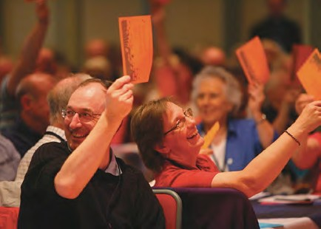
Friday 6 July 2012

British and Irish Ecumenical representatives
Revd John Bradley Churches Together in England
Revd Philip Cooper British Province of the Moravian Church
Dame Anne Doyle Roman Catholic Bishops’ Conference of England and Wales
Revd Dr John C A Emmett Methodist Church
Revd David Howe Baptist Union of Great Britain
Mr Richard Lake Presbyterian Church of Wales
Revd Alison McDonald Church of Scotland
Revd Malcolm T Muir Congregational Federation
Rt Revd Onye Obika International Ministerial Council of Great Britain
Rt Revd Dr Roy Patton Presbyterian Church in Ireland
Ven Dr Joy Tetley Church of England

Overseas representatives
Revd Bae Tae-Jin Presbyterian Church in the Republic of Korea
Revd Annie Chapon Eglise Réformée de France
Revd Wayne Hawkins CWM Europe
Revd Dr Setri Nyomi World Communion of Reformed Churches Bishop Wesis Porop The United Church of Papua New Guinea Revd Lala Rasendrahasina The Church of Jesus Christ in Madagascar

Bible Studies
The Moderator then introduced the Bible Study Leader, Professor Marilyn Legge, to the Assembly and she gave a brief introduction to the studies.
Two members of the Fellowship of United Reformed Youth (FURY) provided an introduction and demonstration of consensus decision-making.

The Clerk moved Resolution 1:
Resolution 1
Appointment of the Convener of Tellers for the election of the Moderators

General Assembly appoints Dr Jim Merrilees to serve as Convener of Tellers for the election of the Moderators.

Resolution 1 was passed by consensus.
The Clerk moved Resolution 2, noting that the members of the facilitation group were ready to act as “neutral friends” should work need to done on any of the resolutions as part of the consensus decision making process.

Resolution 2
Appointment of Facilitation Group members

General Assembly appoints Mr John Bunker, the Revd Janet Calderley, Mrs Sarah Lane Cawte, the Revd Trevor Jamison, the Revd Derrick Dzandu-Hedidor, the Revd Jacky Embrey, Mr Alistair Wilson and the Revd Stephen Newell
to serve as Facilitation Group members, with the freedom to involve others as appropriate.

Resolution 2 was passed by consensus.

The Clerk moved Resolution 37:
Friday 6 July 2012

Resolution 37
Changes to the Rules of Procedure

General Assembly resolves
- to suspend those parts of the Rules of Procedure relating to the election of Moderator of Assembly (paragraphs 3:1 and 3:14).
- that nominations by synods of elders as candidates for election submitted up to 31 May 2012 may be accepted.
- to elect a lay Moderator to serve from the meeting of Mission Council in May 2013 until the induction of the Moderators at the Assembly of 2016.

It was confirmed that the suspension would remain in force only for the duration of the current meeting of the Assembly. Resolution 37 was passed by consensus.

Mission Council
The Revd Dr Kirsty Thorpe introduced the Mission Council report and responded to questions and comments.
Dr Thorpe introduced Resolution 3:

Resolution 3 – Change to the Structure of the United Reformed Church
(The full text may be found on page 18.)

The Assembly was informed that the synods had been consulted concerning this proposed change to the Structure, and that the Eastern Synod had reported that the synod had passed a resolution “that the proposal be not proceeded with”, and in accordance with clause 3.1.(f) of the Structure, a representative of that synod, the Revd Professor David Thompson, presented the synod’s reasons for objecting.
After debate the resolution was put to the vote. The result being unclear and time preventing a tellered count the matter was remaindered.

Notice of a motion in the name of the Revd Clare Downing and the Revd Michael Hopkins, to be moved if Resolution 3 was adopted, was given.

Resolution 4
Disciplinary Process amendments to Part I

General Assembly agrees to ratify Resolution 5 of General Assembly 2010 to make the following changes to Part I of the Disciplinary Process (Section O):

Paragraph 1.1
In the second sentence after the words “Assembly Commission” remove the words “or, in the event of an appeal, the Appeals Commission”. {Note: Do not remove these words in the first or third sentences. They are correct there.}

In the final sentence, after the words “is also able to” remove the words “make recommendations (other than recommendations under Paragraph 1.3) and”.

After the words “Section F” insert “or, in the event of an appeal, Section G”.

Paragraph 1.3.1
Friday 6 July 2012
Remove the words “or, in the event of an appeal, the Appeals Commission”.

Paragraph 1.3.2
Replace the words “within the time limit therein specified” with “with all due expedition, consistent with the consultation process laid down by the Incapacity Procedure”.

(Note: This ties in with the change made by Mission Council to Part II, Para E.5.3.15.)
Remove the words “or the Appeals Commission”.

Paragraph 1.3.3 and Paragraph 1.3.4
Remove the words “or the Appeals Commission”.

Paragraph 2
After the words “Appeals Commission” insert “, the Special Appeals Body”.

Paragraph 7.2
After the words “case law” add “and/or official statements of good practice issued by a government department or agency”.

Resolution 4 was passed.

Resolution 5
Incapacity Procedure amendments to Part I

General Assembly agrees to ratify Resolution 6 of General Assembly 2010 making the following changes to Part I of the Incapacity Procedure (Section P):

Paragraph 1.1
The existing Paragraph 1 to become 1.1.

Paragraph 1.2
Add a new paragraph as follows:-
“The Review Commission may also decide to make a recommendation/referral in accordance with Part II Section H. The Review Commission or, in the event of an appeal the Appeals Review Commission, is also able to make recommendations (other than recommendations under Part II Section H) and offer guidance, but only within the limits prescribed in Part II Sections K and L”.

Paragraph 2
After the words “Appeals Review Commission” insert “, the Special Appeals Body”.

Paragraph 7
After the words “case law” insert “and/or official statements of good practice issued by a government department or agency”.

Resolution 5 was passed.

Resolution 6
Friday 6 July 2012
Amendment to the Structure of the United Reformed Church

General Assembly agrees to ratify Resolution 9 of General Assembly 2010 making the following changes to the Structure of the United Reformed Church:

Paragraph 2(6)(A)(xi)
Remove the words “Part I of the Statement of the Ministerial Disciplinary Process referred to in Function (xxxiii) below, and Part I of the Incapacity Procedure referred to in Paragraph 6 of the Structure.”

Paragraph 3.(1)
Change the reference in the text from “Paragraph 2.5.xi.” to “Paragraph 2(6) (A)(xi)”.

Paragraph 5.(2)
Change the reference in the text from “Paragraph 5(3)” to “Paragraph 6”. Resolution 6 was passed.

Resolution 7
Amendment to the Ministerial Disciplinary Process

Resolution 7 – Amendment to the Ministerial Disciplinary Process
General Assembly agrees to ratify Resolution 7 of General Assembly 2010 making the following change to Part I of the Disciplinary Process (Section O):

Paragraph 7
Remove this paragraph in its entirety.

Resolution 7 was passed.

Resolution 8
Amendment to the Incapacity Procedure

General Assembly agrees to ratify Resolution 8 of General Assembly 2010 making the following change to Part I of the Incapacity Procedure (Section P):

Paragraphs 6 and 7
Remove these two paragraphs in their entirety.

Resolution 8 was passed.

The General Secretary named those ministers who were celebrating ministerial jubilees during the year.

50th Anniversary
Derrick Peter Ackling Kenneth Douglas Alway-Jones Lionel George Anderson Marjorie Ayton
Peter Ward Beaman MBE Arthur Jack Beeson Anthony Gerald Burnham Alan Odian Cassingham John William Stewart Clark David Vandepeer Clarke Michael Graham Dunford Donald Wakefield Elliott Robert James Ellis
David Charles Macara Gardner Jack Ernest Garside
Wilfred Kievill Gathercole Anthony John Wigton Groom Michael Edmind Heard Frederick Leon Hill
Micah Hopley
John Johansen-Berg Peter Stanley Killick Graham Ellis Henry Long

John William McCrum Miller Max Armstrong Moore David Cranford Morgan Barry Richard Parker
Donald L Pines Donald Powis
John Patrick Reardon Roy Stanley Richards John Robinson Roger Kaye Scopes John David Shakesby Malcolm Shapland Kenneth Simpkin Brian John Slater John Malcolm Smith
Dorothy Constance Spence Frederick Ernest Thomson Antony Arthur Tomlinson Harold Robert Tonks
Alan David Trinder Robert Waters Adrian John Wells Donald Whitehead

60th Anniversary
Basil Ernest Bridge Eric Carless
James Dey
Norman Keith Fisher Colin Ray Garwood David Stanton Goodall Albert Greasley
Leslie Craven Green Paul Green
Kenneth John Henry Hibberd Cyril Allsebrook Hobson Charles J Alexander Innes Leslie Smith Ivory
Richard Kayes Alan William Lyde
Thomas Howard Owen Willian Trevor Parr John Dennis Pickering Donald Schofield
70th Anniversary
Stanley Hodges Henry Martin Cook
Charles Ernest Burland Cranfield Lawrence S Squires

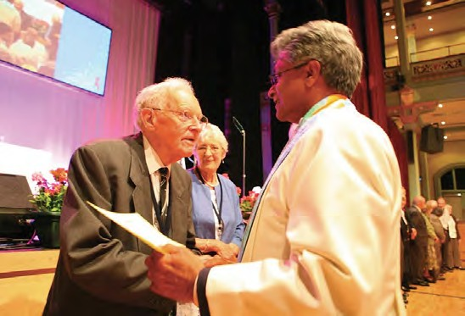
Friday 6 July 2012
Those present were greeted by the Moderators and received the warm applause of the Assembly.

Special mention was made of the Revd Bernard Thorogood O.B.E., who started his ministry in 1952, who served as General Secretary of both CWM and the URC and who now resides in Australia in retirement and of the Revd Reg Dean aged 109, celebrating 83 years of ministry.

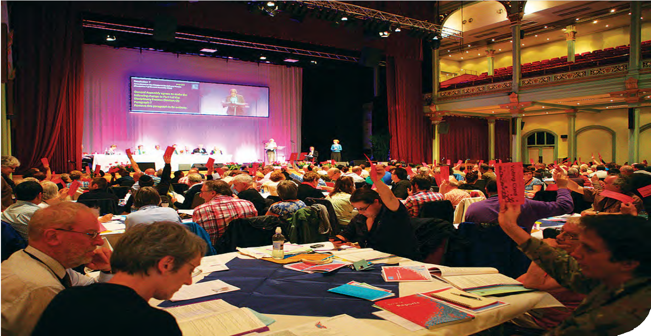Our history 1
Friday 6 July 2012
The Revd Professor Stephen Orchard delivered the first of his talks on the history of the United Reformed Church.

Welcome from the Mayor and Mayoress of Scarborough
The Moderator received the Mayor and Mayoress of Scarborough, Councillor Helen and Miss Lucy Mallory, and invited Councillor Helen Mallory to address the Assembly.

The retiring Moderators, the Revd Dr Kirsty Thorpe and Mrs Val Morrison, addressed the Assembly, reflecting on their two years in office.

The Assembly adjourned for dinner.

Record of Assembly

Friday 6 July 2012 Second Session

The Moderator, Dr Jagessar, took the chair. The Children’s Assembly joined the Assembly.
The Moderators greeted the Revds Clare Downing, Nicola Furley-Smith and Peter Meek, Synod Moderators inducted since the last Assembly, and the Revd Simon Walkling soon to be inducted as Synod Moderator in Wales.

Worship
The chaplain, Melanie Smith, led the Assembly in prayer.

She announced that Silcoates School choir regretted that they could not attend Assembly due to the bad weather and poor weather forecast. Assembly joined in singing.

The Children’s Assembly
The Moderator welcomed the children to the large Assembly gathering.

Who are we sitting next to?
Mrs Morrison suggested that members of Assembly found a person they did not already know and introduce themselves.

Youth and Children’s Work video
Members of Assembly watched a short film about children in our society with some of the difficulties they face.

Nominations Committee
The Committee convener, the Revd John Durell, presented the report from the committee. He thanked all those who graciously and willingly give of their best to the Church.

He proposed the resolution:

Resolution 30
Nominations

General Assembly appoints committees and representatives of the Church as set out on pages 146 to 160 of the Book of Reports, subject to the additions and corrections contained in the Supplementary Report to Assembly.

The Revd David Tatem was invited to respond to a question from the floor. Mr Durell responded to other questions and comments.

Resolution 30 was passed by consensus.
(N.B. The full list of appointments appears as Appendix 3 page 63)

The Chaplain Melanie Smith invited Assembly to sing ‘Spirit of Holiness’ by way of a prayer of thanks to all those who serve the Church.

Reception of New Ministers
Friday 6 July 2012
The Moderators greeted those ministers and Church Related Community Workers
(CRCWs) present, who had been ordained or commissioned or received by transfer since the previous meeting of the Assembly.

- Northern Synod The Revd Rowena Francis introduced:
*Kate Baxter, non-stipendiary 07/08/2010
Belford, Chatton, Crookham, St Cuthbert’s North Sunderland, Wooler, Berwick, 2010-

*Alison Mills, non-stipendiary 09/10/2010
Mid Northumberland Mission Partnership with pastoral charge of St Mark’s Church, Amble 2010-

Joan Ross, stipendiary by transfer 21/04/2012 Ponteland, Newcastle upon Tyne 2012-

- North West Synod The Revd Richard Church introduced:
Mark Bates, stipendiary 17/09/2011 Bolton Vision Pastorate 2011-

Andrew Hall, stipendiary 17/07/2010
Christ Church, South Manchester and Levenshulme 2010-

Anthea Wickens, stipendiary 21/11/2010 Littleborough 2010-

- Mersey Synod The Revd Howard Sharpe introduced:
Jeff Hughes, stipendiary 04/09/2010 Prenton and Wallasey Village 2010-

Liz Thomson, stipendiary 13/08/2011 Hoole and Farndon 2011-

- Yorkshire Synod The Revd Kevin Watson introduced:
Mark Robinson, stipendiary 25/06/2011 Spen and Calter Enterprise (SPACE) 2011-

- East Midlands Synod The Revd Peter Meek introduced:
Jennie Crane, CRCW 01/08/2011 Castle Hill 2011-

- West Midlands Synod The Revd Roy Lowes introduced:
James Church, stipendiary 30/07/2011 Lillington Free Church and Radford Road 2011-

Sue McCoan, stipendiary 10/07/2010 Wylde Green 2010-

James Taylor, stipendiary 26/06/2010 Tetbury, Fairford and South Cerney 2010-

Revd Wilbert Sayimani from Presbyterian Church of Zimbabwe Walsall Pastorate (Broadway, Blakenall and Hatherton) 2012-

- Eastern Synod The Revd Paul Whittle introduced:
Julian Sanders, stipendiary 31/07/2010 Thetford, Wattisfield and Diss 2010-

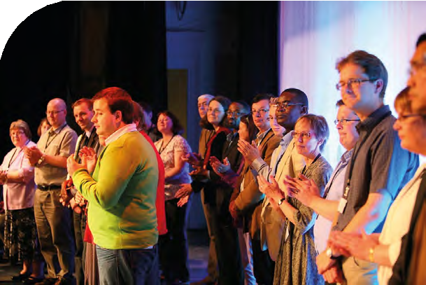
Friday 6 July 2012

Matthew Stone, stipendiary 07/08/2010 Wroxham and Hoveton, Mattishall, Wymondham,
The United Reformed Church
in Norwich – Ipswich Road, Jessopp Road, Princes Street, Trinity 2010-

South Western Synod
The Revd David Grosch-Miller introduced:
Sue Cossey, non-stipendiary 30/04/2011 South Western Synod 2011-

James Jang, stipendiary 01/04/2011
East Bristol Group of Hanham, Oldland Common and Wick, 2011-

- Wessex Synod The Revd Clare Downing introduced:
*Nicola Gilbert, non-stipendiary 03/03/2012 Wessex South East Area Minister 2012-

John Lee, non-stipendiary 02/10/2010 Thatcham 2010-

- Thames North Synod The Revd Dr Andrew Prasad introduced:
*Lucy Berry, non-stipendiary 03/10/2010 Bethnal Green Meeting House 2010-

- Southern Synod The Revd Nicola Furley-Smith introduced:
Heather Cadoux, stipendiary 22/10/2011 Epsom, Ewell and Tolworth 2011-

Bernard Fidder, non-stipendiary 23/09/2010 Robertsbridge and Sedlescombe 2010-

Ana Gobledale, stipendiary by transfer 22/07/2010 Brockley, New Cross 2010-

* Tod Gobledale, non-stipendiary by transfer 22/07/2010 Brockley, New Cross 2010-

Iain McLaren, stipendiary 11/09/2010
Peckham, Copleston Centre Church, Dulwich Grove and Camberwell Green 2010-

Reggie Mudenda, stipendiary by transfer 16/08/2011 Streatham, Brixton Hill and Stockwell 2011-

Kim Plumpton, stipendiary 25/09/2010 Cobham 2010-

- Synod of Wales The Revd Simon Walkling introduced:
Sue Fender, stipendiary 16/07/2011 Elfed Avenue, Penarth 2011-

Paul Robinson, stipendiary 18/06/2011 The United Church in Rhyl 2011-

- Synod of Scotland The Revd John Humphries introduced:
Alan McGougan, stipendiary 27/08/2011 Annan 2011-

* These ministers could not be present

The children left the Assembly at this point.
Friday 6 July 2012

Assembly joined in the song, ‘I, the Lord of sea and sky.’

Local Ecumenical guests
The Revd Kevin Watson introduced the Chairman of Sheffield Methodist District, the Revd Vernon Marsh, and from the West Yorkshire Ecumenical Council, the Revd Dr Clive Barrett. Hestor Miller, the co-clerk of Scarborough Local Quaker Meeting, had been present for the afternoon session only.

British and Irish Ecumenical guests were introduced by the Revd David Tatem. The Revd John Emmett addressed the Assembly.

World Church guests were introduced by the Revd Jane Rowell. The Revd Lala Rasendrahasina from the Church of Jesus Christ in Madagascar addressed the Assembly.

Assembly joined in the song, ‘Walk in the light of the Lord.’

Moderator’s Address
Mrs Val Morrison introduced this section, looking forward. She felt that living conversations need to challenge, inspire and recognise God’s blessings so that small conversations could grow into significant actions for Christ’s sake.

“Why are we here?”
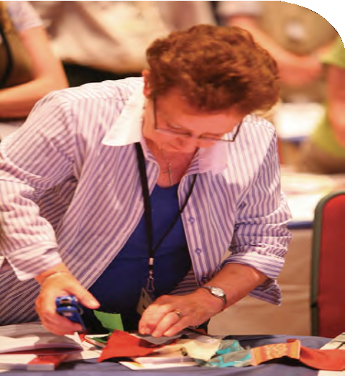Dr Jagessar spoke with passion and enthusiasm as he looked forward to the United Reformed Church reaching beyond the usual preoccupations of shrinking numbers and resources. We needed to start conversations about radical new directions; organise our finances; and decide how we might share the good news. We should affirm our many blessings and expect God to use us and work through us. There is hope and much potential in a small grain if we are able to trust in our generous God and in each other. We are not alone and God has, by grace, chosen us to further his work if we are bold enough to grasp the possibilities.

The music group sang ‘Spirit of gentleness’.

“What is going to happen?” Covenanting together in living conversations
The chaplains and Moderators led prayers of confession and commitment.

Assembly sang ‘Let us build a house’ during which fabric squares were joined together at each table.

The chaplain led the closing prayer. Assembly adjourned at 9.30 pm.


Record of Assembly

Saturday 7 July 2012 First Session

Opening worship was led by the Chaplain, Melanie Smith, assisted by two representatives of the Children’s Assembly. The children then left to continue their own work.

Professor Marilyn Legge led the Assembly in Bible study – “Living Conversations Then” Dr Jagessar took the chair and gave an outline of the business for the morning.

Synod Moderators report
The Revd David Grosch-Miller introduced the Synod Moderators report, “Wilderness ways and transitional tremors.” He asked that the report might be made available for use in local congregations. Mr Grosch-Miller responded to questions from the floor.

Moderators’ Think Tank – “the vision!”
Dr Thorpe introduced the report from the Moderators’ Think Tank.
A request was made that material concerning the Think Tank might be made available for synods and local churches.

Finance Committee – “setting the scene”
Mr John Ellis explained the background to the financial situation within the Church. The Moderator invited table groups to discuss two questions based on the three
reports just offered. The chaplain then led the Assembly in prayer.

Following the conversations, the Moderator thanked everyone for their involvement and invited the sharing of comments.

The presenters of the three reports responded.

Mrs Morrison took the Chair and the children joined the Assembly to participate in the next business.

vision2020
Ms Francis Brienen and Jo Williams updated Assembly about vision2020. They encouraged members of Assembly to familiarise themselves with the vision2020 statements and then complete the activity sheets on the tables.

Ms Brienen thanked everyone for the ‘speed visioning’. The Moderator expressed the thanks of the Assembly.

The Revd Dr Setri Nyomi, General Secretary of the World Communion of Reformed Churches, addressed the Assembly.

The Moderator then presented Dr Nyomi with a gift from the United Reformed Church.

Notice of Motion
Saturday 7 July 2012
The Revd Professor David Thompson gave notice of a resolution to be put later should Resolution 3 be passed:

Resolution 44
General Assembly resolves that when amendments to the Basis of Union are proposed, it shall also decide whether or not this change might be approved for a second time by Mission Council.

Proposed by the Revd Clare Downing and seconded by the Revd Professor David Thompson.

It was noted that the proposed resolution in the names of the Revd Clare Downing and the Revd Michael Hopkins had been withdrawn.

Resolution 3
Change to the Structure of the United Reformed Church

General Assembly resolves to ratify Resolution 26 of General Assembly 2010 amending paragraph 3 of the Structure of the United Reformed Church to read: 3.(1) No exercise of the function of constitutional amendment contained in
2.5.xi shall have effect unless the following procedure has been followed:
- The proposal for the amendment shall be made in accordance with the Standing Orders of the General Assembly.
- Either the General Assembly or, in years when the General Assembly does not meet, the Mission Council shall vote on a motion to approve the proposal which shall require a majority of two-thirds of the members present and voting to pass.
- If such motion to approve the proposal is passed the General Assembly or the Mission Council, as the case may be, shall refer the proposal to synods and may, if it deems appropriate, in exceptional cases also to local churches.
- If the proposal has been agreed by the General Assembly it shall set a final date for responses to be made, which shall normally be at an
appropriate time before a meeting of the Mission Council not less than nine months after the meeting of the General Assembly at which the proposal was agreed.
- If the proposal has been agreed by the Mission Council it shall set a final date for responses to be made which shall normally be at an appropriate date before the next ordinary meeting of the General Assembly.
- If by such date notice has been received by the General Secretary from more than one third of synods (or, if it has been so referred, more than one third of local churches) that a motion ‘that the proposal be not proceeded with’ has been passed by a majority of members present and voting at a duly convened meeting of such body, then the Assembly or the Mission Council, as the case may be, in its concern for the unity of the church shall not proceed to ratify the proposal.
- If by such date such notice has not been received, a motion to agree the proposed amendment shall come before the General Assembly at its next meeting or before the Mission Council at a meeting specified by the
General Assembly. If such a motion is before the General Assembly it shall require a majority of two-thirds of the members present and voting to pass. If the motion is before the Mission Council it shall require a simple majority of the members present and voting to pass. In its concern for mutual understanding within the life of the church, before voting on such a motion the General Assembly or Mission Council shall invite a representative of any synod from which the General Secretary has duly received notification under 3(1)(e) to present the main reasons for
its objection.

- If such a motion is passed by such a majority the amendment shall have effect.
Saturday 7 July 2012
- For the purposes of this paragraph 3(1), only synods and local churches in existence on the date set for responses to be made shall be counted in the calculations.
3.(2) In the case of motions which would have the effect of terminating the separate existence of the United Reformed Church, or of a synod within it, by union with other churches, the voting process to be used shall be not less
stringent than in 3.(1) and that process shall be determined by a single vote of the General Assembly which shall require a two-thirds majority of those present and voting to pass. In the case of a proposed union affecting only Scotland or Wales no action will be taken by the General Assembly until a decision in favour of union has been taken by the relevant synod.

Having been deferred from the first session of the Assembly the vote on this resolution was taken. Resolution 3 was passed by a large majority.

Resolution 43 containing the text of a statement to be presented to the Member of Parliament for Scarborough was proposed by the Revd Dr Michael N Jagessar and seconded by Mrs Val Morrison.

Resolution 43
Statement to Mr Robert Goodwill MP

Scarborough Statement

The General Assembly of the United Reformed Church meeting at The Spa Complex in Scarborough from 6-9 July 2012 has reflected on a report on the social impact of poverty and inequality in the UK.
- We are alarmed by the unjust distribution of wealth in the UK. The economic growth before the crash did not reach the poorest – who got poorer in real terms – and we are appalled that austerity measures are hitting the same people. As 1500 congregations across England, Scotland and Wales, we are witnessing the effect of austerity.
- We are particularly concerned about the impact of these reforms on children living in poverty, people with disabilities, asylum seekers and other vulnerable groups of people needing compassion and care. We are also alarmed at the increasing rate at which people are being rendered destitute and homeless as a result of the protracted economic recession and ensuing unemployment and the high number of young people not in education, employment or training.
- We are deeply disturbed by the moral scandal where those least responsible for the global financial crisis and economic recession are paying the highest cost in terms of destroyed livelihoods, loss of income, home and, most importantly, loss of hope.
- Our biblical reflections underscore that this is not the way to the flourishing life that God desires for humanity based on a just ordering of society and commitment to the common good. We believe that every human being has inherent worth as a being created in the image of God which bestows dignity
and respect of each and every person regardless of their social status or income.
- We therefore reject the negative stereotyping of the poor and other vulnerable groups of people and affirm that they are not merely to be seen as objects of our pity and charity, but as individuals and communities bearing rights – specifically the right to be treated with the dignity and respect that their worth requires. This leads us to an understanding of justice as inherent rights and the belief that justice is present in a society insofar as the members of society enjoy the life-goods which are due to them (i.e. the goods to which they have a right).

- Motivated by the above, we believe that the current reforms to public policy are creating an unjust social order in the UK which systematically wrongs the most vulnerable members of our communities.
Saturday 7 July 2012
- We therefore call on the Government to:
  - establish an independent commission to assess the impact of the spending cuts and social policy reforms on vulnerable people in the UK
– particularly people with disabilities, the elderly, asylum seekers and those without secure housing– and to review all policy reforms in the light of this assessment;
  - expedite the reforms to tax laws to ensure that tax avoidance is outlawed by the introduction of the simple principle that actions done with the main intention of avoiding tax are not taken into consideration by tax authorities – a General Anti-Avoidance Rule;
  - respond to the overwhelming body of evidence in support of the efficacy and utility of introducing a financial transaction tax, as an innovative means to raise finance to address the deepening poverty and inequality in the UK and other good causes overseas;
  - continue to provide funding for legal aid and debt counselling from Central Government to enable vulnerable people to access the legal services they need.
- Finally, we thank Mr Robert Goodwill, MP for agreeing to receive this statement on behalf of the Government and request him to raise the issues outlined above with the relevant Minister and Government Departments and to come back to us with their response.

After debate Resolution 43 was passed.

Election of Moderators of General Assembly 2013-16 and 2014-16
The Clerk explained the election process. Mrs Morrison led the Assembly in prayer before members of the Assembly cast their votes.

Members of the Children’s Assembly sang grace, after which Assembly adjourned.

Saturday 7 July 2012 Second Session

Dr Jagessar took the chair. The chaplain led the Assembly in prayer for the Revd Paul Floe’s family. Mr Floe had left the Assembly owing to his son’s serious illness.

The minutes of First and Second Sessions were presented. A number of corrections were noted and would be incorporated into the Record.

Resolution 13 – Human sexuality, civil partnerships
Dr Thorpe introduced this item of business. The Revd John Waller presented the report.

Mr Waller declared that the resolution was framed in the spirit of the Commitment made by the Assembly in 2007. He said that recognising our diversity was one of our strengths and that this issue was only one aspect of that diversity. Acceptance of the resolution would set us apart from some other denominations but would give each local United Reformed Church the ability to make its own decisions on the matter. A number of questions for clarification were asked, to which Mr Waller responded.

Resolution 13
The registration of civil partnerships on religious premises

General Assembly, recognising the considerable differences of conviction held within the Church on same-sex relationships and holding to its commitment on human sexuality passed in 2007, grants its consent for church meetings within the United Reformed Church, if they so wish, to direct the trustees of their church’s premises (or to request the trustees of other premises, the use of which their church shares) to apply for approval of those premises for the registration of Civil Partnerships.

This would be applicable in England and Wales only. It would not apply in Scotland, the Channel Isles or the Isle of Man where the law on civil partnership registration has not yet changed. The Scottish Government has initiated a separate consultation and the Synod of Scotland has made a submission in response.

Following discussion Resolution 13 was passed by agreement. The following members of Assembly subsequently registered their dissent from this decision:

Revd Geoff Felton Revd Paul Robinson Revd Mark Woodhouse Revd Chris Vivian
Record of Assembly
Revd James Church Revd Matthew Stone Revd Heather Cadoux Revd Steven Manders Revd Sohail Ejaz
Revd David Howe Revd Carolyn White Revd Gary McGowan Revd Steve Faber
Mr David Walters
Revd Bernard Fidder Mrs Sue Russell
Mrs Marguerite Sobol Revd Stephen Newell Revd James Jang
Mr Simon Fairnington Mr George Kalu
Ms Mary Mbae Revd Sheila Coop
Miss Judith Haughton Revd Debbie Brown Mrs Liz Scarisbrick
Mr Duncan Reid

Dr Thorpe thanked Mr Waller for his work as convener of the Human Sexuality Task Group.
Saturday 7 July 2012

Mrs Morrison took the chair.

Mission Committee
The Revd Tracey Lewis, Convener, presented the report including a film made by Ann Morisy who was not able to be present.

Ms Lewis initiated discussion and asked that the responses be given in writing to the Mission Committee for further consideration.

Ms Lewis paid tribute to the work of the former convener, the Revd Ed Cox. The Moderator then invited Ms Lewis to respond to the comments made. She did so, and thanked all who had made comments, stating that Mission Committee needed to know what people in the Church were thinking.

The Moderator welcomed Paul Morrison from the Joint Public Issues Team who presented resolution 28 beginning with a brief video on poverty.

Resolution 28
Addressing the social impact of poverty and inequality in the UK

General Assembly resolves to encourage members of the United Reformed
Church to “keep faith with the poor and challenge injustice” (vision2020) and to work to end inequality in our society by:
- affirming the work of CRCWs and others in working with the poorest communities;
- welcoming the moves by synods and congregations to commit to paying the Living Wage and encouraging others to do the same (which presently equates to £7.20 per hour outside of London and £8.30 in London);
- renewing our call for the introduction of a multi-lateral financial transaction tax as an innovative way of mitigating the impacts of poverty and inequality in the UK and supporting other good causes such as climate change mitigation and adaptation and poverty alleviation overseas;
- encouraging churches and church members to actively challenge attitudes and language which treats those in poverty as anything less than people made in the image of God and to ask the Joint Public Issues Team to provide resources to help do this effectively both in the public and the private spheres;
- committing the Church to speak prophetically, particularly through the work of the Joint Public Issues Team and the Close the Gap campaign;
- supporting work to highlight injustices against the poorest, including spending decisions, unfair taxation and misrepresentation of the poorest.

Resolution 28 was passed by consensus.

Ms Lewis thanked the Mission Team for their expertise and hard work.

The children re-joined the Assembly for the presentation of the Community Awards.

The Moderator introduced Ms Margaret Slater from Congregational and General Insurance, the company which sponsors the awards. There were four winners.
Each received a plaque and cheque.

The following three projects each received £2,000:

The Avenue, Southampton, for work with mothers and children among asylum seekers;
Saturday 7 July 2012
The Terminus Initiative in Sheffield, an ecumenical café and shop, community centre and garden;
Our Tribe, the LGBT welcoming and affirming ministry at Augustine United Church, Edinburgh.

The Winning Project: The Edge, a project for young people in Bradford, received a cheque for £3,000.

Wheatcroft School Singing Squad
The singing group from the school sang songs to the Assembly.

Ecumenical matters
The Revd David Tatem introduced the Rt Revd Albert Bogle, Moderator of the General Assembly of the Church of Scotland, who was greeted by the Moderator.

Mr Tatem reported that the URC had not made the significant ecumenical progress it had hoped would be possible since formation in 1972, although there was much to be optimistic about. The Ven Joy Tetley, Church of England, expressed her feelings after the service of Healing and Reconciliation at Westminster Abbey in February. A newly formed group from both our Churches would continue to work for closer understanding.
Roman Catholic / United Reformed Church conversations had been on-going for 5 years. Dame Anne Doyle addressed the Assembly. She encouraged the URC to talk with other denominations about the issues that they have in common. The Revd John Bradley from Churches Together in England reported on his current perspective.

Report from the Children’s Assembly
Representatives from the Children’s Assembly explained their work. The children used ‘Thinking Hats’ to demonstrate how conceptualising things in different ways could bring creative insights and solutions to problems.

  - 23

Youth and Children’s Work Committee
Saturday 7 July 2012
Revd Rob Weston, Convener, presented the report. The video shown on the previous day was repeated. Mr Weston proposed and Mrs Jane Leighton seconded Resolution 31.

Resolution 31
Affirming Pilots

General Assembly affirms the Youth and Children’s work offered by Pilots and commends it to all local churches.

Resolution 31 was passed by consensus.

Mr Weston and Mrs Leighton then moved Resolution 32.

Resolution 32
A Pilots Sunday

General Assembly encourages local churches to celebrate Pilots through a dedicated Sunday service, suggesting a Sunday in June, every year.

Resolution 32 was passed by consensus.

Review of the Role of Synod Moderator
The Revd Professor Stephen Orchard presented the report and there was some discussion.

Business was interrupted for several minutes by a false Fire Alarm, following which the business related to the Review of the Role of Synod Moderator was remaindered.

The Moderator invited the Rt Revd Albert Bogle to say grace.

The General Assembly adjourned to meet again at 9.00 am on the following day at St Andrew’s URC.

Saturday evening celebration of the Fortieth Birthday of the United Reformed Church
After dinner the General Secretary introduced the Revd Paul Robinson, who would be compering the evening. Pictures of the Uniting Assembly were shown and some in the hall indicated that they had been present at the ceremony. The spirit of ecumenism was still abroad in 1981 when the Reformed Association of Churches of Christ of Great Britain and Ireland joined, and in 2000, the Congregational Union of Scotland.

There was much to celebrate: 75 years of Pilots; 25 Years at the Windermere Centre; 25 years of Training for Learning and Serving (TLS); the completion of Vision4Life;
20 years of Commitment for Life with projects in Zimbabwe, Palestine, Bangladesh and later Jamaica. Assembly sang a new hymn written by Alan Gaunt for the birthday year and heard encouragement from the General Secretary to continue to move forward as inheritors of a tradition of dynamic energy and hope.

The party moved on to the Grand Hotel where there was a further celebratory concert led by the Revd Stephen Brown and “Thursday’s Child”.

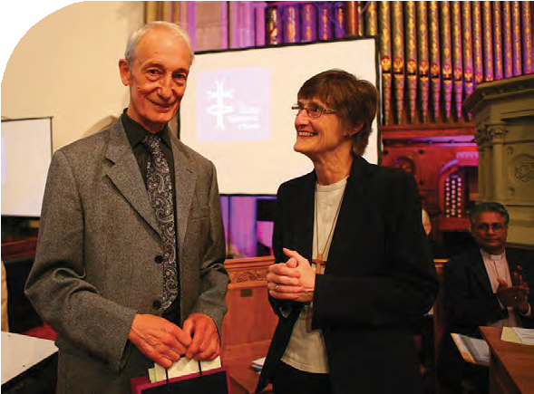
Record of Assembly

Sunday 8 July 2012 First Session

Assembly gathered at St Andrew’s Church, Ramshill Road where a welcome was given by the minister, the Revd Jason McCullagh.

Announcement of Moderators-elect 2013-16 and 2014-16
The Moderator, Mrs Morrison, invited Dr James Merrilees to announce the result of the election of Moderators of Assembly.

Dr Merrilees reported that in the election for the Ministerial Moderator, 275 votes had been cast, 1 paper had been spoiled, and the Revd David Grosch-Miller had been duly elected as Ministerial Moderator for 2014-16; in the election for the Elder Moderator, 274 votes had been cast, 2 papers spoiled and Mr John Ellis had been duly elected as Elder Moderator for 2013-16.

Our history
The Revd Professor Stephen Orchard gave his second presentation. He focused on hymnody over the period of our history.

Presbyterian Church in Ghana
The Revd Jane Rowell gave an update of the current position.

Thanks to Hartley Oldham
The Moderator and General Secretary thanked Mr Oldham for his service to the United Reformed
Church over very many years. The Assembly greeted Mr Oldham with prolonged applause and the Moderator presented a gift to mark our thanks.

Assembly Arrangements Committee
The Convener, Dr David Robinson, spoke to the report.

Church changes
The General Secretary proposed that:

Resolution 11
Church changes

General Assembly receives notice of the closure of the local churches listed on pages 173 to 180 (of the 2012 Book of Reports) and in the Order Paper for Sunday 8th July and gives thanks to God for their worship, witness and service.

Aylesbeare United Reformed Church, South Western Synod
Beeston United Reformed Church, East Midlands Synod
Trinity Church (Methodist and United Reformed), Burton-on-Trent, East Midlands Synod

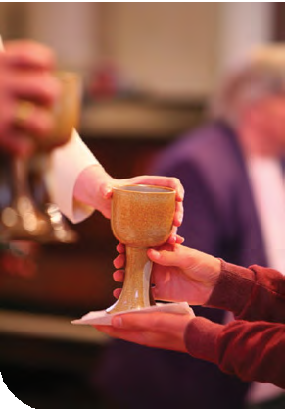

Clyro with Hay-on-Wye, Synod of Wales
Sunday 8 July 2012
Trinity Church, Cottam Hall, Preston, North Western Synod Zion United Reformed Church, Flockton, Yorkshire Synod Galashiels United Reformed Church, Synod of Scotland Garn United Reformed Church, Abercarn, Synod of Wales Gnoll United Reformed Church, Neath, Synod of Wales High Easter United Reformed Church, Essex, Eastern Synod
Trinity United Reformed Church, Ifield, Crawley, Southern Synod
Christ Church, Johnstown, Wrexham, Synod of Wales
Kimberworth Road United Reformed Church, Rotherham, Yorkshire Synod Linthorpe United Reformed Church, Middlesbrough, Northern Synod Maiden Bradley United Reformed Church, Wessex Synod
St John’s Local Ecumenical Partnership, Grove Green, Maidstone, Southern Synod
Marlborough United Reformed Church, South Western Synod
Newton-in-Bowland, North Western Synod
Christ Church Painswick (Baptist and United Reformed Church), West Midlands Synod
Trinity United Reformed Church, Pembroke Dock, Synod of Wales Slough United Reformed Asian Christian Church, Thames North Synod South Cave United Reformed Church, Yorkshire Synod
Church of Reconciliation, Westcliff, Scunthorpe, East Midlands Synod Toxteth with Sefton Park United Reformed Church, Mersey Synod Wethersfield United Reformed Church, Eastern Synod
Whixall United Reformed Church, Stanley Green, Whitchurch, West Midlands Synod Wootton Trinity Christian Centre (Methodist and United Reformed), Northampton, East Midlands Synod

Resolution 11 was passed by consensus.

The General Secretary proposed Resolutions 9 and 10:

Resolution 9
Bournemouth International Church

General Assembly receives the Bournemouth International Church as a local church of the United Reformed Church.

Resolution 9 was passed by consensus.

Resolution 10
Heston Asian United Reformed Church

General Assembly welcomes the West London United Reformed Asian Christian Fellowship, a mission project of the United Reformed Church, as a local church of the United Reformed Church, to be known as the Heston Asian United Reformed Church (HAURC).

Resolution 10 was passed by consensus.

Representatives of the two churches were greeted by the Moderators.

Dedication of new communion vessels
The Assembly turned to the dedication of new communion cups and plates. These were the gift of Mrs Judith Johnson and designed by her husband, Martin, and made by his son, Graham, and Mr Albert Reed. The Moderator, Dr Jagessar, dedicated the vessels with thanks and prayer.

26 • United Reformed Church • Record of General Assembly 2012

The Children joined Assembly to share worship.

Celebration of Holy Communion
The act of worship and celebration included the commemoration of ministers and missionaries who had died since the Assembly met in Loughborough in 2010.
Assembly remembered:

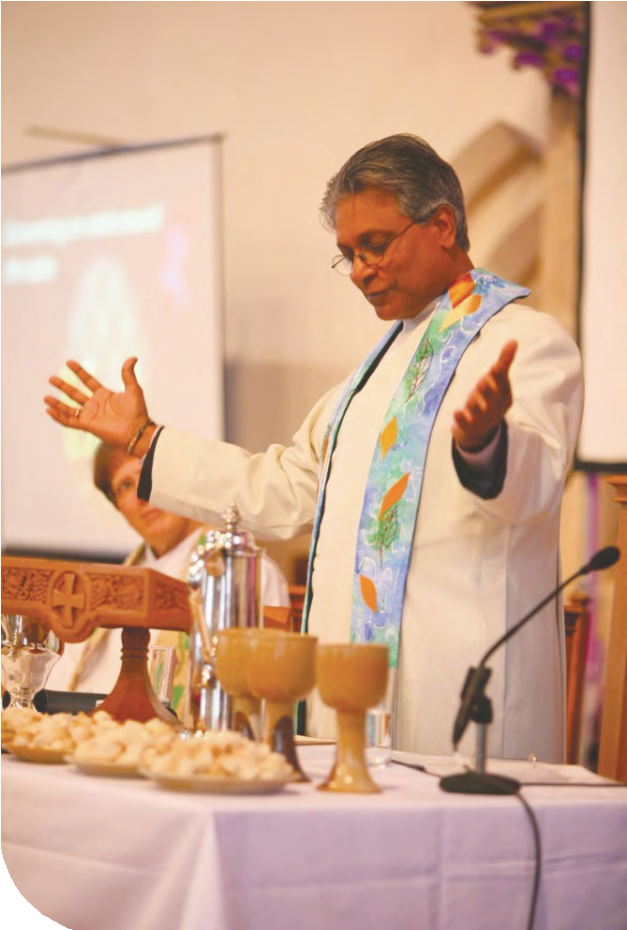Evelyn Ella (Lyn) AGNEW Kwadwo Ntiamoa AMANING Douglas William BALE
Sunday 8 July 2012
Alan BATTERBEE
Daisy Beryl BENNETT Bevan BIRD
Irene Guendolen BLIGH Gillian Mary BOBBETT Ronald Arthur BOCKING Frederick William CARD Edwin Charles CHUBB Arthur Ernest CIRCUS David Ernest CLARK Richard John COLLINS Ivor DAVIES
Bryan DAWSON John McBride DEAN
Robert Howat DUNCAN William EDWARDS Sidney Samuel EVANS Andrew FRASER
Frank GARVEY Ronald Harry GATES
Terence Edward GIRLING Thomas McClure GORDON John Carrick GOUDIE Gordon Ewart HARRIS Richard George HELMN
John Stronach HENDERSON (Missionary) Donald Harold HILTON
John Hugh HINDS David William HOLLEY
Wilfred (Wilfrid) HOUGH Christine Finlayson HUNTER George Norman HUYTON Pearce JONES
Robert Douglas JONES Thomas JONES
William Brighouse JONES Olive Sylvia KIMBERLEY
Ernest Norman KINGSLEY-SMITH
Ian Ralph Matheson LATTO (Missionary) Beryl LYDE
John J MacKELVIE
Norman Frederick McPHERSON Stuart Hardy MARSH
Monica Ann MILLS Frederick Ernest MOORE Frank Ronald NUNN Clifford Bewley PARKIN John Craddock PRICE John Nigel ROGERS
James Adolphus RYAN Bernard SHEPPARD Owen SKILLETER
Alfred Victor SMITH Wallace SNADE Ronald Dougall SPEIRS Howard Alan STARR
Derek Homewood STRANGE Olive Doreen SYMES
Alan Edward TAYLOR John Horace TAYLOR Andrew THOMPSON Sheila Elizabeth THORPE Francis Roger TOMES Harold Keith TRICE Peter Llywelyn TROW Alasdair John WALKER Muriel Lilian WATERTON
Christopher John WEDDLE Roland John WHITE
Alan WILLIAMSON
Kathleen Mary WILSON

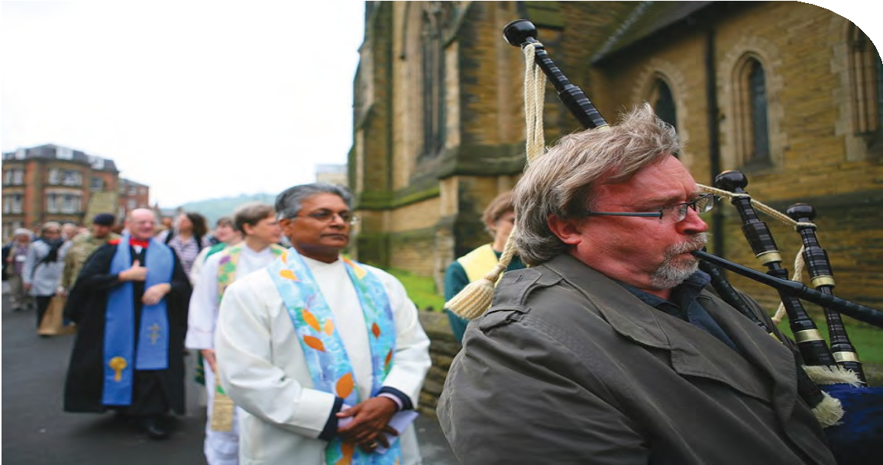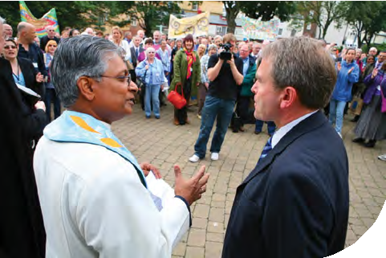Walk of Witness to the Town Hall
Sunday 8 July 2012
Members of Assembly walked to the town hall as an act of witness where the local Member of Parliament, Mr Robert Goodwill MP, was presented with a copy of the “Scarborough Statement” agreed in a previous session of Assembly.

Sunday 8 July 2012 Second Session

The Revd Dr Michael Jagessar took the Chair and apologised for an error in the consensus decision making process on Saturday afternoon.

Resolution 33 – Adults aged 20 to 40 Youth and Children’s Work
In response to the growing numbers of adults aged 20 to 40 that are disappearing from the United Reformed Church, General Assembly asks Mission Council to address this issue and consider how to improve the integration of this age group at every level of the United Reformed Church.

The resolution was presented by the FURY Moderator, Mrs Jane Leighton, who challenged the whole Church to take the issue seriously and indicated that the
United Reformed Church might be able to work ecumenically on the matter. She then responded to questions.

An alternative wording of the resolution was proposed by Miss Victoria Paulding and Mr Andrew Weston.

The Revd Robert Weston, convener, responded that the committee would be content with the passing of either form of the resolution and after further discussion the Moderator suggested that the two sets of wording be referred to a facilitation group. This was agreed.
Revd Robert Weston

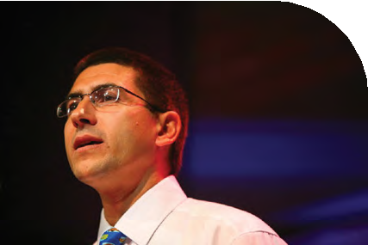
Record of Assembly

Ministries Committee
The Revd Ruth Whitehead, Convener of the committee, presented the report. There were no questions or comments.

Ms Whitehead then introduced the Revd Clare Callanan, Assembly representative from the Armed Forces Chaplains, who showed a DVD showing some of the work of the chaplains. Dr Jagessar’s chaplain, Melanie Smith, led the Assembly in prayer.

Ms Whitehead then introduced Resolution 26 of the Ministries Committee on Resourcing Ministry. Ms Whitehead noted that in paragraph 17 of the report there were missing figures, and asked the Assembly to note that the reference should have been to
“up to 26 CRCW posts and 60 SCM posts”.

Resolution 26 – Resourcing Ministries
General Assembly:
- receives the report of the Ministries Committee working party on resourcing ministry;
- agrees that the resources used to support the Special Category Ministry programme will now be available to synods to support a wider range of ministry and sets the central Church costs of 2.5 stipends as the amount available to
each synod;
- requests the Ministries Committee to monitor the effects of this policy and consider whether it is practical and desirable to move to a method of funding all ministry that is delivered by a block grant to each synod.

- In light of the proposal to delegate decisions about special ministries to the synods, General Assembly agrees that the Ministries Committee should end the practice of making grants out of central funds to support higher education chaplaincy or workplace ministry.
Sunday 8 July 2012

Ms Whitehead said that it could be that instead of using the blanket figure of 2.5 stipends as in b) above, the number of stipends could vary for each synod. She presented suggested figures ranged between 1.7 and 3.1 stipends which were based on the same weighting as that currently used for deployment numbers.

Ms Whitehead and the Revd Craig Bowman responded to questions. It was noted that if a lay person were employed using the resources proposed, it would be the synod who was the employer. It was also confirmed that no existing posts would be terminated, but that they would be allowed to come to an end naturally. There would therefore be no need for redundancies. After considerable discussion this matter was remaindered.

Interfaith guests
The Moderator welcomed Interfaith guests and the Imam, Quari Asim, brought greetings.

Westminster College appeal
The Principal, the Revd Dr Susan Durber, expressed the thanks of the College for the financial support which had been given by the Assembly. Dr Durber reported that the total raised to date was £5,832,176, the target being £7 million.

Dr Jagessar offered the good wishes of Assembly.

Resolution 44

General Assembly resolves that when amendments to the Basis of Union are proposed, it shall also decide whether or not this change might be approved for a second time by Mission Council.

Resolution 44, which was proposed by the Revd Clare Downing and seconded by the Revd Professor David Thompson, was moved and passed. The Clerk assured Assembly that Mission Council would be asked to approve a change to the Rules of Procedure to incorporate this decision.

Mrs Val Morrison then took the Chair.

Finance
Mr John Ellis, the Honorary Treasurer, presented the Finance Report. Mr Ellis moved Resolution 17.

Resolution 17
Trustees’ Report and Financial Statements for 2011

General Assembly notes the Trustees’ Report and Financial Statements for the year ended 31 December 2011.

Resolution 17 was passed by consensus.

The Clerk explained that it was necessary to replace the existing Governing Document, which had been adopted by General Assembly 2007 and which set out the relationship between the United Reformed Church Trust and the Assembly, with a new document

Sunday 8 July 2012

which would more accurately reflect that relationship. Accordingly Mr Breslin moved Resolution 39.

Resolution 39

General Assembly rescinds the Resolution 23 of Assembly 2007 adopting the Governing Document setting out the relationship between General Assembly and the United Reformed Church Trust.

Resolution 39 was passed with the necessary 75% majority. The Treasurer then moved Resolution 40.

Resolution 40
Selection and appointment of Members of the United Reformed Church Trust.

General Assembly receives and adopts the document: “Policy in relation to the
Selection and Appointment of Members of the United Reformed Church Trust” as printed in Appendix 2.

Resolution 40 was passed by a majority vote. The Clerk then moved Resolution 45.

Resolution 45
Extension of Service on Trust

Assembly agrees to extend the Revd Professor David Thompson’s period of service upon the Board of the United Reformed Church Trust by two years, until the General Assembly of 2014.

Mr Breslin answered questions and Resolution 45 was passed by consensus. The Revd Dr Kirsty Thorpe moved Resolution 18.

Resolution 18
Giving to the Ministry and Mission Fund

General Assembly, acknowledging the overflowing generosity of God and the desire of God’s people to respond with grateful hearts:
  - thanks sincerely all church members and treasurers whose commitment has made possible Ministry and Mission Fund receipts totalling over £40m across the last two years;
  - reiterates its policy agreed in 1992 and reiterated in 2003 that church members should be encouraged to give at least 5% of their income after tax to the Church;
  - calls on all ministers, elders and lay preachers to present creatively the financial dimensions of Christian discipleship so that the Church becomes a community of cheerful givers.

Dr Thorpe responded to questions, and Resolution 18 was passed by consensus.

Dr Thorpe then introduced and moved Resolution 19.
Sunday 8 July 2012

Resolution 19
Trends in Minister numbers

General Assembly directs that for 2013 and until further notice, the target number of stipendiary ministers should be set so that the direct cost of supporting the ministry from the Assembly budget moves in line with the trend in overall membership numbers across the Church.

Resolution 19 was passed by consensus.

Mr Ellis then introduced and moved Resolution 20.

Resolution 20
Reshaping the 2013 Budget

General Assembly, noting the need for a substantial reduction in net expenditure for the 2013 budget and the work done by Mission Council on specific areas of costs, requests that in preparing their 2013 budgets Committees achieve the following minimum net expenditure reductions relative to their 2012 budgets:

Assembly Arrangements Committee £50k Communications and Editorial Committee £40k Education and Learning Committee £200k Ministries Committee £60k
Mission Committee £150k

Youth and Children’s Work Committee £100k

The Moderator invited questions and comments of which there were many expressing wide ranging views. It was clear that proposed cuts were unwelcome and resisted in many instances.

Mr Ellis thanked members of Assembly for the variety of helpful comments. He gave responses with clarity.

Resolution 20 was passed by agreement. The following members of Assembly subsequently registered their dissent from this decision:

Revd Sohail Ejaz Revd Mark Meatcher Ms Charis Unsworth Mrs Jane Leighton
Ms Eleanor MacIntyre Mr Stephen Ball
Mr Matthew Appleyard Mrs Faith Paulding
Mr Simon Peters Ms Katie Steel
Ms Katy Unsworth Revd Robert Weston Revd Stuart Radcliffe Mr Alex Nunn
Revd Debbie Brown Ms Victoria Paulding Mr Andrew Weston

Mr Ellis introduced and moved Resolution 21, noting that it had been commended by Mission Council.
Sunday 8 July 2012

Resolution 21
Synod financial safety net

General Assembly agrees to a last resort financial safety net for synods outlined in the following form (included in the report to Assembly as paragraphs 4-7):

- The stipends and some related costs of synod moderators are already funded from the Assembly budget. In broad terms the other essential core costs of running a synod arise from the following requirements:

- holding decision-making sessions of synod, traditionally two annually;
- providing administrative support for the synod moderator;
- providing administrative and professional support for the synod trust, especially with regard to property matters, and the trust providing such support to local churches;
- overseeing ministers/CRCWs and candidates for the ministry and providing pastoral and mission support to churches;
- fulfilling the functions of synod between synod meetings;
- liaising with General Assembly as required;
- providing support to local churches regarding good practice;
- functions required, urged or requested by Assembly resolutions, including currently:
  - employing and providing line management for a Children and Youth Development Officer (CYDO);
  - implementing Local Ministry and Mission Review and various other training requirements for EM2, EM3, elders, lay preachers and others.

- To fulfil these responsibilities core costs in practice may have to cover, depending on the availability of skilled volunteers:

- costs of holding two full meetings of the synod per year;
- provision of an office base for administrative staff;
- administrative and venue costs for committee meetings;
- part-time administrator to liaise with Church House and act as PA to the moderator;
- CYDO, also acting as safeguarding adviser;
- training and development officer;
- part-time trust and property officer;
- part-time book-keeper;
- audit, accountancy and legal fees.

- If a financial safety net were needed at some point for a synod to fulfil these basic core tasks, the following process would provide it within the framework of relationships that makes the United Reformed Church what it is today.

- The safety net process would only be initiated at the request of the synod concerned.
- If the synod had not already supplied a three year budget plan to the Finance Committee it would present one.
- The Finance Committee would provide someone – the finance friend – to work alongside the synod to clarify its financial position and consider options for the future.
- If the synod wished to pursue the possibility of support from the Assembly budget, the finance friend would bring to the Finance Committee proposals supported by the synod.
- The Finance Committee would make recommendations to Mission Council within the context of the Assembly budget in the light of the request from

the synod. Any proposal for support would make clear whether this was a short term measure or expected to continue for the longer term.
Sunday 8 July 2012

- In implementing this procedure, the following principles would be followed:

- the synod would accept that all its resources, including designated funds and property, would be part of the discussion with the finance friend;
- the synod would accept that only the sort of core costs outlined above would be eligible for any support from the Assembly budget;
- the synod and Assembly would accept their legal and moral responsibilities towards all employees, and to ministers and CRCWs carrying out synod duties as part of their scoping.

Mr Ellis responded to questions and Resolution 21 was passed by consensus. Mr Ellis introduced Resolution 22.
Resolution 22 – Ministers’ Pension Fund: revision of benefits
General Assembly authorises Mission Council to agree to changes in the Rules of the Ministers’ Pension Fund to reflect those changes in benefits on which the members’ consultation in 2012 was based.

Mr Ellis thanked those who had contributed their views and confirmed that entitlement to housing would remain the same as at present at age 65.

The Revd Gethin Rhys moved the amendment which had been printed on the Order Paper for Sunday, 8 July:

Delete the final full-stop and replace with a comma, then add the words:

and instructs the Ministries Committee and Synods urgently to put in place the necessary pastoral support for ministers, CRCWs and churches affected by these changes, to consult with ecumenical partners and others affected by these changes, and to engage in long-term workforce planning taking full account of the wishes
of individual ministers and CRCWs regarding their retirement plans and pension entitlements.

The proposed amendment was passed by a large majority. Mr Ellis then moved the amended Resolution 22.

Resolution 22
Ministers’ Pension Fund: revision of benefits

General Assembly authorises Mission Council to agree to changes in the Rules of the Ministers’ Pension Fund to reflect those changes in benefits on which the members’ consultation in 2012 was based, and instructs the Ministries Committee and synods urgently to put in place the necessary pastoral support for ministers, CRCWs and churches affected by these changes, to consult
with ecumenical partners and others affected by these changes, and to engage in long-term workforce planning taking full account of the wishes of individual ministers and CRCWs regarding their retirement plans and pension entitlements.

Resolution 22, as amended, was passed by majority vote.

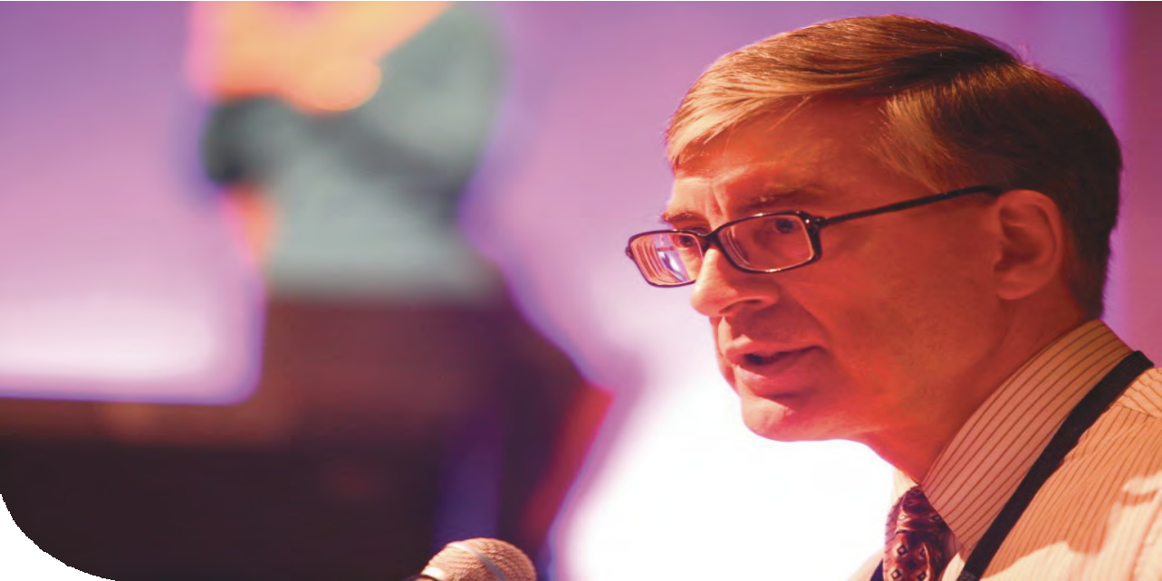
Sunday 8 July 2012

Mr Ellis then moved Resolution 23.

Resolution 23
Ministers’ Pension Fund: rationale for ill-health pension enhancement

General Assembly, on behalf of the United Reformed Church, confirms to the Trustee of the United Reformed Church Ministers’ Pension Fund that it
reasonably appears to the United Reformed Church that the introduction of a phased service enhancement to members of the Pension Fund joining after 31 December 2012, to be paid upon retirement in circumstances of ill-health (in the manner described in Appendix 1: “Proposals for change to the United Reformed Ministers’ Pension Fund”) fulfils a “business” need and will be to the benefit of members of the Pension Fund and the United Reformed Church.

Resolution 23 was passed by majority vote. Mr Ellis then moved Resolution 24.

Resolution 24
Pensions Auto-Enrolment

General Assembly agrees that from 1 July 2012 the Church will only offer two pension schemes for ministers and lay staff: The United Reformed Church Ministers’ Pension Fund and The Pensions Trust Final Salary Scheme.

Mr Ellis responded to questions. Resolution 24 was passed by majority vote. The Assembly adjourned for dinner.

Record of Assembly

Sunday 8 July 2012 Third Session

The chaplain, the Revd Dr James Coleman, opened the evening session with a Call to Worship.

Professor Dr Marilyn Legge used images of water to discuss ‘Living conversations about power and identity’, which included group discussion around the tables.

Mrs Morrison took the Chair and advised the Assembly of revisions to the order of business and of her intention to reach Resolution 38 not later than 8.15 pm.

She then sought an update on the condition of the Revd Paul Floe’s son. The Revd Elizabeth Kemp reported that he was in Swansea Hospital, and had been taken off life support. The Assembly was pleased to hear that it was expected that he would make a full recovery.

The Convener of the Ministries Committee, the Revd Ruth Whitehead, moved Resolution 25:

Resolution 25
Ending of full-time stipendiary service

Assembly agrees that full-time stipendiary service for Ministers and Church Related Community Workers will cease at the end of the month in which a person reaches her/his 68th birthday unless:

- a commitment to extend has been agreed through current procedures before 6 July 2012; or
- a case has been accepted by the Accreditation Sub-committee that there are exceptional reasons why the particular piece of stipendiary service should be extended for a limited time.

The Convener explained that working until 68 and then retiring was not compulsory. Retirement at 65 would still be possible for those who wished to do so but would have some impact on the level of pension paid. She took a number of questions among which was a question concerning the date of commencement. Ms Whitehead clarified that if the resolution was passed the change would take effect immediately.

Resolution 25 was passed by consensus.

Resolution 41
Retirement Age of Moderators of Synod

Assembly agrees to amend clause 7.2.3 of the Rules of Procedure to read,
“. Moderators shall not be eligible to hold office following the elapse of one month from their sixty eighth birthday unless the General Assembly in special circumstances determines otherwise.”

The Assembly Clerk proposed the resolution, which was seconded by the General Secretary. Resolution 41 was passed by consensus.

Sunday 8 July 2012

Resolution 12 – Re-appointment of the Treasurer
General Assembly appoints John Ellis as Honorary Treasurer for a further period of service from 2013 to 2017.

In the light of the fact that Mr Ellis had been elected as Moderator for General Assembly 2013-2016 it was proposed that this matter should be referred to the
Mission Council Advisory Group (MCAG) and then taken to Mission Council for decision. This was agreed.

Resolution 15
Changes to the Structure

General Assembly agrees to make the following changes to the Structure of the United Reformed Church: (Where sections are replaced, changes from the existing are shown in red type.)
Synod Functions 2(4)(A)(xvii)
Amend to read as follows:
where the Synod, acting through its Moderator (or his/her duly appointed deputy) in accordance with either the Disciplinary Process contained in Section O of the Manual of the United Reformed Church (where the issues relate to perceived disciplinary breach(es)) or the Incapacity Procedure contained in Section P of the Manual (where the issues relate to perceived incapacity as defined in the Incapacity Procedure), considers that a minister or Church Related
Community Worker is not or may not be exercising his/her ministry in accordance with Paragraph 2 of Schedule E or Paragraph 2 of Schedule F, Part II to the Basis of Union, as the case may be, to take the appropriate one of the following courses namely (i) to refer the case of that minister or Church Related Community Worker into the Disciplinary Process in the manner prescribed by that Process and to
act in accordance with the provisions thereof as regards the suspension of the minister or Church Related Community Worker concerned pending the resolution of the matter under that Process (reference to be made to Paragraph 7.5 of the Structure to ascertain the point at which a Disciplinary case shall commence) or
(ii) to follow the Consultation Procedure prescribed by the Incapacity Procedure which could in its turn lead to the case of the minister or Church Related Community Worker being referred into the Incapacity Procedure and to act in accordance with the provisions thereof as regards the suspension of the minister or Church Related Community Worker concerned pending the resolution of
the matter under that Procedure (reference to be made to Paragraph 6.5 of the Structure to ascertain the point at which a case shall commence within the Incapacity Procedure) (the transitional overlap which occurs when a case is
referred back from the Disciplinary Process or the Incapacity Procedure leading to the commencement of a case within the other of them shall be a permitted extension of the Function).

2(4)(A)(xviii)
Amend to read as follows:
to ensure that, where an Assembly Commission or an Appeals Commission following a Hearing under the Disciplinary Process contained in Section O
of the Manual of the United Reformed Church or a Review Commission or an Appeals Review Commission following a Hearing under the Incapacity Procedure contained in Section P of the Manual{words omitted} appends guidance to its decision to delete the name of the minister or Church Related Community Worker from the respective Roll, any such {words omitted} guidance is brought fully to the attention of those responsible for exercising oversight of the minister or Church Related Community Worker and any others who might in the future be identified as being proper and appropriate persons to receive such information;

2(4)(A)(xxi)
Sunday 8 July 2012
Amend to read as follows:
to consider the resignation of ministers or Church Related Community Workers not currently the subject of any case within the Disciplinary Process contained in Section O and in consultation with the moderator of the Synod to decide upon appropriate action {words omitted};

2(4)(B) Remove this paragraph altogether.

2(4)(C) This paragraph now becomes 2(4)( B) and is amended to read as follows:

2(4)(B) No appeal shall lie against the decision by a Synod to initiate the Disciplinary Process contained in Section O or the Incapacity Procedure contained in Section P in respect of any minister or Church Related Community Worker under Function (xvii).
Area Functions 2(5)(A)(viii)
Amend to read as follows:
to consider the resignation of ministers or Church Related Community Workers not currently the subject of any case within the Disciplinary Process contained in Section O and in consultation with the moderator of the Synod to decide upon appropriate action (see also Paragraphs 2(4)(A)(xxi) and 2(6)(A) (xviii));

2(5)(A)(xviii)
Amend to read as follows:
to ensure that, where an Assembly Commission or an Appeals Commission following a Hearing under the Disciplinary Process contained in Section O of the Manual of the United Reformed Church or a Review
Commission or an Appeals Review Commission following a Hearing under the Incapacity Procedure contained in Section P of the Manual appends {words omitted} guidance to its decision to delete the name of the minister or Church Related Community Worker from the respective Roll, any such {words omitted} guidance is brought fully to the attention of those responsible for exercising oversight of the minister or Church Related Community Worker and any others who might in the future be identified as being proper and appropriate persons to receive such information;

2(5)(B) Remove this paragraph altogether. General Assembly Functions
2(6)(A)(xi) [Changes to this paragraph were approved under Resolution 9 of General Assembly 2010 and require ratification by General Assembly 2012.]

2(6)(A)(xviii)
Amend to read as follows:
to decide upon questions regarding the inclusion on the Roll of Ministers and the Roll of Church Related Community Workers of the United Reformed Church which have been previously considered and transmitted with recommendations by synods (but excluding any matter which is dealt with
in accordance with the Disciplinary Process referred to in Paragraph 7 of the Structure). {words omitted}

Sunday 8 July 2012

2(6)(A)(xxiii)
Amend to read as follows:
in the absence of any reference into either the Disciplinary Process contained in Section O of the Manual of the United Reformed Church (where the issues relate to perceived disciplinary breach(es)) or the Incapacity Procedure contained in Section P of the Manual (where the issues relate to perceived incapacity as defined in the Incapacity Procedure) by the appropriate Synod (the case of any minister who is the General Secretary, the Deputy General Secretary or a Moderator of Synod being necessarily dealt with under this provision) and where the General Assembly (or Mission Council on its behalf) (acting through the Deputy General Secretary or his/her duly appointed deputy) considers that a minister or Church Related Community Worker is not or may not be exercising his/her ministry in accordance with Paragraph 2 of Schedule E or Paragraph
2 of Schedule F, Part II to the Basis of Union, as the case may be, to take the appropriate one of the following courses namely (i) to refer the case of that minister or Church Related Community Worker into the Disciplinary Process in the manner prescribed by that Process and to act in accordance with the provisions thereof as regards the suspension of the minister or Church Related
Community Worker concerned pending the resolution of the matter under that Process (reference to be made to Paragraph 7.5 of the Structure to ascertain the point at which a Disciplinary case shall commence) or (ii) to follow the Consultation Procedure prescribed by the Incapacity Procedure which could in its turn lead to the case of the minister or Church Related Community Worker being referred into the Incapacity Procedure and to act in accordance with the provisions thereof as regards the suspension of the minister or Church Related Community Worker concerned pending the resolution of the matter under that Procedure (reference to be made to Paragraph 6.5 of the Structure to ascertain the point at which a case shall commence within the Incapacity Procedure) (the transitional overlap which occurs when a case is referred back from the Disciplinary Process or the Incapacity Procedure leading to the commencement
of a case within the other of them shall be a permitted extension of the Function);

2(6)(A)(xxvi)
Amend to read as follows:
without detracting from the general delegatory powers held by Mission Council, to give specific authority to Mission Council acting in the name of General Assembly to make with immediate effect such changes to any part of the Ministerial Disciplinary Process contained in Section O of the Manual or the Ministerial Incapacity Procedure contained in Section P as are recommended to Mission Council by the MIND Advisory Group (or such other Group or Committee as may in the future perform the functions of that Group), all such changes to be reported to the next meeting of the General Assembly.

2(6)(A)(xxvii) The existing Function (xxvi) becomes (xxvii) 2(6)(B) Remove this paragraph.
5. APPEALS

5(1) Remove this Paragraph.

5(2) This Paragraph to become Paragraph 5 and the opening words to read:

5. “The procedure for dealing with references and appeals falling outside Paragraph 6 (Incapacity Procedure) and Paragraph 7 (Disciplinary Process) is as follows:-”

The remaining 4 unnumbered paragraphs under the existing 5(2) are unchanged.

- INCAPACITY PROCEDURE
Sunday 8 July 2012

  - After the words “…consider that s/he is…” insert the word “not” and after the words “(in the case of CRCWs” insert a closing bracket.

  - Add the following words at the end of this paragraph:

“…, and once so initiated that case shall be resolved in accordance with the Incapacity Procedure and not under Paragraph 5 above.”

  - , 6.4 These paragraphs are unchanged.

6.5 Add a new paragraph 6.5 as follows:

6.5 A case shall commence within the Incapacity Procedure when the Synod Moderator or the Deputy General Secretary shall send or deliver to the Secretary of the Review Commission* a Certificate of Entry* and a Commencement Notice* (the expressions marked * being defined in the Incapacity Procedure).

7. Insert new Section 7 as follows:

- DISCIPLINARY PROCESS

  - The Provisions of this Paragraph 7 shall apply to cases proceeding under the Disciplinary Process (Section O of the Manual of the United Reformed Church) where the person responsible for initiating it in respect of a particular minister or Church Related Community Worker considers that s/he is not or may not be exercising the ministry of word and sacrament or the ministry of church related community work as the case may be in accordance (in the case of ministers) with Paragraph 2 of Schedule E of the Basis of Union and (in the
case of CRCWs) with Paragraph 2 of Schedule F, Part II thereto and perceives the issue as a disciplinary one not falling within Paragraph 6 above.

  - No right of appeal shall lie against any decision taken in accordance with Paragraph 7.1 above to initiate the Disciplinary Process in respect of any minister or CRCW, and once so initiated that case shall be resolved in accordance with the Disciplinary Process and not under Paragraph 5 above.

  - The decision reached in any particular case (whether or not on appeal) under the Disciplinary Process shall be made in the name of the General Assembly and shall be final and binding.

  - As soon as any minister or CRCW becomes the subject of a case under the Disciplinary Process, none of the Councils of the Church shall exercise any of
its functions in respect of that minister or CRCW in such a manner as to affect, compromise or interfere with the due process of that case provided that the provision of such pastoral care as shall be deemed appropriate shall not be regarded as a breach of this paragraph.

    - In any case in which the Caution Stage (as defined in the Disciplinary Process) is invoked, that case shall begin with the calling in of the Synod Appointees as described in the Disciplinary Process.

    - In any case in which the Caution Stage is not invoked, that case shall begin with the calling in of the Mandated Group as described in the Disciplinary Process.

Sunday 8 July 2012

The General Secretary in moving the resolution explained that it did not make changes to the Disciplinary Process or the Incapacity Procedure but would ensure that both
the Process and Procedure as amended by earlier resolutions would operate fully in accordance with the Church’s Structure.

The Revd John Bremner brought to the attention of Assembly a minor error in paragraph numbering; the Clerk agreed to make the necessary correction. {N.B. This correction has been made in the text of the resolution shown above.}

Resolution 15 was passed with the two-thirds majority required for a change to The Structure. The General Secretary moved that the matter be referred to synods with responses to be received by 8 April 2013. This was agreed.

Resolution 35 – Locally Ordained Ministry
General Assembly requests the Ministries Committee and the Faith and Order Committee to consider whether some form of locally ordained ministry would be helpful to the mission of the United Reformed Church and to report back to Mission Council with a view to further discussion and a decision at General Assembly 2014.

This resolution of the Wessex Synod was moved by the Revd Clare Downing, Moderator, and seconded by the Revd Michael Hopkins. Following consultation with the proposer and seconder and with their agreement, the General Secretary proposed that the matter be remitted to the Mission Council and the committees referred to and suggested that comments could be submitted to the Mission Council for consideration. The Assembly approved this process.

Dr Jagessar took the Chair.

Resolution 38 – Private Members’ resolution
Assembly resolves to appoint a small group to act as an independent Scrutiny Commission with the following terms of reference.
      - To examine the material available to the Assembly Officers in considering how to handle the matters raised in the closed session of the March 2012 Mission Council;
      - To consider the conduct of the closed session and the content of subsequent communications relating to it;
      - To interview those Assembly Officers and others affected by the closed session business whom the Commission judges to be in possession of relevant information relating to the circumstances leading up to the resignation of the
Moderator Elect and to receive written submissions from any members of Mission Council and others directly affected by these matters.
      - To assess the appropriateness of the decisions taken by the Assembly Officers with particular reference to the use made of legal advice;
      - To undertake all this work in the light of the Church’s governance structures and its commitment to justice for all;
      - To ensure that appropriate and adequate processes have been put in place to begin to heal fractured and strained relationships, both personal and collective, and if not to advise what future steps should be taken;
      - To make recommendations for the future, if appropriate;
      - To make at least an initial report to the October 2012 Mission Council.

The Revd Richard Church moved the resolution and the Revd Geoffrey Clarke seconded it.

The Moderator advised the Assembly that this resolution, referring to a closed session of Mission Council in March 2012, related to the process only. He cautioned those who spoke to be aware of the need to preserve confidentiality concerning those involved, and asked that no reference be made to named individuals. He ruled that speeches be limited to three minutes.

The Clerk, the Revd James Breslin, said that advice had been obtained from the Church’s legal adviser, and that senior counsel had confirmed that that advice was sound. Furthermore, Mr Breslin stated that he stood by the advice which he, as Clerk, had given to the other Assembly Officers.
Sunday 8 July 2012

Questions were asked covering a number of issues. The General Secretary noted that internal investigations were proceeding concerning employment matters and that those matters were covered by employment legislation.

There was considerable discussion during which it became clear that although the Assembly would not be minded to pass the resolution as it stood, there was a positive response to several suggested revisions of wording.

The Assembly agreed to appoint a facilitation group which was charged with bringing a revised resolution to a later session.

Melanie Smith, chaplain, led closing prayers and the Assembly adjourned.

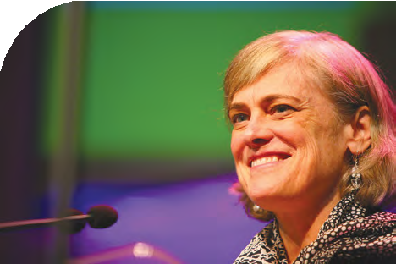
Record of Assembly

Monday 9 July 2012 Final Session

The Revd Dr Michael Jagessar took the chair.

Opening Worship
The Chaplain, Melanie Smith, led the Assembly in worship.

Bible Study –
“Living conversations now”
Professor Marilyn Legge completed her third study and the Moderator presented Professor Legge with a gift on behalf of the Assembly.

The Clerk presented the business of the day.
The Moderator ruled that those speaking should only make one point and take no more than two minutes.

Resolution 36 – Human Sexuality Task Group: extension of remit
- General Assembly thanks the members of the Human Sexuality Task Group for their work and instructs Mission Council to agree the terms of reference for a successor task group and to appoint members to serve on it.
- General Assembly instructs Mission Council to include in the remit of the successor task group: “ To consider the issues arising from government proposals on ‘marriage’ between persons of the same gender and, in consultation with the Faith and Order Committee and the Law and Polity Advisory Group, to bring a report to Mission Council by May 2013.”
The resolution was proposed by the Clerk and seconded by the General Secretary.
The Assembly Clerk reported that Mission Council had already begun this work, and that the Revd Elizabeth Caswell would be the convener of the group. Resolution 36 was withdrawn.
The facilitation group working on Resolution 33 presented a revised form of the resolution:

Resolution 33
Adults aged 20 to 40
General Assembly celebrates the contributions of young adults in the life of the United Reformed Church and recognises:
- the reducing number of adults aged 20-40 in the United Reformed Church and
- the concerns of the United Reformed Church Youth Assembly 2012 that many people on reaching the age of 26 and leaving FURY drift away from any engagement in the United Reformed Church.
General Assembly asks Mission Council to address these issues and consider how to improve the integration of this age group at every level of the United Reformed Church.

The revised Resolution 33 was passed by consensus. Thanks were offered to the facilitation group.

Resolution 38 – Private Members’ resolution
Monday 9 July 2012
Following work done by the facilitation group which comprised the Revd Nigel Appleton, the Revd Dr John Bradbury, the Revd Geoffrey Clarke, the Revd Richard Church, the Revd Jacky Embrey, the Revd Sheila Maxey, the Revd Stephen Newell and the Revd Prof David Thompson, Resolution 38 was presented in the following form:

Resolution 38

In view of a variety of general issues which have been brought to a head by the resignation of the Moderator Elect, Assembly appoints an independent commission (the prospective members being the Revd Dr David Peel, the Revd Dr David Dadswell and a female member) to consult with those involved to identify issues that arise from this unhappy experience.

Assembly requests:

- They liaise with the Pastoral Reference Committee to initiate a process of reconciliation, both personal and collective, and

- They refer to the Law and Polity Advisory Group any procedural issues that emerge pertaining to the relationship between the Officers of Assembly, Mission Council/General Assembly and the law.

Assembly requests that the commission make a progress report to the October 2012 Mission Council.

This resolution was moved on behalf of the facilitation group by the Revd Dr John Bradbury and seconded by the Revd Richard Church.

The revised Resolution 38 was passed by consensus. The Moderator then led the Assembly in prayer.
Mission Council Business 2 Zero Intolerance final report
The General Secretary responded to questions and reported that the copyright over the posters was held by the United Reformed Church, and that Mission Council would be asked to consider how the material might be used.

One of the Assembly signers at work

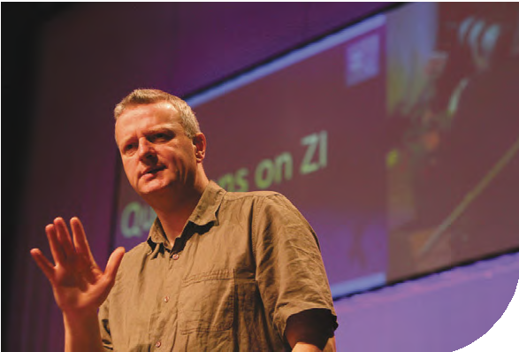
In response to a question regarding the steering group’s statement on the Evangelical Alliance position on homosexuality, Mrs Rominger confirmed that this statement had been formally
withdrawn and that it was now for each local church to discuss sexuality within the broad range of issues raised by the challenge of radical welcome.

Mrs Rominger reported that the total expenditure on ZI was £325,000 and that the Council for World Mission (CWM) was content that the URC had used and was using its grant in accordance with the purposes for which it had been given. £80,000 remained in the CWM fund to be used for radical welcome and work was continuing in the Mission, Education and Learning and Communications and Editorial Committees. The Mission Committee would co-ordinate the work and hoped to report to the October meeting of Mission Council with proposals for the future.

Mrs Morrison took the Chair.

Report of the Education and Learning Committee
The Revd John Smith, convener of the committee, presented the report and a DVD was shown which gave an overview of Education and Learning in the United Reformed Church.

The Moderator invited questions on the report to which the convener responded. Amongst other items that were noted, the death of the Revd Professor John Hick was recorded. Professor Hick was one of the foremost Reformed theologians of the last

Revd John Smith

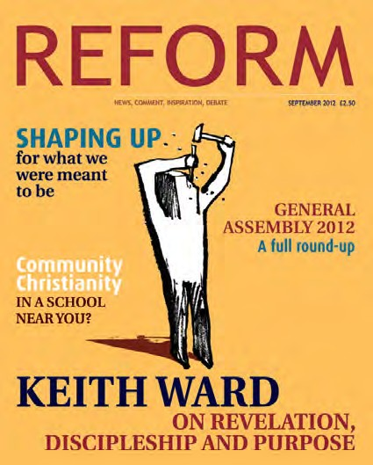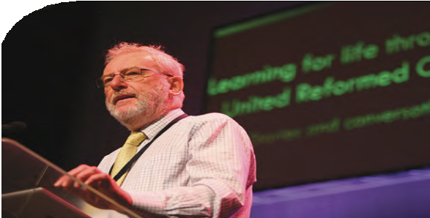quarter of the 20th Century. Born in Scarborough and commencing his ministry in Belford Presbyterian Church, Professor Hick had an international academic career in Princeton and Cornell universities in the USA and in Birmingham and Cambridge Universities in
Monday 9 July 2012
the UK. Tributes were paid by the Revd Kevin Watson and the Assembly Clerk.

A plea was made for affirmation and support for those engaged in Fresh Expressions.

It was noted that recent decisions of the Methodist Church could affect some of the United Reformed Church’s resource centres for learning. The committee would monitor the situation. The convener confirmed that existing EM3 commitments would be honoured.

Resolution 16
Mandatory training

General Assembly accepts that it will sometimes be appropriate to make certain additional training mandatory under our EM3 provisions for Ministers of Word and Sacraments and Church Related Community Workers. It will be for Mission Council to agree the nature, expected outcomes, and monitoring of such training.

The Revd Fiona Thomas presented the resolution and responded to questions. The Revd John Smith moved Resolution 16.

Resolution 16 was passed by consensus.

Communications and Editorial report
The report was presented by the Revd John Humphreys, convener of the committee. As this report was not included in the Reports to Assembly it appears overleaf. Mr Humphreys stated that the coming two years would be challenging because of the rapidly changing media environment. In reply to questions the convener reported that REFORM had not used the full amount of subsidy which had been budgeted for 2011 and that the number of copies of REFORM sold corresponded to about 10% of the Church’s membership, though it was thought that several people read most copies bought. Mr Humphreys undertook to explore ways in which the URC diary could reflect the fact that we are
a Church in three nations. It was explained that the Assembly
bookstall was not as large as had been planned, because the bookshop which had expected to supply this withdrew at a very late stage. The URC publications unit had stepped in, but it had not been possible to provide a full range of books or materials.

A concern was raised concerning the live streaming of Assembly. The Revd Martin Hazell said that it had been intended to provide such streaming for some time, and that this was the first Assembly at which it had been possible. He apologised that no announcement had been made.

Communications and Editorial report
Monday 9 July 2012
Committee Members
Convener: Secretary: Members:
John Humphreys (Kirsty Thorpe until December 2011) The Director of Communications
Lucy Berry (until Assembly 2012), Justin Brierley (until
Assembly 2012), Ian Fosten, Stan Hazell (until Assembly 2012), Helen Jones, Andy Littlejohns (until 2010) Peter Lyth, Peter Ranscombe, Esther Searle (until 2011), Orin Stephens, Heather Whyte

- The world we live in is undergoing a communications revolution with social media leading the way. Millions of people share the story of their lives through Twitter, Facebook and YouTube. News coverage is 24 hour, life moves fast and your mobile telephone can get you online, take pictures and offer a wide range of extras. Texts fly between people, conversations in real time litter our lives, and even in the remotest parts of the world modern communications have usually taken hold. We now rely so much on modern technology that when it disconnects we are at a total loss.

  - Meanwhile, we have seen bookshops closing because people can buy more cheaply on line and some opt for ebooks because these are easy to carry around. Magazines are shutting down because paper costs push up their costs. Meanwhile, the internet gives people the same information, more cheaply and more immediately. Writing letters is a disappearing art while posting written material is becoming ever more expensive. Some of us may decry these developments but the world is moving on. The Church cannot expect to keep providing information and communication in the same old ways.

  - So how can the Church respond to this exciting, life-transforming communications revolution? The goal and challenge of good communications continue to be at the centre of the life of the communications department and this committee. What can good communication achieve and what does it engender? What encourages communication and what hinders it? How do these concerns impact on the life of the United Reformed Church, within and beyond the communications department? When we try to answer these questions the contrast between using new forms of media and past ways of communicating dominated by printed paper are more pronounced than ever. Communications and Editorial’s story over the past two years has been about communicating well using as much new technology as we can without alienating local church members. The reality is that the declining, old ways of communicating are become increasingly expensive and sometimes financially prohibitive.

  - Some of the Church’s communication is outwards, with the world, and needs to be evaluated with that focus in mind. Other parts of the work are about communicating with one another. There are differences between these two areas of
operation as well as common factors. Certain elements of our communicating need to be aimed both at one another and the wider community at the same time.

  - In part the communications department is a service provider for different parts of the United Reformed Church as well as being a generator of creative material and resources for new initiatives. Whatever the task, the committee aims to be aspirational, offering the very best communication tools for the United Reformed Church within the limits of the budget and resources.

- REFORM is the United Reformed Church’s flagship magazine. It is valued by many more than our circulation figure of 11,000 suggests, since most copies will have two or three readers; it is appreciated by our ecumenical partners and in some part it is a successful tool for evangelism and mission. Under the leadership of Kay Parris, it remains essential reading for the more progressive Christian. True, it can

Monday 9 July 2012

be controversial and cutting edge, frustrating and broad, but it is also spiritual and thoughtful in its exploration of difficult issues and beliefs. REFORM’s team of three produces ten editions each year. Charissa King coordinates marketing and production as well as contributing news, DIGEST and features stories. Chris Andrews designs the magazine to a high standard, often including his own illustrations and photography. He also maintains REFORM’s website at www.reform-magazine.co.uk. In a world that has seen the demise of the paper version of the ‘Baptist Times’ and a fast-declining market place for print journalism the United Reformed Church should be proud of the achievement and dedication of the REFORM staff. They responded to the criticism of too little United Reformed Church news content with the creation of the DIGEST section. We hope that now people appreciate the better balance.

  - The cost, though, is high. Subscriptions have not increased as had been hoped four years ago and advertising revenue has been very hard to maintain. In 2011, Mission Council recognised the place REFORM has in our history and character by allowing it
a deficit of about £90K per year for the next two years. The committee sees this as an investment in a worthwhile resource. Recent budget cuts have eaten into that amount but the team have made savings without any loss of overall quality and seriousness by reducing the number of pages in each edition and the quality of paper used. Explorations
continue into the possibility of an online or ‘kindle’ version of the magazine. The questions remain though: Is this ‘our’ magazine, full of ‘our’ news, aimed at ‘our’ members or is it a tool to reach, interest and attract people who are not ‘us’? Can it be both?

- The same can be asked of our website. Is this a reference library for Church documents – the Manual, committee papers, rules of procedure and reports? Many think so. For those who want to find a local church or learn something about the United Reformed Church in simple terms, all that documentation is an irrelevant and unnecessary hindrance. It may give us a warm, cosy feeling to see someone we know on the website front page story but what does it say to visitors who are not (yet) ‘us’?

  - The department encountered problems when the website became too expensive to maintain. As a way of gaining better control over it we moved to a new open source website in February 2012. Unfortunately the need to migrate a vast amount of material coincided with a period of staff sickness. A year’s work was squeezed into four weeks, with a loss of the site for a while. The transfer was an amazing achievement made possible by several people who worked extra hours
to build the new site. It is not problem-free, by any means, and after Assembly the department will work on the comments that have been received. Pablo Cabello
is a new member of staff, responsible for the website’s development and the improvements which are ongoing. The committee thanks Sudhir Pasham, who has now left the staff team, for his perseverance, expertise and serenity. He managed the transfer from one platform to another and maintained the database and backing up of over 100 local church websites.

- We have had a successful two years in terms of publications despite the devastating blow of the loss of the United Reformed Church bookshop in autumn 2010. Disappointing though this was, the closure was the right thing to do. Our battle against online book retailers was always going to be tough but we hoped that people would continue to shop with us out of loyalty. Instead, a lot of our customers viewed books in our shop only to buy them online at a huge saving. When the new manager resigned, the cost of advertising, interviewing and appointing a successor during the best selling period of the bookselling year was too high to contemplate. The end of the bookshop was not a failure – rather a sign of the times.

  - Our published output continues to include regular titles such as the Prayer Handbook, ably edited over the past three years by Susan Durber. We thank her warmly as she hands on that role to Francis Brienen and Michael Jagessar. The possibility of selling this valuable resource more widely through other churches in future is being explored. Whilst the Year Book continues to appear, its future remains under constant review because of the high cost involved.

  - Keeping on top of the design and print tasks for the United Reformed Church’s books, booklets, leaflets, certificates and fliers is down to two of our hard working staff – Sara Foyle and Tina Yardley. In an average month they design and print about 125 different jobs. Booking jobs in and overseeing their position in the process is often made more difficult by unexpected demands from committees and staff members. Juggling this is a mammoth task and we rely totally on Sara and Tina’s skill and knowledge to complete all this work. Sara designs the Year Book, the
Monday 9 July 2012
Assembly Book of Reports, TLS material and other publications such as this year’s Story of the Moderators and Pathway to the Cross. Mark Howard, a top photographer and designer, regularly designs the Prayer Handbook and recently the second in the series of Barbara Bennett’s remarkable books A Great Cloud of Witnesses. Both Sara and Mark are wonderfully creative spirits who turn words into living material.

  - However, in the next few years, hard decisions will have to be made. It is impossible to keep adding to the department’s portfolio without reviewing and ceasing some activities. Because we publish a limited number of books each year we only employ Becky Harrington to oversee book orders on a Friday. We receive
frequent complaints about this but we need to use our limited resources wisely so we can reap some benefit from our investment in publishing. We are also grateful to our dispatch person Robert Wadey, who helps staff in Church House to send out their material, while keeping on top of the publications orders and covering reception during lunchtime.

- A significant development over the past two years has been addressing the need for local churches to receive specific United Reformed Church material
and information. Gill Nichol, our press and media officer, has been instrumental in making this possible. Not only does she contribute stories for the DIGEST pages in REFORM, but she writes and oversees the production of our electronic newsletter, Quarterly Update, QU, to all church ministers and secretaries with an email address. This has been very successful and replaces the old postal mailing which cost many hundreds of pounds each time. It has also prevented Celia Meiras (and during Celia’s maternity leave Lauren Parrish) and Emma Pearce having to spend hours away from their administrative roles to prepare and stuff nearly 1700 envelopes.

  - Gill Nichol has provided an essential public relations (PR) oversight for our communications work. She has helped tell the stories of many of our members, crafted news and press items and maintained the reputation of the United Reformed Church. Working with many members over the UK she has kept them up to date, visited them and encouraged them with information and assistance.

  - With the cost of mail-outs rising it is now vital for every church to provide us with an email contact who can receive communications and information. Our communications response to the 2012 Olympics has also been overseen by Gill
Nichol, primarily through her involvement with More than Gold. She is an important link between that organisation and events across our Church.

5.4 We encourage leaders in the Church to become better able to present our message through the media and Gill’s training and experience have also been valuable here. These became very important as the Zero Intolerance (ZI) campaign grew and developed. Gill edited the majority of the training material for this
and advised the Steering Group how best to present the material to churches. Following the departure of the co-ordinator of the project, Gill was the key person in formulating action plans and taking the venture forward. The time and energy she put into ZI deserve recognition.

- The work of the communications department also includes major tasks such as maintaining the central information database in Church House, advising on copyright matters, providing technical support at meetings of Mission Council, preparing and undertaking all communication aspects of General Assembly and reporting from it and organising the biennial community awards.

Monday 9 July 2012

- In common with all other central departments we are now engaged with the challenges presented to us by reduced resources. This is work in progress, which requires us to do some difficult prioritising of our work.

- Last year the committee said farewell to Andy Littlejohns and Esther
Searle, and this year Lucy Berry, Justin Brierley, and Stan Hazell have completed their membership with us. The committee thanks them for seeing the work of
the department through a difficult two years. A special thank you is needed to Kirsty Thorpe who continued as convener after convener elect Richard Bittleston stood down following major illness last year. Kirsty brought her experienced journalistic background to the role, offering support to the staff and committee through a period of many changes. In December 2011, Kirsty handed over to John Humphreys.

Pastoral Reference and Welfare Committee
The convener of the committee, the Revd Sheila Maxey, presented the report.

Equal Opportunities Committee report
The convener of the committee, the Revd Elizabeth Nash, presented the report. She drew particular attention to the new remit of the committee and apologised that the loop system in the church on Sunday was not as efficient as had been hoped. She agreed that any loop system to be used in future would be properly checked.

Report on the Disciplinary Process
The General Secretary reported on the outcome of the one case since the last Assembly. The cost was £6409.71 and the name of Peter Crocker had been removed from the Roll of Ministers.

Resolution 26 – Resourcing Ministries

General Assembly
- receives the report of the Ministries Committee Working Party on resourcing ministry.
- accepts a moratorium on the renewal of all special category ministry posts (except for the three agreed evangelist posts) and of the creation of new SCM posts.
- Releases the synods to choose to take up to 2.5 full time equivalent posts as a grant in place of current deployment figures.
- Requests the Ministries Committee to monitor the effects of actions b) and
- above through discussion with synods and to report back to General Assembly 2014.
- Instructs the Mission Committee to report back to Mission Council on the appropriateness of making grants from central funds to support individual ministries.

The convener of the Ministries Committee, the Revd Ruth Whitehead, presented the revised Resolution 26. She replied to questions and gave assurance that: those approaching retirement would be dealt with sensitively; there would be a review of
evangelist posts; the Mission Committee would help synods needing assistance with administering the scheme and provide a consultancy for those planning special posts.

Following discussion clause a. of the resolution was passed by consensus. It was further resolved by consensus that the remaining clauses should be referred back to the Ministries Committee which following further consideration on the matter should then report to Mission Council.

Resolution 29
Monday 9 July 2012
Drones

General Assembly:
- receives the report and commends it for study;
- directs the Joint Public Issues Team to produce appropriate materials to enable our churches to reflect biblically on the issues raised;
- reaffirms the Christian vocation of peacemaking and the crucial importance of strict adherence to international law in the deployment of military force;
- notes the growing concern regarding the humanitarian impact of explosive weaponry in civilian areas and urges that this concern be addressed in any use of Armed Unmanned Aerial Systems (AUAS);
- petitions the UK Government to publish as much information as possible concerning current strategy and effect of AUAS strikes alongside future plans for AUAS development and use and in particular to:
  - provide greater clarity on the role that armed unmanned aerial systems play in current military strategy, with particular reference to counter-insurgency;
  - affirm that known individuals are not targeted unless such persons are directly engaged in hostilities at the time;
  - release information on all drone strikes including number of fatalities and publish a summary of all investigations into civilian casualties;
  - in the interests of international law and joint cooperation on counter-terrorism, clearly state the UK Government’s position on targeted killings and urge the United States to discontinue the practice of targeting suspected members of terrorist organisations with AUAS.
- urges the UK government to begin to explore ways in which the international community might implement an arms control regime to reduce the threat posed by the development of systems capable of autonomous targeting and weapons delivery;
- upholds the people of northern Pakistan and Afghanistan in prayer and welcomes opportunities for the United Reformed Church to join with ecumenical partners, academic institutions, the Fellowship of Reconciliation and the Christian Council on Approaches to Defence and Disarmament in the further exploration and promotion of measures to encourage peace, justice and reconciliation in the context of violent insurgency.

Mr Steve Hucklesby, a Methodist Church Policy Advisor and member of the Joint Public Issues Team (JPIT), addressed Assembly. He responded to questions raised.

Resolution 29 was passed by consensus.

Resolution 34
The Occupy movement (National Synod of Wales)

General Assembly resolves:
- to listen collectively to the witness of the Occupy movement in the UK and worldwide, and especially for the Gospel resonances within what is
being said, and to share our own Gospel insights to enrich and enliven this conversation through our varied communication channels;
- to encourage the Mission Committee of the United Reformed Church to engage wherever possible with this movement and other partners in a common search for a more equitable economic system;
- to resist all proposals for reform which target the poor, in the UK and overseas, to pay the price for the mistakes of the rich and to request the Joint Public Issues Team to monitor and respond appropriately to such policy reforms;

Monday 9 July 2012

- to examine ourselves prayerfully and penitentially, our investment policies and our deployment and mission strategies as the URC, to see where the critique of the Occupy movement might rightly be directed at us;
- strongly to urge trusts, committees and local churches within the United Reformed Church to take this resolution into account in taking decisions – both financial and otherwise.

The resolution was proposed by the Revd Simon Walkling and seconded by the Revd Gethin Rhys, using a DVD as part of the presentation.

Resolution 34 was passed by consensus.

Review of the Role of Synod Moderators
Resolution 14 – Review of the Role of the Synod Moderator
- Assembly receives the report of the Review Group on the Role of Synod Moderator and endorses the six principles for change incorporated within it.

- Assembly instructs the general secretary to establish a group to give effect to the six principles in the report. This group should:
  - incorporate the insights of other reviews currently underway;
  - consult with the synods;
  - create coherent proposals for changes in the procedures of the Church; and report to General Assembly 2014, noting any outstanding issues requiring further work.

Responding to a clear sense that Assembly did not have time to deal adequately with this report, the General Secretary suggested that she might co-ordinate the work of several groups which are engaged in strategic thinking and bring proposals for furthering the work to the next meeting of the Mission Council. Assembly agreed with this suggestion, and Resolution 14 was withdrawn.

Resolution 42 – Assembly Arrangements report
General Assembly, recognising the need to make financial savings, resolves:
- to re-time the Assembly to meet in July 2014 convening at noon on Day 1 and concluding mid-afternoon on Day 3 at the time and place to be determined by Mission Council;
- that the number of ecumenical and overseas guests attending future Assemblies be reduced from 24 to 12 (with six in each category).

The convener of the Assembly Arrangements Committee, Dr David Robinson, before proposing the resolution announced that the offering at the communion service had mounted to £1720. Dr Robinson then proposed the resolution. Following discussion it became clear that the Assembly could not reach a view on the matter, and the General Secretary proposed that Resolution 42 be withdrawn and moved the following resolution:

General Assembly delegates authority to Mission Council to decide how to deliver the next Assembly within the budget agreed in Resolution 20.

The Moderator asked for a vote; tellers were called. The result was declared to be 133 votes in favour and 87 votes against. The resolution was passed.

Address to the Throne
Monday 9 July 2012
The Revd Dr Kirsty Thorpe presented the Address, which was approved by consensus.

To the Queen’s Most Excellent Majesty,
The General Assembly of the United Reformed Church meeting in Scarborough conveys warm greetings and congratulations to Your Majesty on the occasion of your Diamond Jubilee and recent Birthday celebrations. We give thanks to God for Your Majesty’s continued good health and strength in this Your 60th year
on the throne and for Your dedicated service to the people of Britain and the Commonwealth nations over the past six decades of your reign.

Your diligent service to God and the British people has been an inspiring example of steadfastness and commitment to duty in the midst of rapid changes in society and erosion of trust in public institutions. The outpouring of love
and support from millions of people in the United Kingdom and beyond these shores during Your Majesty’s Diamond Jubilee celebrations is a clear expression of the gratitude and high esteem in which Your Majesty is held by your subjects and people across the world.

We are also greatly encouraged by Your Majesty’s affirmation of the Christian faith and commendation of the virtues of family and community life which have been conveyed to the nation and beyond through Your recent broadcasts. The celebrations across the United Kingdom on the occasion of Your Diamond Jubilee have provided a wonderful opportunity for good neighbourliness
and hospitality. Many of our church communities participated in these events and we now look forward to welcoming visitors to our shores during the forthcoming Olympic and Paralympic Games.

We are mindful that in the midst of these celebrations there is also a growing sense of anxiety and despair for many thousands of people across the United Kingdom as a result of the hardship associated with the prolonged economic recession and reforms to social welfare. We are deeply concerned that those least responsible for the global financial crisis and ensuing economic downturn
– the poor and vulnerable – appear to be paying the highest price in terms of the loss of livelihoods and welfare support.

Our biblical reflections underscore that this is not the way to the flourishing life that God desires for humanity, based on a just ordering of society and commitment to the common good. The Reformed tradition teaches that we are called to shape the economic system, as we are called to shape every aspect of our lives, as a service to God. Therefore, we evaluate any economic system not
simply on the basis of the material goods and services it provides, but especially on the basis of its human consequences: what it does to, with and for people, particularly the most vulnerable among us.

Economic behaviour, like all behaviour, must be subject to moral scrutiny. For this reason the Church needs to address the devastation brought about by the present economic crisis and share the hope to which we bear witness: that, in Christ, a more just order is arising!

2012 is not only a significant year for Your Majesty but also a special year of celebration and reflection for the United Reformed Church. We are
celebrating the 40th anniversary of the inauguration of the United Reformed Church through the union of the Presbyterian Church of England and the Congregational Church in England and Wales in 1972. This was followed by further unions with the Reformed Churches of Christ and the Congregational Union of Scotland in 1981 and 2000. We are now a fellowship of some 1500 congregations across England, Scotland and Wales which play a dynamic and challenging part in their local communities.


Monday 9 July 2012

We also participated in a deeply significant and symbolic Service of Reconciliation, Healing of Memories, and Mutual Commitment between ourselves and the Church of England at Westminster Abbey in February to commemorate the 350th anniversary of the Great Ejectment. In special litanies both Churches expressed penitence for their part in perpetuating Christian disunity. We offered prayers for the healing of memories and for grace to work more closely together, in study, prayer, and mission, in the future.

In keeping with this theme, we pay tribute to Your Majesty for Your recent visit to Northern Ireland, following Your visit last year to the Republic of Ireland.
These represent a symbol of hope and opportunity for healing and reconciliation between the United Kingdom and Ireland. We trust that political and religious leaders will continue to build on this solid foundation in the months and years
to come.

Finally, we are pleased that HRH The Duke of Edinburgh has recovered from his recent ill-health and pray that you will both continue to enjoy good health for many years to come.

May the God who gives endurance and encouragement strengthen and sustain Your Majesty in the coming years!

Children’s Assembly report
Jo Williams reported on the work of Children’s Assembly which mirrored the subjects covered by General Assembly, including vision, finance and future planning. Children participated in
a programme to plan a community project for their church; the winning group presented their idea to Assembly.

The children were presented with certificates
to mark their good ideas and a grant of £100 will
be offered to each of their churches to help make the project happen.

Children’s Assembly also shared their ideas for the 2014 General Assembly agenda which included greater emphasis on international issues, more participation by children and the need for adult members to have more opportunities to relax.

Resolution 27 – Multicultural church, intercultural habit
- General Assembly celebrates its bold 2005 multicultural declaration, mindful of the changing landscape and context(s) for mission and ministry, what it means to be ‘church’ today, and of our need to deepen the ways we live justly as an inclusive Church.
- General Assembly, adopts a newly named focus: multicultural church, intercultural habit, marking the on-going journey we are all on.
- General Assembly endorses the multicultural church, intercultural habit charter as an intentional way to enable renewal and a refocusing of how we live out our life together.
- General Assembly commends the aspirations of the Charter to the whole of the United Reformed Church (synods, local congregations and resource centres) encouraging all to seek relevant and contextual ways to make these real in our life together.

In view of the lack of time the Clerk asked that Resolution 27 be referred to Mission Council. Assembly agreed.

Moderators’ acceptance speeches
Monday 9 July 2012
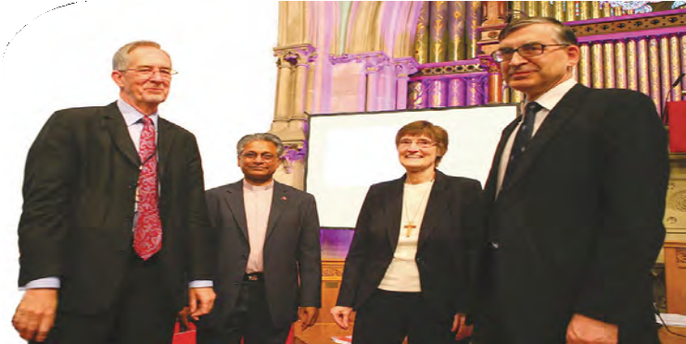The Revd David Grosch-Miller and Mr John Ellis addressed the Assembly.

Mr Ellis paid tribute to the other candidates for allowing themselves to be part of the election process.

Thanks
The Revd John Marsh offered the thanks of Assembly to: the staff of the Spa Complex; Ann Barton and the office team; the Yorkshire synod for local arrangements; the Revd Ray Adams and the musicians; New Malden’s string quartet; the Singing Squad; the communications and technical teams; the signers; and all who had made Assembly possible.

Moderators, left to right: The Revd David Grosch-Miller, The Revd Michael Jagessar, Ms Val Morisson and Mr John Ellis

Dr Jagessar thanked:
the planning teams; the Chaplains; the Revd Pauline Barnes; the facilitation groups and the Revd Dr Kirsty Thorpe for her wisdom and love of the URC.

The General Secretary thanked the Revd James Breslin, Clerk to Assembly since 2002. She presented a gift to mark Assembly’s appreciation.

The Clerk responded and paid tribute to the late Revd Arthur Macarthur, former Clerk, for support given over the years. He also thanked the staff team for the support given.

Mrs Morrison thanked:
the Revd Elizabeth Gray-King, artist in residence, and the Revd Dr Stephen Orchard for his presentations on the history of the URC, apologising for cutting his final session.

The General Secretary thanked the Moderators for being able to ‘hold the vision’ in the challenging issues that have been before Assembly.

Minutes
The Clerk presented the minutes for the evening of 7th July and the first session of 8th July, noting that minor errors had been identified and would be corrected. In accordance with Standing Order 12b Mr Breslin proposed that the minutes of the remaining sessions of the Assembly would be inserted in the Record following review and any necessary correction by the officers of the Assembly. This was agreed.

The General Secretary announced that Assembly had completed its business and would adjourn with worship, to meet at such place and time as should be determined by Mission Council.

Closing Worship
Closing worship was led by the chaplains with the assistance of some of the young people.

Appendix 1

Proposals for change to the United Reformed Ministers’ Pension Fund

The United Reformed Church Ministers’ Pension Fund (URCMPF)

Proposals for change
In the light of the deficiency arising in recent valuations of the Fund the Pensions Executive has been considering whether any changes should be made to the benefit structure of the Fund, and if so what these should be. This paper summarises the conclusions of the Pensions Executive which are endorsed by (MoM/Ministries). It should be noted that these proposals are based on our current understanding of the funding position and if accepted would be incorporated into the next valuation of the Fund on
1 January 2012 with a view to amending the Rules at General Assembly in 2012. Should that valuation reveal an unfavourable result compared to our expectations then further changes may need to be brought to Assembly. It should further be noted that some of the proposals are subject to a further consultation with Fund members which could lead to additional revisions.

Introduction
The United Reformed Church Ministers’ Pension Fund has fallen into deficit in recent years through a number of factors. The principal ones being an improvement in the life expectancy of our ministers, which whilst welcomed does represent a greater pension cost as pensions are paid longer, disappointing investment returns over recent years as the economic situation has deteriorated and the need for greater reserves to be held to satisfy a regulatory view of prudence.

We are not alone in facing these challenges and they are being addressed in different ways by all the major denominations in the UK, as they have been by many of the country’s private sector employers and latterly by the government as an employer.

Over-riding context
In the light of General Assembly’s recognition of the Church’s responsibility towards its ministers and CRCWs and its continuing tangible expressions of support for ministers to be provided with stipends, pensions and housing at an adequate level we have assumed that this will continue to be the case.

Method of pension provision
In the private sector to meet the challenges of funding pension schemes many pension arrangements have now been established on a money-purchase basis. Whilst this limits the contributions to a known amount it transfers risk to individuals and so the deficiencies that we have faced as a Church by reference to improvements in longevity
and stock-market fluctuations, are borne by the individual. This does not guarantee that an adequate pension can be provided. The Church’s obligation is to care for its ministers unlike those private sector employers whose duty also includes improving the position of shareholders as well as their obligations to their employees. Whilst we have considered other models of pension provision we have concluded that the present approach of providing a final salary pension scheme remains the most equitable and cost effective way of providing adequate income to our ministers and their dependants at a time when

they are unable to support themselves. We, therefore, at this time recommend the retention of the current scheme.
Appendix 1

This means that a minister retiring after a full career in ministry (say 40 years) will receive a pension from the URCMPF of 50% of stipend together with a state pension comprising the basic state pension and the additional state pension. Allowing for housing we believe that this will aim to provide a total net retirement income after also allowing for tax, national insurance, pension contributions etc. of between 85% and 90% of pre-retirement disposable income. Whilst the Government at the time of writing has not clarified its intentions going forward it seems probable that changes will result in a reduction of the state element in the longer term by say 5%.

Cost issues
Notwithstanding the comments above the Church does face cost pressures. Much of the URCMPF liability is in respect of current pensioners for whom benefits cannot be changed unilaterally. Similarly no change in benefits can be made in respect of service already completed by current members. The only changes that can be made are to the provision of pensions for new entrants to ministry and the Fund and for the future accrual of benefits by current members. We have looked at a range of options having regard not only to the cost issues but also to the needs of the Church and those likely to have meaningful financial impact are discussed in the following sections.

Accrual rate
The pension entitlement currently accrues at the rate of 1.25% (one eightieth) of stipend for each year of membership, leading to a pension of 50% of stipend after 40 years of ministry. We have considered whether this should be reduced but have concluded that the income replacement ratios described in 3 above represent a fair interpretation of the Church’s obligations to its ministers. Whilst this may need to be reviewed in the future depending upon the level of State benefit and/or the Church’s
financial capability we have concluded and hence we recommend that no change should be made to the accrual rate at this time.

Pension age
The concept of a set age of retirement has now largely disappeared as the government no longer permits (current pension regulations before parliament) the compulsory retirement of employees at a specific age. Nevertheless the availability of pension income will remain the main driver behind the individual’s choice of a retirement age.

Both the state and non-state pensions have seen the effects of rising longevity. We have seen an increase in the life expectancy of ministers retiring at age 65 of perhaps 8 years over the existence of the URC. Not surprisingly this has proved to be a significant additional cost. The state retirement age is now due to increase for both sexes to 66 by
2020 and currently to 68 by 2046. It is our view that increase to age 68 will occur much earlier. It will certainly be at least that for younger entrants to ministry going forward.

In the past the Church has not slavishly followed the State in its Pension Age and there is no necessity to do so now. We have considered various possible pension ages for the URCMPF and have concluded that the most appropriate is age 68. This would only apply to future service and it would continue to be possible to retire at an earlier age
e.g. 65 with a reduction being made in the future service element to reflect the fact that the pension will be payable for longer. This would have a minimal impact on the pension of ministers retiring in the next few years at the current age of 65.

It should be understood that the Pension Age is only the pivotal age at which benefits are calculated. As stated above there is nothing in these proposals which compels a minister to retire at that age. Under the rules a minister can retire either at an earlier age or at a later age with an appropriate adjustment to the pension payable.

Appendix 1

For example, if we take the case of a minister who has 30 years membership at age 65 of which 5 years is after the date of change, then should the minister decides to retire at age 65 the pension calculation (using the current stipend of £ 23,232) would be
5 years at 80’ths 5/80 times £23,232 = £1,452
This would be reduced by some 18% as it would be payable for three years longer to give: plus
 | £1,452 times 82% | = | £1,190
25 Years at 80’ths | 25/80 times £23,232 | = | £7,260
Total pension |  |  | £8,450 per annum

This may be compared with the current pension when no reduction is applied of
£8,712 per annum.

Consequently we recommend that a Pension Age of 68 be adopted for the accrual of benefits in the future.

Ill-health early retirement
Currently the URCMPF provides a pension on ill-health based on full prospective service to Pension Age, so that, for example, an individual awarded an ill-health pension at age 40 with 10 years membership will receive a pension based on not just the ten years completed but also the 25 years that will not be served until age 65. The pension will similarly be payable for life.

Our current rules ensure that a minister is eligible for an ill-health pension if they are permanently unable to carry out the duties of a stipendiary URC minister or CRCW. There are provisions for the pension to be reduced or to cease if the member recovers. These eligibility rules are unfortunately difficult to follow and can be interpreted to the effect that in some rare cases ministers not in pastoral charge may not be eligible. We therefore propose to rewrite these eligibility rules for current members to make them clearer, there will be no change in their intent.

We do believe, however, that the eligibility rules should be tightened up in one respect. We believe that the URCMPF should not be required to pay an ill-health pension at the full level if the minister is able to carry out a different occupation. In practice we do not see this as materially different in intent from the present rule but will remove a perceived ambiguity. We propose this change should apply to future members only.

Whilst many ill-health retirements occur close to Pension Age a number occur within a relatively short time in ministry. We believe that it is in the interests of the Church that this particular benefit should reflect to a greater degree the experience of a stipendiary minister or CRCW within the URC.

We therefore propose that in the future this benefit shall only be calculated by reference to full prospective service once twenty years of service has been completed. Where
less than ten years of service has been completed the pension would only be based on accrued service. For ill-health retirement at intermediate points a uniform sliding scale would apply, so that in the example above the ill health pension would be based on only the ten years served. If ill-health retirement occurred at age 45, i.e. with a further five years service, then a credit of half of the prospective future service would be given. In this case the pension would therefore be based on a service of 25 years being the 15 years completed and ten years being half of the future service. We also propose that in calculating the prospective service this will be not be changed but will continue to be calculated by reference to service to age 65.

This new formula will apply to existing members but they will also be provided with an underpin which will protect the accrued pension. The underpin will continue to be linked

to stipend increases in the future and will be calculated as a proportion of the current full prospective pension. The proportion will be the ratio of service at the date the changes commence to the total service completed at the date an ill-health pension commences.
Appendix 1

In relation to existing members at the date of change we also propose a further underpin that the ill-health pension will be subject to a minimum of the pension based on the current rules but with the stipend fixed at the level applying at the date of change. In this way there will be no diminution in the ill-health pension that would be payable to a minister retiring on account of ill-health on the day after the change. There would be a gradual reduction depending on service completed and the absence of future stipend increases applying to this underpin as time progresses.

Whilst this paper is primarily concerned with the Pension aspects of the Church’s obligations, we note that there is a continuing obligation on the councils of the Church both locally and centrally to provide ongoing support and care to ministers to minimise the likelihood of needing to provide a pension on ill-health whilst also ensuring that in appropriate circumstances application for a pension is made.

We, therefore, recommend a modification to the rules covering eligibility for an ill-health retirement pension in respect of new members.

We further recommend a reduction in the amount of ill-health pension subject to an underpin for existing members.

Death benefits
In conjunction with the change of Pension Age to 68 there will be an improvement in benefit levels payable on death before age 68.

The Fund provides a lump sum on death in service before retirement of either two or three times stipend depending upon personal circumstances (three times if there are dependants). At present, therefore, a minister who remains in contributory service after age 65 continues to enjoy this benefit. This will continue to be the case.

The level of a spouse’s pension payable on death in service is based on the prospective service of the minister to Pension Age. If the Pension Age increases then this pension will also increase.

We consider the levels of benefit currently payable as doing no more than meeting our obligation to ministers to care for their dependants should they die prematurely, hence we do not advocate a change in these benefit levels.

We note that the financial implications of the small improvement in benefits for an unfortunate few are equally small and that the improvements are a logical consequence of the move to a pension age of 68.

We therefore recommend no change in the calculation of death benefits, accepting the cost of the slight additional benefit to be provided on death.

Pension Increase after retirement
Our current rules provide for pensions in payment to increase each year by reference to the previous year’s increase in the Retail Prices Index subject to a 5% maximum.
This is broadly in line with historic legislation.

The government has amended the provisions surrounding state pension increases to reflect not the Retail Prices Index (RPI) but the Consumer Prices Index (CPI).
It is generally accepted that due to both the composition of this latter index and its method of calculation the result will be a lower level of increases applying to pensions going forward.

Appendix 1

Legislation is being amended so that it will be lawful for any scheme to calculate increases by reference to CPI rather than RPI as at present.

Whilst the legislation is, therefore, permissive it is not over-riding. Each pension scheme must abide with its own constitution and rules. In our case the present rule came into force as part of a previous cost reduction exercise whereby each minister individually consented to the change and the provisions are hard-wired into our rules. Our legal advice is that we cannot change this for current members. In any event we consider it appropriate to seek to maintain an adequate pension throughout retirement and are therefore not of a view that we should seek to curtail this benefit.

Pensions increases between leaving the Fund and reaching retirement age (Deferred pensions)
Similar to increases to pensions in payment the government has introduced legislation changing the increase we must provide over this period to retirement to be calculated by reference to CPI rather than as at present RPI.

In practice we have relatively few deferred pensioners, representing less than 3% of our liabilities. Should any deferred member return to active membership of the Fund there are provisions in our rules permitting previous periods of membership to be re-instated, as they invariably are.

Unlike the case of pensioner members our rules are hard-wired in the opposite direction so that if we do nothing we will need to use CPI going forward.

Considering the points above we recommend that no action be taken in respect of Deferred pensions, in consequence the new legislative minimum will apply.

Contributions
Following each of the last two valuations the Church has asked active members to increase their contribution to the Fund. This has been to share the cost of the improving longevity which directly benefits members between the Church and serving ministers. A consequence of raising the Pension Age will be that such contributions are payable for a longer period. In view of the proposed increase in Pension Age we have considered whether a corresponding reduction should be made to the members’ contribution rate.

We have concluded that since the financial effects of the proposed change in Pension Age will only gradually be reflected in members’ benefits, and in view of the continuing financial pressures on the Church that it would be inappropriate to adjust members’ contributions for this reason as part of this review.

Similarly we have considered whether it would be appropriate to recommend an increase in members’ contributions to more adequately reflect the value of the pension and to share the cost to a greater extent with the Church. At present members contribute at
the rate of 7.5% of stipend compared to almost 25% of stipend being contributed by the Church.

We have concluded that a further increase should not be recommended at this time but that this may need to be re-visited depending upon the results of the next actuarial valuation.

We therefore recommend no change be made to the members’ contribution rate.

Membership
Following a previous review driven by financial pressures it was decided not to permit membership of the Fund to ministers over the age of 55 at the date of entry. This
was done since it was perceived that pensions cost more the older one is. Instead of

providing scheme membership a contribution of 10% of stipend has been made to personal pension arrangements in the few cases to which this applied. The government has now introduced legislation whereby we must provide a pension arrangement of a suitable standard for every minister over the age of 22. Our present arrangements for mature entrants will therefore need to change.
Appendix 1

We believe it is appropriate to allow such late entrants into stipendiary ministry to enter the Fund in the normal way. In so doing we:
• Meet our obligation set out in 2 above, which the present approach does not
• Reduce discrimination on the grounds of age
• Recognise the changes in work practice whereby a default set retirement age no longer applies
• Reduce the administrative burden (and associated cost) on the Church of running another pension arrangement

We, therefore, recommend that the Fund admission policy be revised so that membership is available to all stipendiary ministers/CRCWs, regardless of age.

Existing ministers who have not been admitted because of age would be permitted to enter should they wish for their future service. No credit would be given for historic service covered by their personal arrangements.

Financial implications
As discussed above the proposals do not in any way affect benefits which have already accrued to serving ministers or pensioners. The Fund deficit is in respect of such accrued benefits and hence the proposals have a negligible effect on the deficit.

Financial savings arise from the reduction in benefits for future service primarily in respect of the proposed change in Pension Age.

We are advised by our actuary that the proposals above will lead to a reduction in the annual contribution made by the Church to the Pension Fund in the region
of £300,000 - £350,000. This is a reduction of some 10% in the Church’s annual contribution to the URCMPF.

Conclusion
Whilst we are aware that more radical proposals could have been made to the nature of the scheme, the retirement age or the accrual rate, we believe the above proposals are appropriate at the present time. In particular we believe that they provide a way to reduce the Church’s contribution to the Fund whilst continuing to meet the Church’s moral obligation to care for its ministers when they or their dependants are not in a position to care for themselves.

We accept that it may be necessary to carry out further reviews in the future but commend the results of this review to Mission Council for their further consideration.

Pensions Executive, 10 March 2011

Appendix 2

United Reformed Church Trust and the United Reformed Church

Policy in relation to the selection and appointment of members of United Reformed Church Trust
This document represents the expectations of the United Reformed Church Trust (URCT) the General Assembly and Mission Council of the United Reformed Church as to how those members of the URCT appointed by General Assembly and/or Mission Council, as provided by Article 2 of the Articles of Association of the URCT, are to be selected for membership. It is recognised that there are circumstances when a variation from these agreed principles might be required, and any such variation shall not invalidate the selection, appointment or membership of a member of URCT in any way.

This document replaces in its entirety that known as the “Governing Document” which was adopted as Resolution 23 by General Assembly in 2007.

Interpretation
Articles of Association: shall mean the Articles of Association of United Reformed Church Trust (URCT) from time to time.

Member: shall mean the person appointed to membership in accordance with Article 2 of the Articles of Association by the General Assembly or Mission Council of the United Reformed Church (URC), Article 2 of the Articles of Association of URCT being set out in Appendix A.

Director: shall mean members of URCT appointed as directors in accordance with Article
2.3 of the Articles of Association the directors being collectively the charity trustees of the URCT.

Appointing Council: shall mean either General Assembly or Mission Council while exercising the power to appoint in accordance with the appointment and selection procedures set out below.

United Reformed Church Trust
United Reformed Church Trust (URCT) is a company limited by guarantee (registered in England and Wales with number 00135934) and registered charity with charity registration number 1133373. URCT is governed by its own Memorandum and Articles of Association.

The procedure for selecting members of the United Reformed Church Trust
The categories of membership of URCT set out in Article 2.1 (a), (b) and (d) are not subject to the selection procedure as set out below, their membership being by virtue of the provisions of Article 2.1 (a) (b) and (d).

The expectation is that those appointed under Article 2.1 (c) of the Articles of Association of URCT will be selected by General Assembly/Mission Council taking account of the following general principles:-

- Synods from which nominations for membership may be received shall be grouped into three constituencies (Synod Groups) as shown below:-
Appendix 2

Group 1
Northern, North Western, Mersey and Scotland;

Group 2
West Midlands, South Western, Wessex and Wales; and

Group 3
Yorkshire, East Midlands, Eastern, Thames North and Southern.

- Each Group may nominate up to three members whose membership, if appointed, will be from the date of the appointing resolution to the expiry of the term of membership, initially four years, subject to a maximum of eight years. A member’s period of appointment will be either four years from the appointing resolution or, where that four year period does not coincide with a meeting of the Appointing Council, shall be until the meeting of whichever Council immediately follows the expiry of the four year period (Article 2.5(c)), save that such term can be extended with the consent of the Board, without cessation of membership, by a further Resolution of the Appointing Council, for a further term of up to four years but in any event subject always to a maximum total term of membership of eight years.

- So far as reasonably possible, the synods will cooperate so as to nominate at least one member who has experience in the areas of :-

  - the law;
  - financial matters;
  - human resources, and;
  - the life and witness of a local church, whether he or she is a minister or an elder.

In addition to the above appointments, the Directors of URCT may nominate up to three additional Members for election to membership by General Assembly or Mission Council in accordance with article 2.1(c) of the Articles of Association as indicated below:

- One to be a representative of FURY; and
- Two members whose membership will take account of the issues of gender and ethnic representation of the life of the Church.

Timetable and process for nomination for membership
Synod Groups and Mission Council will consider candidates’ suitability as potential members whom they may then nominate. In each case the individual concerned will be asked to consent to nomination and agree to stand for election. Synod Groups and Mission Council may nominate more candidates than the number of vacancies; although if they do so they should list candidates in order of preference.

Synod Groups and Mission Council will provide their nominations to the Nominations Committee by the end of November in the year preceding General Assembly.

The Nominations Committee will take up references, review eligibility and discuss the nominations with the Directors at the earliest opportunity in the year in which General Assembly is due to meet.

The Directors may then interview candidates.

The Nominations Committee, in agreement with the Directors, will then nominate preferred candidates to General Assembly or to Mission Council acting under delegated authority from General Assembly for election to membership.

Appendix 3

Nominations Committee list of Assembly committees and other appointments

Assembly committees and other appointments
Notes:
  - The moderators, the moderators elect, the immediate past moderators and the general secretary are members ex officio of every standing committee.
  - Symbols have been used as follows:
** denotes those whom General Assembly is invited to appoint for the first time;
† denotes those who have been invited to extend their periods of service; # denotes a convener elect who will become convener in 2013;
/ the name after the slash is the alternate for the one before it.
  - The number in round brackets following the name indicates the member’s synod:
    - Northern, (2) North Western, (3) Mersey, (4) Yorkshire, (5) East Midlands, (6) West Midlands, (7) Eastern, (8) South Western, (9) Wessex, (10) Thames North, (11) Southern,
(12) Wales, (13) Scotland. This numbering is not shown where it is not relevant.
  - When a member of a committee is there as a representative of another body or a particular category this is indicated in round brackets following the name.
  - Committee membership is normally for a period of four years, though this may sometimes exceptionally be renewable. Committee conveners serve an additional preliminary year as convener elect. In sections 1-4 of the report, appointments with a different term are noted.
  - The date in square brackets following the name indicates the date of retirement, assuming a full term.
  - In accordance with the decision of General Assembly 2000 some nominations are made directly by the National Synods of Wales and Scotland.
  - In years when General Assembly meets, new committee members normally take up their roles at the conclusion of Assembly. In years when General Assembly does not meet, they normally begin on 1st July.

1 MISSION COUNCIL
Mission Council acts on behalf of General Assembly. It consists of the officers of Assembly, the synod moderators and three representatives from each synod together with the conveners of Assembly committees, the chair of the United Reformed Church Trust and three FURY members, including the FURY moderator.

(Synods appoint and decide terms for their representatives)
Northern Synod Revd Ann Jackson, Mr Robert Jones, Vacancy
North Western Synod Revd Geoffrey Clarke, Miss Judith Haughton, Revd Sarah Moore Mersey Synod Mr Arthur Swift, Miss Emma Pugh, Revd A Gordon Smith Yorkshire Synod Mr Chris Reed, Mrs Jenny Poulter, Revd Sue Macbeth
East Midlands Synod Mr Duncan Smith, Revd Jenny Mills, Mrs Jill Turner
West Midlands Synod Revd Jackie Embrey, Mrs Margaret Marshall, Mrs Val Phillips Eastern Synod Revd Dr Catherine Ball, Mrs Linda Harrison, Mr Clifford Patten South Western Synod Mr George Faris, Revd Dougie Burnett, Mrs Sarah Lane Cawte Wessex Synod Mr Peter Pay, Revd Michael Hopkins, Revd Mary Thomas
Thames North Synod Mr Simon Fairnington, Ms Elizabeth Lawson, Revd Edward Sanniez Southern Synod Revd Derrick Sena Dzandu-Hedidor, Revd John Gordon,
Mr Alistair Wilson
National Synod of Wales Revd Shelagh Pollard, Mrs Ruth Henriksen, Revd Gethin Rhys National Synod of Scotland Revd Connie Bonner, Revd Stephen Brown, Mrs Barbara Bruce [In attendance: Minute Secretary: Mrs Irene Wren† [2015]
Consensus Adviser: Revd Pauline Barnes [2014]
together with staff secretaries, moderators’ chaplains and others as appropriate]

0.1 Mission Council Advisory Group Convener: Moderators of General Assembly Secretary: Deputy General Secretary
Appendix 3
Revd Derrick Sena Dzandu-Hedidor [2014] Revd Elizabeth Nash [2015] Revd Nicola Furley-Smith [2016]
Moderators elect of General Assembly Immediate past Moderators of General Assembly
[ex officio: General Secretary Honorary Treasurer]

  - Staffing Advisory Group Convener: Revd Rowena Francis Secretary: General Secretary
Mrs Sally Abbott Revd Ann Jack Mr Peter Pay Mr Keith Webster Head of Human Resources

  - Law and Polity Advisory Group Convener: Revd Prof David Thompson [2014] Secretary: Dr Augur Pearce [2016]
Mr David Eldridge [2014] Ms Morag McLintock [2016] Mr Duncan Smith [2016] (Synod Clerk) Mrs Kath Fowler (PLATO) [ex officio: Clerk to General Assembly Legal Adviser]

  - Listed Buildings Advisory Group Convener: Mr Peter West [2015] Secretary: Mr David Figures
Correspondent for each synod (apart from the Synod of Scotland)

  - Sexual Ethics Advisory Group Convener: Revd David A L Jenkins [2014] Revd Rowena Francis (Synod Moderator)
Revd Elizabeth Gray-King (Education and Learning)
Revd David Skitt
[ex officio: Deputy General Secretary Coordinator Pastoral Response Team]

MIND (Ministerial Incapacity and Discipline) Advisory Group
Convener: Revd Peter Poulter [2016] Secretary: Revd Hugh Graham[2014]
Convener of the Assembly Commission: Mrs Kathleen Cross Secretary of the Assembly Commission: Mrs Gwen Jennings**
Convener of the Review Commission of the Incapacity Procedure: Mr Donald Swift Secretary of the Review Commission of the Incapacity Procedure: Revd Ray Adams Consultant for Ministers and CRCWs: Revd David Skitt
Consultant for Mandated Groups: Revd Alison Davis Training Coordinator: Mr Keith Webster
Coopted: Mr Hartley Oldham
General Secretary Clerk to Assembly Secretary for Ministries Legal Adviser

  - Resource Sharing Task Group Convener: Revd David Grosch-Miller Secretary: Mr John Rea
Treasurer: Revd Dick Gray
Miss Margaret Atkinson Mr Mike Gould Mrs Rachel Wakeman [ex officio: Honorary Treasurer]

Human Sexuality Task Group (2008)
Convener: Revd Elizabeth Caswell Revised membership to be agreed by MCAG.

Appendix 3

MISSION DEPARTMENT
  - Mission Committee Convener: Revd Tracey Lewis [2016] Secretary: Secretary for Mission
Mrs Pat Poinen (1) [2015] Vacancy (2)
Revd Andrew Willett (3) [2014] Mrs Tessa Henry-Robinson (4) [2015]
Revd David Dean (5) [2015] Revd Louise Franklin (6) [2014]
Revd Sam White (7) [2015] Revd Janet Sutton Webb** (8) [2016]
Revd Peter Hurter (9) [2014] Revd John Macaulay (10) [2015]
Mr Martin Hayward (11) [2015] Revd Nick Stanyon (12) [2014]
Revd Lindsey Sanderson (13) [2015]

International Exchange Reference Group
Convener: Mr Chris Wright [2015]
Secretary: Secretary for World Church Relations
Members: Revd Dr Andrew Prasad (Synod Moderator) [2014] Mrs Judith North** (5) [2016]

    - Commitment for Life Reference Group
Convener: Mr John Griffith** [2016]

Methodist/United Reformed Church Interfaith Reference Group
(Members normally serve for six years – in parallel with Methodist terms)
Co-Convener: Revd Peter Brain [2013]
Co-Convener elect: #Revd Claire Downing** [2019]
Mr David Jonathan (10) [2014] Revd Bill Burgess (3) [2015]
Revd Tim Clarke (10) [2015]

Joint Public Issues Team Strategy and Policy Group
Ms Marie Trubic** (Spokesperson on Public Issues for the United Reformed Church)
(Other members appointed by the Methodist Church and the Baptist Union of Great Britain.)

Rural Strategy Group (United Reformed Church/Methodist)
Revd Roy Lowes Revd Louise Franklin Revd Peter Ball

MINISTRIES OF THE CHURCH DEPARTMENT
  - Ministries Committee Convener: Revd Ruth Whitehead [2014] Secretary: Secretary for Ministries
Ms Brenda Jesse (8) [2013] Revd David Skitt (11) [2013]
Revd John Cox (7) [2014] Mr Andy Buxton (12) [2014]
Revd Heather Pencavel (8) [2015] Revd Clive Sutcliffe** (7) [2016] Mrs Judith Johnson (Leadership in Worship Advocate) [2015] Convener, Assessment Board

    - Ministries – Accreditation Sub-committee Convener: Revd Geoffrey Townsend [2013] Convener elect: #Revd Fran Ruthven** [2017] Secretary: Secretary for Ministries
Revd Malcolm Fife (5) [2013] Revd Richard Church (Synod Moderator) [2015] Mrs Tessa Henry-Robinson (4) [2013] Mr Jim Murison (4) [2014]
Revd Helga Cornell (6) [2015]

Ministries – CRCW Programme Sub-committee
Convener: Revd Jacky Embrey [2016] Secretaries: CRCW Development Workers
Prof John Mellor (9) [2013] Ms Marie Trubic (CRCW) [2014] Revd Carolyn Smyth** (13) [2016] Revd Keith Morrison** (5) [2016]
Revd Dr John Campbell** (10) [2016] Mr Graham Ghaleb (Coopted CRCW) Revd Paul Whittle (CRCW Development Workers’ Line Manager)

Ministries – Maintenance of Ministry Sub-committee
Appendix 3
Convener: Revd Dr Anthony Haws [2013] Convener elect: Vacancy
Mr Andrew Martlew (3) [2014] Revd Alison Hall (3) [2014]
Revd Richard Turnbull (5) [2015] Mr Peter Rippon** (5) [2016]
Mrs Eilidh Young** (13) [2016]
[ex officio: Honorary Treasurer Convener, Pensions Executive]

Ministries – Retired Ministers’ Housing Sub-committee
(Members will normally serve for four years but appointments may be extended for a further two years.)
Convener: Revd David Bedford [2015]
Secretary: Secretary, Retired Ministers’ Housing Society Ltd
Revd Anne Bedford (3) [2015] Revd John Humphreys (Synod Moderator) [2013] Mr Peter West (7) [2015] Mr Malcolm Lindo** (10) [2016]
[ex officio: Honorary Treasurer]
(Properties are managed by a Company viz: Retired Ministers’ Housing Society Ltd.. Details of the Members of the board etc may be obtained from the secretary, Mr Tony Bayley, at Church House.)

Assessment Board
(Members normally serve for five years as training is required.)
Convener: Dr Graham Campling [2014]
Retiring 2013 Mrs Irene Wren (5), Revd Lis Mullen (2), Revd Gary McGowan (3), Revd Val Towler (1)
Retiring 2014 Mr Mark Hayes (7), Mr Robin Pencavel (8), Revd Jamie Kissack (4), Revd Paul Floe (12)
Retiring 2015 Mrs Judith Garthwaite (4), Mr Rod Morrison (4), Ms Mercy Nimako (11), Mrs Maureen Campbell (10)
Retiring 2016 Mrs Adella Pritchard (6), Revd Franziska Herring (6), Revd Sue Kirkbride (13) Retiring 2017 Ms Alex Bediako** (10), Mr Bill Gould** (3), Revd Peter Henderson** (8),
Revd Shahbaz Javed** (10)

Education and Learning Committee
Convener: Revd John Smith [2015]
Secretary: Secretary for Education and Learning Revd Dr Susan Durber (Resource Centre) [2013]
Revd Dr David Whiting (1) [2013] Mr Celvon Binns (6) [2014]
Mrs Lindsey Cole (5) [2014] Ms Sue Matthews (6) [2014]
Mrs Liz Bird (7) [2015] Mr Mal Breeze** (12) [2016]
Mrs Julie Jeffries** (6) [2016] Revd Dr Irene John** (13) [2016] Coopted: Revd David Salsbury (Synod Development Officer)

Windermere Management Committee
Convener: Revd Howard Sharp [2014]
Minute Secretary: Mrs Jenny Poulter (4) [2013]
Mr Graham Law (6) [2013] Dr Peter Clarke (1) [2015] Mr Peter Farrand (2) [2015] Mrs Joan Stocker (representative of Carver Memorial United Reformed Church) Secretary for Education and Learning

Education for Ministry Phase 2 and 3 (EM2/3) Sub-committee
Convener: Revd Dr Robert Pope
Minute Secretary: Revd Elizabeth Gray-King (EM2/3 Officer)
Vacancy (EM3 minister) Revd Sue Fender (EM2 minister)
Ms Pat Oliver (CRCW) Revd Stephen Collinson (Training and Development Officer)
Vacancy (Training and Development Officer)
Vacancy (Resource Centre) Secretary for Education and Learning [ex officio: Convener, Education and Learning Committee Secretary for Ministries]

Appendix 3

Education and Learning Finance Sub-committee
Convener: Mr Mike Downing
Minute Secretary: Secretary for Education and Learning Convener, Education and Learning Committee
Mr Graham Law
[ex officio: Honorary Treasurer In attendance: Chief Finance Officer]

Youth and Children’s Work Committee
Convener: Revd Robert Weston [2013] Convener elect: #Revd Tim Meachin** [2017] Secretary: Children’s Work Development Officer
Mr Phillip Timson (5) [2013] Revd Shirley Knibbs (4) [2013]
Revd Meg Robb (1) [2013] Miss Tamara Oates (5) [2013]
Ms Angela Such (10) [2014] Revd Tim Lowe (6) [2015]
Revd Sue McKenzie (10) [2015] Ms Alison Hadley (5) [2015]
Mr Mick Smerdon** (13) [2016] Ms Helen Wheelhouse** (4) [2016] FURY moderator FURY moderator elect

Pilots Management Sub-committee
Convener: Mrs Soo Webster [2015] Member: Mrs Tricia Legge [2014]
(Other members of the Sub-committee are appointed by the Youth and Children’s Work Committee. The Congregational Federation also has two representatives.)

ADMINISTRATION AND RESOURCES DEPARTMENT
  - Assembly Arrangements Committee Convener: Dr David Robinson [2014] Convener elect: #Revd Michael Hopkins** [2020] Secretary: Facilities Manager
Assembly Moderators Moderators elect General Secretary
Clerk to General Assembly Convener, Local Arrangements Committee

Communications and Editorial Committee
Convener: Revd John Humphreys [2015] Secretary: Director of Communications
Revd Peter Lyth (3) [2013] Mr Peter Ranscombe (13) [2013]
Mr Orin Stephens (10) [2013] Mrs Helen Jones (6) [2013]
Revd Heather Whyte (8) [2105] Revd Ian Fosten** (7 ) [2015]
Mr Steve Beney** (8) [2016] Revd George Mwaura** (7) [2016]
Mrs Andrea Varnavides** (4) [2016]

  - Equal Opportunities Committee Convener: Revd Elizabeth Nash [2014] Secretary: Mr Andrew Jack (10) [2013] Secretary elect: Revd Adrian Bulley** [2017]
Mrs Gwynneth Tilley (7) [2013] Mrs Tina Ashitey (10) [2013]
Revd Tom Arthur (12) [2014] Mr Tunde Biyi (7) [2014]
Mrs Adella Pritchard** (6) [2016] Mrs Margaret Telfer** (9) [2016]
Revd Helen Mee** (13) [2016] Revd Iain McDonald** (8) [2016]

  - Faith and Order Committee (Members normally serve for six years.) Convener: Revd Elizabeth Welch [2017] Secretary: Secretary for Ecumenical Relations
Revd Dr Michael Jagessar [2014] Revd Dr Sarah Hall [2014]
Revd Dr Neil Messer [2014] Revd Dr Malachie Munyaneza** (6) [2018] Revd Tim Meadows** (3) [2018] Dr Augur Pearce** (7) [2018]

  - Finance Committee Convener: Honorary Treasurer Chief Finance Officer
Appendix 3
Mr Angus Massie†(10) [2013] Mr Richard Dewar (9) [2013]
Revd David Aplin (10) [2013] Revd Edward Sanniez (10) [2014]
Ms Mary Martin (6) [2015] Mr Andrew Mackenzie (7) [2015]
Mrs Elsie Gilliland** (2) [2016] Mr Richard Pryor** (7) [2016] Chair of the Trustees

    - Stewardship Sub-committee Convener: Mrs Faith Paulding [2013] Convener elect: #Mr Keith Berry** [2017]
Revd Dick Gray (8) [2013] Revd Leslie Morrison (13) [2014]
Mr Jim Crawford** (3) (2016] Mrs Rosie Buxton** (12) [2016]

Nominations Committee
(Synods appoint and decide terms for their representative.)
Convener: Revd John Durell [2014] Secretary: Miss Sarah Dodds [2013] Secretary elect: Mrs Carol Rogers** [2017] Synod Representatives:
Revd Val Towler (1) Revd Martin Smith (2) Revd John Oldershaw (3) Mr Chris Reed (4) Mr Duncan Smith (5) Mrs Margaret Marshall (6) Revd Paul Whittle (7) Revd David Grosch-Miller (8) Mr Peter Pay (9)
Mr Simon Fairnington (10) Revd Derrick Sena Dzandu-Hedidor (11) Dr Jean Silvan-Evans (12) Miss Myra Rose (13)
Representative of the Moderators’ Group General Secretary

Panel for General Assembly appointments
(Members normally serve for five years as training is required.)
Retiring 2013 Revd John Durell (1), Revd Roz Harrison (8), Revd John Oldershaw (3), Revd Deborah McVey (7), Revd Robert Street (9), Mrs Susan Wilkinson (2), Revd John Young (13)
Retiring 2015 Revd Terry Hinks (9), Mr Chris Maple (3), Mr Duncan Smith (5), Ms Helen Stenson (13)
Retiring 2016 Mrs Joan Turner (7), Mr Peter Pay (9), Revd Pauline Barnes (5), Revd Alison Termie (4), Ms Angela Quinn (13), Mr Phil Knott (2)
Retiring 2017 Revd Stuart Brock** (1), Revd Dr Jim Coleman** (4), Revd Linda Elliott** (12), Revd Derrick Sena Dzandu-Hedidor** (11), Dr Tony Jeans** (6)
Mrs Hilary Miles** (11), Revd Peter Rand** (1), Mr David Clarkson** (12)

Pastoral Reference and Welfare Committee
Convener: Revd Sheila Maxey [2015] Secretary: Deputy General Secretary
Dr Paul Ashitey (10) [2013] Mrs Irene Wren (5) [2105]
Revd Howard Sharp (Synod Moderator) [2015] Mrs Gabrielle Pagan** (7) [2016] [ex officio: Honorary Treasurer General Secretary Secretary for Welfare]

Disciplinary Process – Commission Panel
(Members serve for five years as regular training is required. They may be invited to continue serving beyond this as experience is especially valuable on this panel.)
Convener: Miss Kathleen Cross [2014] Deputy Convener: Dr Jim Merrilees [2014] Secretary: Mrs Gwen Jennings** [2017] Members:
Retiring 2013 Revd Pauline Calderwood (4), Revd Bill Bowman (11), Dr Peter Campbell Smith (11), Mr Roger Tucker (9)
Retiring 2014 Revd Hazel Allen (8), Mr Mick Barnes (7), Revd James Brown (6),
Revd Mary Burgess (8), Miss Kathleen Cross (2), Mrs Mary Cummings (6), Mr Peter Etwell (1), Revd Christine Fowler (8), Mrs Barbara Groom (8), Mr Andrew Harvey (8), Revd Naison Hove (10), Mr Peter Jolly (2),

Appendix 3

Mrs Barbara Lancaster (2), Mrs Barbara Madge (8), Revd Nicholas Mark (5), Mrs Pat Poinen (1), Revd Shelagh Pollard (12), Mrs Lynne Upsdell (12), Ms Elizabeth Whitten (7)
Retiring 2015 Revd Meryl Court (10), Mrs Pat Crozier (3), Dr Fiona Liddell (12), Mr Colin Macbean (9), Mrs Pamela Sharp (3), Mr Patrick Smyth (13)
Retiring 2016 Mr Geoffrey Milnes (5), Revd David Pattie (8), Mr Neil Robinson (4), Revd Yvonne Stone (6), Ms Nneoma Chyima (10), Revd Wendy White (2)
Retiring 2017 Revd Nick Adlem† (8) Miss Judith Haughton† (2), Revd Colin Offor† (1), Revd Carolyn Smyth† (13), Mr Donald Swift** (3), Mr Douglas Hay** (13), Revd Craig Muir** (6),
Mr Alastair Forsyth** (4), Mr David Rice** (13), Revd John Bremner** (13), Revd Jane Campbell** (5), Mr Keith Webster** (10), Revd Ian Kirby** (8)

Standing Panel for the Incapacity Procedure
(This panel is normally convened by the member with legal experience.)
Secretary: Revd Ray Adams [2017]
Revd Rowena Francis (Synod Moderator) [2013]
Revd John Marsh** (Past Moderator of General Assembly) [2017]
Mr Donald Swift (Legal experience) [2013] Dr Gillian Patterson (GP) [2013] Commission Officer for the Incapacity Procedure: Dr David Westwood [2016]

Criminal Records Bureau (Churches’ Agency for Safeguarding) Advisory Group
Revd Paul Whittle (Synod Moderator) Ms Liz Crocker (Child Care Specialist) Mrs Wilma Frew (Magistrate) Youth Work Development Officer Children’s Work Development Officer Deputy General Secretary

United Reformed Church Trust
(Members normally serve for six years. The directors of the Trust appoint new directors from those appointed as members. The members of the Trust elect the chair from among their own number and appoint a secretary and deputy secretary.)
Chair: To be elected
Secretary: Ms Sandi Hallam-Jones Deputy Secretary: Mr Tony Bayley Members:
Synods Group 1 Synods Group 2
Dr David Robinson (4) [2014] Mrs Rachel Wakeman (6) [2014]
Mr Andrew Atkinson (1) [2016] Revd Dick Gray (8) [2016]
Mr Alastair Forsyth** (4) [2016]
Mr Neil Mackenzie** (3) [2016]
Synods Group 3
Revd Prof David Thompson† (7) [2014]
Mr John Woodman (7) [2014]
Revd Michael Davies (11) [2014]
Mission Council nominated members:
Mrs Claudette Binns [2014] Mr Andy Littlejohns (FURY) [2016] Coopted members:
Miss Joyce Bain [2014] Mr Brian Woodhall [2014] [ex officio: Moderators of General Assembly General Secretary Deputy General Secretary Honorary Treasurer
Clerk to General Assembly In attendance: Convener, Investment Committee]

Church House Management Group
Convener: Mr Donald Swift
Revd Meryl Court Mr Mike Gould Mr John Woodman Head of Human Resources
[ex officio: General Secretary Chief Finance Officer Director of Communications]

    - Remuneration Committee Convener: Deputy General Secretary Secretary: Head of Human Resources Ms Carmila Legarda (Methodist HR)
Appendix 3
Mr William McVey (United Reformed Church elder) Mrs Sara Foyle (Church House Staff representative) Honorary Treasurer Chief Finance Officer

The United Reformed Church Ministers’ Pension Trust Ltd
(Members normally serve for six years. Terms run until the AGM in September. The directors of the Trust appoint new directors from those appointed as members. The board members elect the chair from among their own number and appoint the company secretary.)
Chair: Revd Rowena Francis [2014] Secretary: Ms Sandi Hallam-Jones
Members of URC: Revd Dr John Dyce [2014] Revd Rowena Francis [2014] Revd Roger Woodall [2016] Miss Margaret Atkinson** [2017]
Members of Fund: Revd David Bedford [2013] Revd Duncan Wilson [2014] Revd Jacky Embrey [2014] Revd Kate Gartside [2015]
[ex officio: Honorary Treasurer Convener, Maintenance of Ministry Sub-committee Convener, Pensions Executive In attendance: Convener, Investment Committee]

Pensions Executive
Convener: Mr Maurice Dyson† (six-month extension to allow time for appointment of new Convener)
Secretary: Mrs Judy Stockings
Members: Mrs Liz Tadd (12) [2015] Revd Steven Manders** (13) [2016]
[ex officio: Convener, Maintenance of Ministry Sub-committee Honorary Treasurer] (The Pensions Executive reports to the United Reformed Church Ministers’ Pensions Trust Board, the Maintenance of Ministry Sub-committee and to the Finance Committee.)

  - Investment Committee Convener: Mr Richard Nunn [2014] Secretary: Ms Sandi Hallam-Jones
Members: Mr Andrew Perkins [2013] Mr Brian Hosier [2015] Revd Dick Gray** [2016] Revd Julian Macro** [2016]
[ex officio: Honorary Treasurer Convener, Pensions Executive Chair of United Reformed Church Trust or another Director
Chair of United Reformed Church Ministers’ Pension Trust or another Director Treasurer, Westminster College In attendance: Chief Finance Officer]

REPRESENTATIVES TO MEETINGS OF SISTER CHURCHES
  - Presbyterian Church in Ireland Revd Dr Michael Jagessar [2013]
Vacancy [2013]
  - General Synod of Church of England Revd Graham Maskery [2013]
  - Methodist Conference Secretary for Ecumenical Relations
  - Congregational Federation Secretary for Ecumenical Relations
  - General Assembly of Church of Scotland Revd Dr Michael Jagessar [2013] [note 7] Vacancy [2013]
Revd John Humphreys [2013]
  - United Free Church of Scotland [note 7] Vacancy
  - Scottish Assembly of the Congregational Vacancy Federation [note 7]
  - Scottish Episcopal Church [note 7] Vacancy
  - Methodist Church in Scotland [note 7] Vacancy
  - Baptist Union of Scotland [note 7] Vacancy
  - Presbyterian Church of Wales [note7] Vacancy
  - Union of Welsh Independents [note 7] Vacancy
  - Church in Wales Governing Board [note 7] Vacancy
  - Provincial Synod of the Moravian Church To be decided

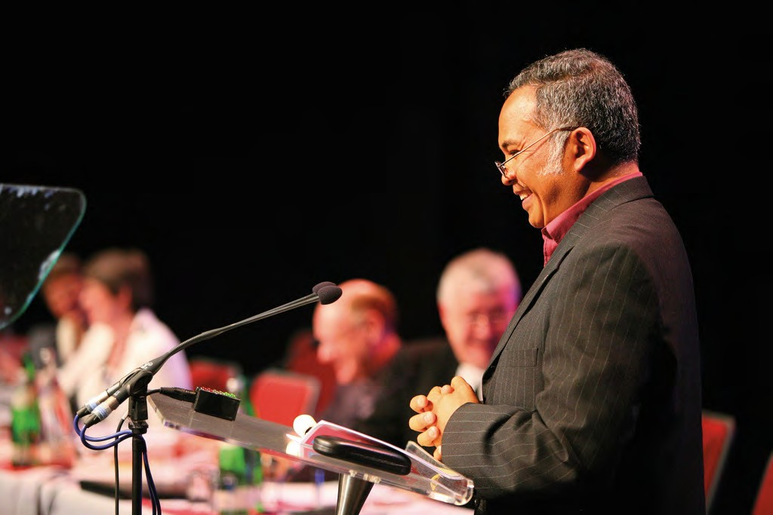
Appendix 3
Ecumenical guest, Revd Lala Rasendrahasina

REPRESENTATIVES ON ECUMENICAL CHURCH BODIES
The following have been nominated as United Reformed Church representatives at the major gatherings of the Ecumenical Bodies listed.

Council for World Mission (CWM)
Revd David Coleman, Mrs Zadie Orr, Mr Philip Timson, Secretary for World Church Relations

CWM European Region Meeting
Revd David Coleman, Mrs Zadie Orr, Mr Philip Timson, Secretary for World Church Relations, Secretary for Mission

World Communion of Reformed Churches (WCRC) General Council
Revd Dr Sarah Hall, Ms Emma Pugh, Revd Dr David Pickering, Secretary for World Church Relations, General Secretary

World Council of Churches (WCC) Central Committee
Represented indirectly

WCC Faith and Order Commission
Represented indirectly

Conference of European Churches Assembly
Secretary for Ecumenical Relations

The Disciples Ecumenical Consultative Council
Revd Rowena Francis, Rev Professor David Thompson, Secretary for World Church Relations

Churches Together in Britain and Ireland (CTBI)

    - CTBI Senior Representatives’ Forum
General Secretary, Secretary for Ecumenical Relations

CTBI Environmental Issues Network
Revd David Coaker, Revd Dr David Pickering

CTBI Church and Public Issues Network
Ms Marie Trubic**, Secretary for Church and Society

CTBI Churches’ Criminal Justice Forum
Appendix 3
Mrs Wilma Frew

CTBI Stewardship Network
Mrs Faith Paulding

CTBI Churches’ International Students’ Network
Ms Eleri Evans [2014]

CTBI Consultative Group on Ministry amongst Children (CGMC)
Mrs Karen Bulley-Morrison, Ms Jo Williams

CTBI Inter-Religious Network
Secretary for Ecumenical Relations

CTBI Racial Justice Network
Secretary for Racial Justice and Multicultural Ministry

CTBI Churches’ Network for Mission
Secretary for Mission

CTBI China Forum
Revd Dr Walter Houston

Churches Together in England (CTE)

    - CTE – Enabling Group
Secretary for Ecumenical Relations

CTE – Coordinating Group for Local Unity
Revd Kevin Watson, Secretary for Ecumenical Relations

CTE – Churches Together for Healing
Revd Deborah McVey, Revd Vivien Henderson [2014]

CTE – Churches’ Joint Education Policy Committee
Mr Graham Handscomb

CTE Churches’ Theology and Unity Group
Secretary for Ecumenical Relations

CTE – Group for Evangelisation
Secretary for Mission

CTE – Spirituality Coordinating Group
Revd Sue Henderson

CTE – Churches’ Rural Group
Revd David Herbert

CTE – Minority Ethnic Affairs Group
Revd John Danso, Secretary for Racial Justice and Multicultural Ministry

CTE Youth Work Matters Group
Secretary for Youth Work

Action of Churches Together in Scotland (ACTS) Members Meeting
[see note 7]
Revd John Humphreys, Revd Mitchell Bunting/Revd Sue Kirkbride

  - National Sponsoring Body for Scotland [see note 7] Revd John Humphreys, Revd Mitchell Bunting

Appendix 3

  - Churches Together in Wales (CYTUN) [see note 7] Vacancy

  - Commission of Covenanted Churches [see note 7] Vacancy

Joint Liturgical Group
Revd Hugh Graham

Free Church Education Committee
Mr Graham Handscomb, Mrs Gillian Kingston

European Churches’ Environmental Network
Revd David Coaker

Churches’ Refugee Network
Mr Geoff Duncan, Revd Fleur Houston

Churches’ Committee on Funerals and Crematoria
Revd Sally Thomas, Revd Kate Hackett [2014]

Churches’ Agency for Safeguarding
Secretary for Youth Work

Churches’ Forum for Safeguarding
Secretary for Youth Work

Churches’ Network for Non-Violence
Secretary for Youth Work

REPRESENTATIVES ON FORMAL BI-LATERAL AND MULTI-LATERAL COMMITTEES

United Reformed Church/Methodist Strategic Oversight Group
General Secretary Deputy General Secretary Honorary Treasurer
Member of Assembly Moderators Group

Methodist/United Reformed Church Liaison Committee
Co-Convener: Revd Kevin Watson (Synod Moderator) Miss Emma Pugh, 3 vacancies, Revd Peter Rand (coopted) Secretary for Ecumenical Relations

Roman Catholic – United Reformed Church Bilateral Dialogue in England and Wales
Revd Prof David Thompson, Revd Dr John Bradbury, Revd Dr Sarah Hall, Mrs Ann Shillaker, Mr Malcolm Townsend
Staff Secretary responsible to be decided.

Church of England – United Reformed Church Bilateral Dialogue (“God’s Reign and our Unity”)
Revd Nicola Furley-Smith, Revd Elizabeth Welch, Revd Dr David Peel Deputy General Secretary

Partnership Conversations of the Scottish Episcopal Church, the Methodist Church and the National Synod of the United Reformed Church
Revd John Humphreys, Revd Mitchell Bunting, Vacancy

UNITED REFORMED CHURCH REPRESENTATIVES ON GOVERNING BODIES OF THEOLOGICAL COLLEGES, ETC
Appendix 3

Northern College
Revd David Jenkins [2013] Mr Steve Wood [2013]
Miss Margaret Atkinson [2015] Revd Dr Robert Pope [2015]
Mr Mark Williams [2015] Secretary for Education and Learning

Luther King House Educational Trust
Secretary for Education and Learning

  - Westminster College: Board of Governors Convener: Professor Sir Anthony Bottoms [2014] Clerk: Revd Cecil White † [2016]
Honorary College Treasurer: Mr Anthony Williams [2016]
Members: Dr Jean Stevenson [2013] Revd Craig Muir [2015] Revd Nigel Appleton [2015] Mr Brian Long MBE [2016] Revd Kristin Ofstad [2016]
Revd Canon Andrew Norman** [2018] (Cambridge Theological Federation)
Secretary for Education and Learning
(together with other Governors appointed by other bodies)

Cheshunt Foundation
Mr Guy Morfett [2013] Revd Craig Muir [2014]

Cambridge Theological Federation
Convener, Westminster College Governors

GOVERNORS OF COLLEGES AND SCHOOLS WITH WHICH THE UNITED REFORMED CHURCH IS ASSOCIATED
  - Caterham School Revd Nicola Furley-Smith [2015]

  - Eltham College Revd Terry Sparks [2015]

  - Walthamstow Hall Mrs Isabel Heald [2015]

Milton Mount Foundation
Ms Hilary Miles [2013] Revd David Cuckson [2013]
Revd Val Towler [2014] Revd Derek Lindfield [2014] Revd Richard Wells [2014]

Silcoates School
Dr Peter Clarke [2013] Dr Moira Gallagher [2013] Revd Dr Janet Lees [2013] Revd Steven Knapton [2014]
Mrs Sue Lee [2015] Mrs Tessa Henry-Robinson [2015]

Taunton School
Revd David Grosch-Miller (Moderator, South Western Synod)

Bishops Stortford College
Mr Anthony Trigg [2015]

Appendix 3

MISCELLANEOUS
The United Reformed Church is represented on a variety of other national organisations and committees as follows:

Arthur Rank Centre
Revd Elizabeth Caswell [2013]

Churches Legislation Advisory Service
Mrs Sheila Duncan/General Secretary/Deputy General Secretary

Congregational Fund Board
Mrs Jackie Haws [2013] Mr Anthony Bayley [2014]
Revd Geoffrey Roper [2014] Revd Eric Allen† [2015] Revd Kate Hackett** [2015]

Congregational Memorial Hall Trust
Revd Derek Wales [2013] Mrs Margaret Thompson [2014]
Mr Hartley Oldham [2015] Mr Graham Stacy [2015]
Dr John Thompson † [2016] Dr Brian Woodhall† [2016]

Discipleship and Witness Board of Trustees
Mrs Patricia Hubbard [from before 1999]

Publications Development Group
Ms Jo Williams [from 2008]

English Heritage’s Places of Worship Forum
Mr Peter West (Convener of the Listed Buildings Advisory Group)

Lord Wharton’s Charity
Dr John Thompson [2013]

Methodist Faith and Order Committee
Revd Anne Sardeson [2014]

Retired Ministers’ and Widows’ Fund
Mr Ken Meekison [from before 1999] Mrs Jill Strong [from 1999] Revd Julian Macro [from 2004]

Samuel Robinson’s Charities
Mr Tony Alderman [from 2004]

Scout Association – URC Faith Adviser
Revd David Marshall-Jones

United Reformed Church History Society Council
Revd Dr Kirsty Thorpe [2013] Revd Prof David Thompson [2014] Revd Fleur Houston [2014] Dr David Robinson [2015]

United Reformed Church Guide and Scout Fellowship
Revd David Marshall-Jones

Westhill Endowment Fund
Mr Howard Bridge, Revd Dr Stephen Orchard, Revd Elizabeth Welch (coopted)

Notes

Index
 | Book of Reports | Record
Assembly Arrangements Committee | 85 | 51
Communications and Editorial Committee |  | 45
Education and Learning Committee | 86 | 45
Equal Opportunities Committee | 100 | 49
Finance Committee | 102 | 30
Ministries Committee | 106 | 45
Mission Committee | 118 | 22
Mission Council | 7 | 8
Nominations Committee | 146 | 63
Pastoral Reference and Welfare Committee | 161 | 49
Youth and Children’s Work Committee | 163 | 24
Synod Moderators’ Report | 166 | 17
Resolutions
1 Appointment of tellers | 239 | 7
2 Appointment of facilitation group members | 239 | 7
3 Change to the Structure (Res 26 from 2010) | 239 | 8/18
4 Changes to disciplinary process (Res 5 from 2010) | 241 | 8
5 Changes to incapacity procedure (Res 6 from 2010) | 242 | 9
6 Amendment to Structure (Res 9 from 2010) | 242 | 10
7 Amendment to disciplinary process (Res 7 from 2010) | 243 | 10
8 Amendment to incapacity procedure (Res 8 from 2010) | 243 | 10
9 Bournemouth International Church | 244 | 26
10 Heston Asian United Reformed Church | 244 | 26
11 Church changes | 173/245 | 25
12 Re-appointment of the Treasurer | 245 | 37
13 Civil partnerships | 245 | 21
14 Review of the role of synod moderator | 246 | 51
15 Changes to the Structure | 246 | 37
16 Mandatory training | 250 | 45
17 Trustees’ report 2011 | 251 | 30
18 Giving to the Ministry and Mission Fund | 251 | 31
19 Trends in minister numbers | 252 | 32
20 Reshaping 2013 budget | 253 | 32
21 Synod financial safety net | 254 | 33
22 Ministers’ Pension Fund – revision of benefits | 256 | 34/55
23 Ministers’ Pension Fund – ill health pension | 257 | 35
24 Ministers’ Pension Fund – auto enrolment | 258 | 35
25 Ending of full-time stipendiary service | 259 | 36
26 Resourcing ministries | 260 | 29/49
27 Multicultural church, intercultural habit | 260 | 53
28 Poverty and inequality | 261 | 22
29 Drones | 261 | 50
30 Nominations | 262 | 30/63
31 Pilots affirmation | 262 | 24
32 Pilots Sunday | 263 | 24
33 Adults aged 20 to 40 | 263 | 43
34 Wales: The Occupy movement | 264 | 50
35 Wessex: Locally ordained ministry | 267 | 41
36 Same gender marriage |  | 43
37 Change to rules of procedure (term of lay moderator) |  | 8
38 Commission to investigate resignation of lay moderator |  | 41/44
39 Rescinding 2007 Governing Document |  | 31
40 Trust nominations |  | 31/61
41 Retirement age of synod moderators |  | 36
42 Assembly Arrangements Committee |  | 51
43 Scarborough Statement to MP |  | 19
44 Supplementary to res 3 on the two-Assembly rule |  | 30
45 Extension of D Thompson’s term as a trustee |  | 31

