

Worship Resource
Generous Love: God’s Abundance

This worship resource can be used in the way that suits your local context. All prayers, sermons, pictures and resources are free to use and share.

Commitment for Life enables you and your congregation to work effectively for justice around the globe, in partnership with Christian Aid and Global Justice Now.

Call to Worship

Psalm 65 various verses

Praise awaits you, our God. The whole earth is filled with awe at your wonders; you care for the land and water it; you enrich it abundantly. Hills are filled with flocks, and the wide meadows drip with grain. And so, we sing to God and shout for joy!

1st Hymn
(see final page for suggestions)

Prayers of Approach and Adoration

Generous God, from the creation of the universe, you demonstrated that abundance is part of your nature; more stars, suns, moons and galaxies than the grains of sand on a beach. You showed the generosity of your heart when you sent us Jesus. We gather to praise you, to share in your abundance, and to share your abundant life. Wondrous God, be present to us as we are present to you. In Jesus’ name. Amen

Opening Reflections

You may wish to share some thoughts about today’s theme: the nature of God’s abundance. Perhaps you can share a story of a time when you had far more than you could ever use. Possibly ask the congregation to share a time when they had more than enough, or when they realised how abundant nature can be: harvest season, apple orchids dripping with fruit, or birds in flocks.

You may want to note that, for the most part, we can observe that human systems tend to destroy God’s abundance – abundance is replaced by scarcity; forests are fenced off or cut down, wildebeest and elephants hunted and destroyed,

bird, bee and butterfly populations in precipitous decline. Humans for the most past seem to convert God’s abundance into dead, inanimate stuff. We seem to be living in the myth of Midas: nature turned into gold that we cannot eat. we starve. Why do we suppose that is? Is it all down to human greed and sinfulness, or is there something else going on? (Intrigue!)

2nd Hymn

Prayers of Confession, Assurance

Giving and forgiving God, we confess that we have sinned against you in thought, word and deed. We look around the world in dismay and see oppression, poverty, destitution, preventable disease and homelessness. Your Kingdom of love has been obscured: Lord, in your mercy… Hear our prayer

We have strayed far from your way of love, rejecting your generosity, disregarding your abundance. We have preferred our human systems to your kingdom: competition has replaced co-operation, fear has replaced faith, greed instead of generosity, division instead of unity, and hierarchies instead of equality. Lord, in your mercy… Hear our prayer

Help us to set aside our way and to follow the Jesus way. May we be the agents of the Kingdom, channels of life and light, lovers of joy and compassion, and bringers of peace and generosity. Send your Holy Spirit: fill us with the determination to be Christ’s presence in a broken world. Lord, in your mercy… Hear our Prayer

Listen, people of God: Jesus has died, Jesus has risen, Jesus is coming again. In Him we find forgiveness and mercy. God has made a way and we are forgiven. We thank God for love, as we say together…

Our Father…

All Age Address

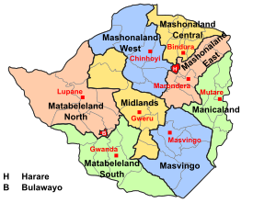

Can you name any animal that begins with a Z?
Zebra, Zokor, Zorilla, Zorro, Zooplankton


Can you name any Bible character whose name begins with a Z?
Zachariah, Zephaniah, Zerubbabel, Zorah, Zacchaeus and over 100 more!

Which Country today begins with a Z?
Zambia & Zimbabwe

What is the national animal of Zimbabwe?
Sable Antelope

And Zimbabwe’s national plant?
Flame Lily

Zimbabwe is also one of the countries supported by Commitment for Life.

Our programmes help young people with disabilities, so that they can go to school and live happy lives. We also help young women so that they can get a good education, be safe and confident that their voice will be heard.

You can help people is Zimbabwe too. Please learn all you can about Zimbabwe. Find out how you can help the animals and the people. But most of all, let us pray for this country…

Dear Jesus: we know that you love the birds, the animals and the children. Today we pray for Zimbabwe. Protect the lions and the elephants. Protect the dung beetles and the bees. Look after the children. Give them good teachers, good food, good schools, good grades and happy families.

Amen

Offering and Prayer of Thanksgiving

You are our life and our salvation, our only hope in this present trouble. God, bless the givers of these gifts and the gifts to your service. Bless those who will be tasked to share them with wisdom, courage and generosity. For Christ’s sake. Amen

3rd Hymn

Readings

Genesis 1:20-25
Luke 6:32-38

Thoughts for Preachers

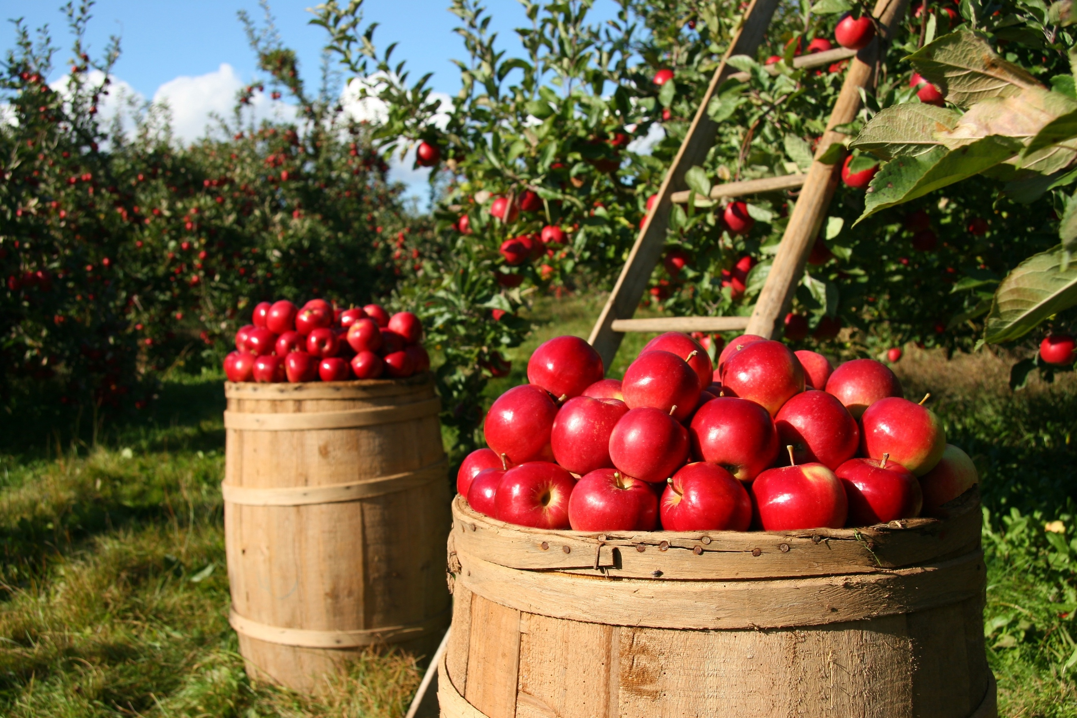
Perhaps begin with a gardening reference - weeding, mowing, picking apples or growing food – something that speaks about tangled, abundant growth. For example, I went on holiday to Turkey in early spring. After only two weeks the lawn looked wild, our shrubs, bushes and trees had started blossoming…. The garden decided in our absence to grow in abundance.

God’s nature is abundance. Generosity is weaved into every aspect of creation. We read it in Genesis. But humanity is caught up in what New Testament scholar Walter Wink calls the ‘Myth of Scarcity.’ There isn’t enough!’ it screams. ‘You must to hoard! Keep it away from those who would steal it away from you!’

And so, we create an economic system based on debt, fear, competition and hoarding. This is at the heart of today’s economics. But we must not succumb to our fears over scarcity. We work by faith not by sight. We know that God provides. All the time. Think about it. We cannot take another breath without God giving it to us. The sparrows neither sow nor reap yet God provides for them! So, how has humanity allowed the false myth of scarcity to shape its life? To understand this, we need to understand from the Bible how abundance operated, and how scarcity crept in...

ABUNDANCE

Genesis starts out as a liturgy of abundance. Genesis 1 is a praise song for God's generosity. It tells the story of the God who creates the world and kept saying how good it was. Genesis speaks about a God that blesses all creation with life and energy and love; “Be fruitful and multiply!”

Creation ends in Sabbath. God is so overrun with fruitfulness that God says, “I’ve got so much, I will give it away as gift. I must share it all freely.”

Psalm 150 is an exuberant expression of amazement at God's goodness. It shouts in joy, “Praise Yahweh, praise Yahweh with lute, praise Yahweh with trumpet, praise, praise, praise.”

Let God loose in the world and abundance follows, pressed down and running over; life filled with wonder and free from anxiety or fear.
Our garden at home is a constant reminder to us, when we both get overwhelmed by sadness that we see in the world because of poverty and injustice… God’s abundance is in our DNA. It shines throughout the world reminding us of the story of God before things went awry.

So how did the story of God’s wonder and plentiful abundance become a story of scarcity? Why do we look the other way when walking past the homeless, the desperate?

SCARCITY

In Genesis, the story starts to turn for the worse. We read of how Pharaoh dreamed famine into the land. Pharaoh’s empire is organised in a such a way as to harness God’s abundance. It creates systems to privatise it, wall it off and shift its wealth to the top. Pharaoh gets a young slave to help him to administer, control, and monopolise of the region’s food supply. Yes: Joseph.

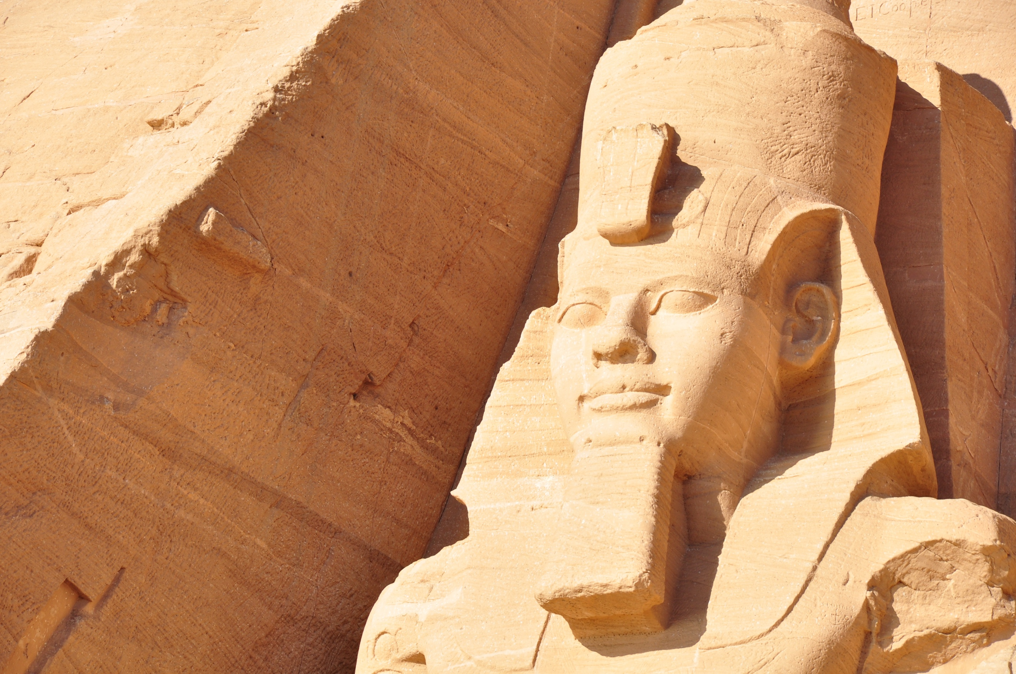
For the first time ever in the Bible, we hear someone cry out, “There is not enough for everyone! Let us hoard into ever bigger barns. Then we shall have enough. Then we shall be safe!”


Very soon almost all the food was taken out of general circulation. People were soon desperate. They went into debt. Ultimately, they were forced to sell themselves into slavery for food. Pharaoh had injected a dark new theme into God’s story of abundance: there is not enough in the world for everyone, you had better find ways of keeping it all for yourself.

And that's how the children of Israel become slaves—through forgetting God’s ways and being sucked into an economic transaction with Pharaoh, enabled and administered by Joseph.

In fact, we might think of the book of Exodus as record of a contest: it is a battle between two competing stories: on the one side, you have the liturgy of God’s generosity, and on the other side you have this new myth of scarcity. That contest continues to tear us apart to this day.

GOD’S WILDERNESS SCHOOL

Exodus tells us how God wanted to break this myth of scarcity that had gotten its claws into the minds of God’s people. God raises up Miriam and her two younger brothers, Moses and Aaron, to lead the people out of empire. God takes them into the desert to teach them to trust in abundance.

However, while they were now freed from physical slavery and bondage, they were still caught up in the myth of scarcity. Very soon, they were fantasising about returning to Egypt. Failing that maybe they could start their own ‘Egypt’ in another part of the world. ‘Look!’ they exclaim, ‘We’ll use this Golden Calf as a basis for our new society.’

But in answer to the people's fears and complaints, something truly extraordinary happens. God's love comes pouring into their lives in the form of bread, and the word “manna” is born. Manna is a gift freely given. Never before had this enslaved people received bread as a free gift. Yes, it was a bit scary: not being able to control, predict, plan or store the manna. No. They had to learn to trust in God.

They learned some important lessons in that faraway desert school, says Daniel Erlander, author of the book Manna and Mercy.

God used the wilderness years to remind the people of God’s ways. Wilderness School to reminded them of the God who cared for them, fed them without sowing or reaping The Wilderness taught them to live with one another. They would be different people when they finally arrived in the Promised Land.

So how did their time in ‘desert school’ reshape their thinking?

First, they learned that hoarding is no longer necessary. God provides enough for each day. Food is for all, not just for those with money. Second, they learned that Pharaoh’s economic system brings rot, death and decay. If you hoard it, it goes bad. Third, they learned that work is not meant for the accumulation of wealth. Work is a dignified activity to help God meet the needs of all people. Fourth, they learned that value of rest. God provides enough so that all can rest on the Sabbath, to enjoy God, family, community and creation.

LESSONS FOR TODAY

What has an abundant God to do with life today? Imagine putting the desert lessons into practice today! No hoarding, no sowing, no reaping… trusting God each day for our well-being. The thought is irrational. It doesn’t fit with how the ‘real’ world’ operates. It annoys our sense of order. But God's abundance is a necessary reminder of the generosity we crave, we long for, we know is right. God’s ways of living transcend the market economy.

One of the things that struck me when we were in Turkey was the lack of homeless people. Have you seen the streets of London? Have you smelled the urine in the doorways of desperate human beings?

Since 2001 we have spent £30 million pounds an HOUR on warfare. We have more than enough wealth. Never before in history has the world had so much money. Never.

But never before has there been such discrepancy between rich and poor, between black and white, between global north and global south.

In the UK, we have a generous percentage of Aid going to poorer third world countries, £1.2 billion a year we give away. However, through unfair trade practices and debt warfare, the global north claws back £2.3 trillion back from the global south. The net wealth flow is from the poor to the rich, sadly.

At Commitment for Life, we emphasise the need for prayer, advocacy action and giving in order to work towards global justice. Simply giving is not going to solve the problems we face. We must deal with the structural causes that entrench inequality.

We have hope. We know Jesus. We are no longer slaves to the worldly system of scarcity. We trust in and worship a God of abundance. So deeply does God love that he sent us Jesus as the greatest gift of all.

Let us learn from the Wilderness School too – how to trust God, how to share what we have, how to give with generosity. What a blessing to be able to follow Jesus’ example, and as Christians to live with confidence in the God of joy and abundance. Will you join me in committing to work for a wold of justice? Amen

Prayers of Intercession

When the rain falls softly on the roof, and the gentle breeze reminds us of summer, we rejoice in your goodness to us, God of all creation.

But, when the wind rips off roofs; and the rain gushes in torrents, there is no joy, only loss
and death.

We pray for those killed when Hurricanes and Cyclones batter the earth. We pray the survivors, clinging to trees and high places,
waiting for rescue.

We pray for those who are doing all that they can to save the people. We pray for those who grieve the loss of family, friends and homes.
May help come quickly, safety found, and rebuilding start soon.
We pray, loving God, that we might respond,
out of the abundance which you have blessed us May we be a world that helps, now and always.
We pray for this congregation, for all who ill, lonely or grieving. We pray for Commitment for Life and its partners in Zimbabwe, Bangladesh, Central America and Israel and the Occupied Palestinian Territory.
May your kingdom come. May we go from this place into our week, knowing that we have met with the Living God of abundance and grace.

Amen

4th Hymn

Benediction

Remember that by the goodness of God we were born. Remember that through the love of Jesus we were saved. Remember that God walks with us moment by moment to guide and comfort us. Remember that by the strength of the Holy Spirit, we follow in the footsteps of the living Christ, to free the prisoner, defend the oppressed, and overcome the evil one. And…

May the grace of our Lord Jesus Christ, love of God, and fellowship of the Holy Spirit be with us now, and evermore.

Amen

Choice of Hymns

Rejoice & Sing | Mission Praise | Songs of Fellowship
620 For the Healing of the Nations | 37 As the Deer pants for the water | 954 You have Broken the Chains
123 Think of a World without any Flowers | 179 He Possessed no Riches (Go tell it on the Mountain) | 1120 Will you Come and Follow Me?
629 Make me a Channel of your Peace | 200 Great is Thy Faithfulness, O God | 1051 To the Ends of the Earth
639 This we can do for Justice & for Peace | 201 Guide me O Though Great Jehovah | 1047 These are the Days of Elijah
108 The love of God is Broad like Beech & Meadow | 225 He’s got the Whole World, in His Hands | 528 The Earth is the Lord’s
642 We utter our cry that Peace may Prevail | 249 How Lovely on the Mountains are the Feet | 475 Refiner’s Fire
625 God of Freedom, God of Justice | 354 Jehovah Jireh, My Provider | 54 Brother, Sister Let me serve you (lyrics need adapting)
90 O Lord, all the World belongs to You | 367 Jesus is Lord, Creation’s voice Proclaims it | 847 I will Cry Mercy
643 When Israel was in Egypt’s Land | 506 O Lord my God, when I in awesome Wonder | 268 I will Enter His Gates
42 For the Fruits of all Creation | 624 Take my Life and Let it be | 903 Lord of the Dance
654 We Turn to you, O God of every Nation | 650 The Kingdom of God is Justice and Joy | 389 May we be a Shining Light

TUNE: Bard of Armagh (Streets of Laredo)

I dream of a church that joins in with God’s vision
Of a people who live without counting the cost;
She trusts in the Spirit of Christ Jesus’ mission
Lifts up the oppressed with Good News for the lost.

I dream of a church that joins in with God’s laughter
Rejoices in justice, and shares all freely:
Turns over the tables of monied disasters
An abundance of mirth in a new Jubilee.

I dream of a church that joins in with God’s prancing
In a swirling star-skirt spun from bright cosmic sky:
Like the prophets of old who lead people by dancing,
Unafraid of the Pharaohs enthroned up on high.

I dream of a church that joins in with God’s caring
As she rises to love the unloved refugee:
This church that shines light on corruption then daring
To forgive and embrace in God’s comm-unity.

Dear God, would you make us a people like Jesus,
With his trust in your kingdom of unfailing grace:
A travelling band of peculiar people
On your journey t’wards joy and true life in this place.

Copyright free: Kevin Snyman

